3

THE INDIvidual entrepreneur

Learning Objectives

1
To identify some key entrepreneurial feelings and motivations.

2
To identify key elements in an entrepreneur’s background.

3
To discuss the importance of role models and support systems.

4
To identify the similarities and differences between male and female entrepreneurs.

5
To explain the differences between inventors and entrepreneurs.

CHAPTER OUTLINE AND TEACHING NOTES
OPENING PROFILE—Robert Mondavi  I. ENTREPRENEURIAL FEELINGS  A. There is no “true entrepreneurial profile”—entrepreneurs come from many educational backgrounds, family situations, and work experiences.  B. Locus of Control.  1. Entrepreneurs must be able to sustain the drive and energy required to form something new and to manage the new enterprise.  2. While research results are inconsistent, internal control seems to be a characteristic of entrepreneurs.  3. Internal beliefs appear to differentiate entrepreneurs from the general public, but not from managers since both tend toward internality.  C. Feelings about Independence and Need for Achievement.  1. The entrepreneur also has the need for independence, to do things in his or her own way and time.  2. Another controversial characteristic is the entrepreneur’s need for achievement.  3. McClelland concluded that a high need for achievement leads individuals to engage in entrepreneurial behavior, although other studies have been inconsistent.  D. Risk Taking.  1. Risk taking seems a part of the entrepreneurial process.  2. Although many studies have focused on risk taking in entrepreneurship, no conclusive relationship has been established. | PowerPoint Slide 3-1  Entrepreneurship Title (See PowerPoint slide show beginning on page 96 of this manual.)  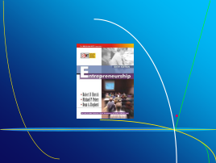  PowerPoint Slide 3-2  Chapter Title (See PowerPoint slide show beginning on page 96 of this manual.)  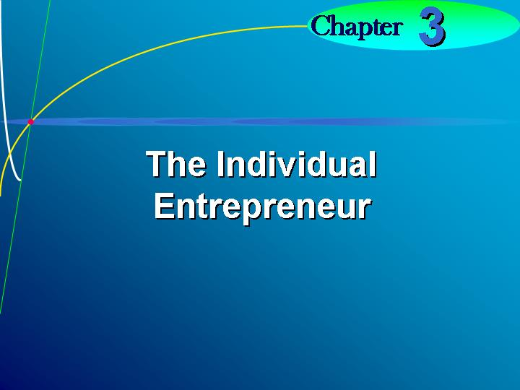    Locus of control.  An attribute indicating the sense of control that a person has over life.  Text Table 3.1 “Checklist for Feelings About Control”  (Text table on page 64.)  Need for independence.  Being one’s own boss—one of the strongest needs of an entrepreneur.  Need for achievement.  An individual’s need to be recognized.  Learning Objective 1.  To identify some key entrepreneurial feelings and motivations.  PowerPoint Slide 3-3 (Transparency Master 3-1)  “Entrepreneurial Feelings” (See PowerPoint slide show beginning on page 96 of this manual. Also included as a transparency master in Section 6 of this manual.)  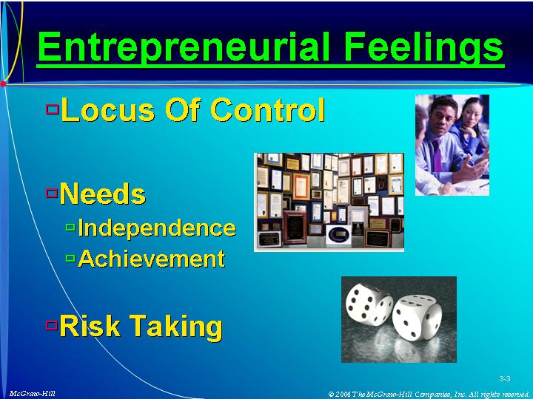  Text Table 3.2 “Checklist for Feelings About Independence”  (Text table on page 63.)  Text Table 3.3 “Checklist for Willingness to Take Risks”  (Text table on page 69.)
II. ENTREPRENEURIAL BACKGROUND AND CHARACTERISTICS  A. Only a few background characteristics have differentiated the entrepreneur from managers.  B. Childhood Family Environment.  1. The impact of birth order and social status has had conflicting research results.  2. Some studies have found that entrepreneurs tend to be firstborn; others find no relationship.  3. There is strong evidence that entrepreneurs, both male and female, tend to have self-employed or entrepreneurial parents.  a. Having a father or mother who is self-employed provides a strong inspiration in the example of independence and flexibility of self-employment.  b. This feeling of independence is often further enforced by an entrepreneurial mother.  4. The overall parental relationship may be the most important aspect of the childhood environment in establishing the desirability of entrepreneurial activity.  5. Parents of entrepreneurs need to be supportive and encourage independence, achievement, and responsibility.  a. This supportive relationship appears to be most important for females.  b. Female entrepreneurs tend to grow up in middle- to upper-class environments, where families are child-centered, and are similar to their fathers in personality.  C. Education.  1. Education appears important in the upbringing of the entrepreneur, in the level of education obtained, and in playing a major role in coping with problems.  2. Although formal education is not necessary for starting a new business, it does provide a good background.  3. Few women entrepreneurs have degrees in engineering, science, or math.  4. The ability to communicate clearly in written and spoken work is also important.  D. Personal Values.  1. Studies have failed to indicate that entrepreneurs can be differentiated on personal valued from managers, unsuccessful entrepreneurs, or the general public.  2. Studies have shown that the entrepreneur has a different set of attitudes about the nature of management.  3. Five consensus characteristics have been found:  a. Superior product quality.  b. Quality service to customers.  c. Flexibility, or the ability to adapt to changes in the marketplace.  d. High-caliber management.  e. Honesty and ethics in business practices.  4. Ethics and ethical behavior are also very important to entrepreneurs.  E. Age.  1. Entrepreneurial age, as contrasted to chronological age, is the age of the entrepreneur reflected in the experience.  2. Entrepreneurial experience is one of the best predictors of success.  3. In chronological age, most entrepreneurs start their careers between ages 22 and 55.  4. There are milestones years every five years.  5. Generally, male entrepreneurs start their first venture in their early 30s, while women tend to do so in their middle 30s.  F. Work History.  1. Dissatisfaction with one’s job often motivates the launching of a new venture.  2. Previous technical and industry experience is also important once the decision to start a business is made.  3. Experience in the following areas is particularly important: financing; product or service development; manufacturing; development of distribution channels; and preparation of a marketing plan.  4. As the venture becomes established, managerial experience and skills become more important.  5. Entrepreneurial experience is also important. | Learning Objective 2.  To identify key elements in an entrepreneur’s background.  Social status.  The level at which an individual is viewed by society.  PowerPoint Slide 3-4 (Transparency Master 3-2)  “Background/Characteristics” (See PowerPoint slide show beginning on page 96 of this manual. Also included as a transparency master in Section 6 of this manual.)  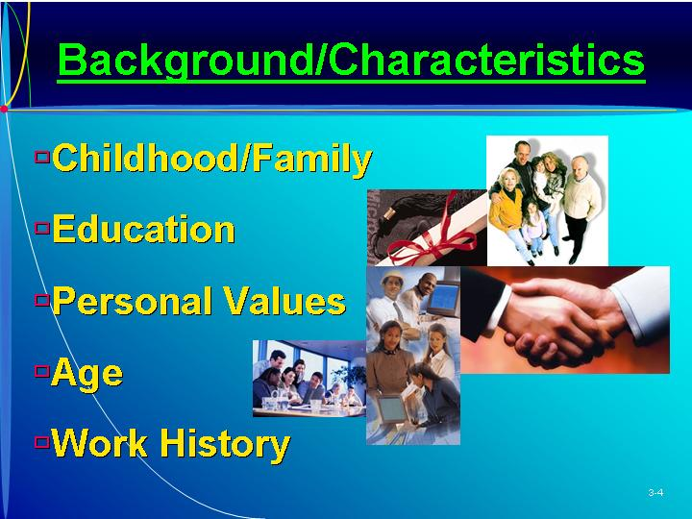    ethics.  Emerging entrepreneurial companies set the ethical tone for the future economic system of the world. (Box in text on page 66)  Work history.  The past work experience of an individual.
III. MOTIVATION  A. While motivations may vary, the reason cited most often for becoming an entrepreneur is independence—not wanting to work for anyone else.  B. Other motivating factors differ between male and female entrepreneurs.  1. Money is the second reason for men’s starting a venture.  2. Job satisfaction, achievement, opportunity, and money are the rank order reasons for women. | Motivations.  What causes people to do something.  PowerPoint Slide 3-5 (Transparency Master 3-3)  “Motivation/Support Systems” (See PowerPoint slide show beginning on page 96 of this manual. Also included as a transparency master in Section 6 of this manual.)  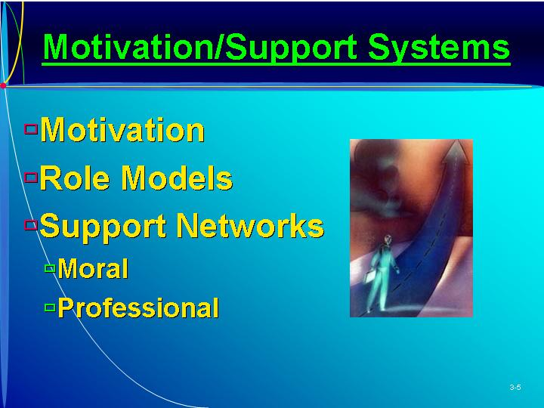
IV. ROLE MODELS AND SUPPORT SYSTEMS  A. One of the most important factors influencing entrepreneurs in their career choice is the choice of role models.  1. Role models can be parents, relatives, or successful entrepreneurs in the community.  2. Role models can also serve in a supportive capacity as mentors during and after the new venture is launched.  a. This support system is most crucial during the start-up phase.  b. It is important that an entrepreneur establish connections and eventually networks early in the venture formation process.  3. As contacts expand they form a network with density (extensiveness of ties between two individuals) and centrality (the total distance of the entrepreneur to all other individuals.)  a. The strength of ties between the entrepreneur and any individual is dependent on the frequency, level, and reciprocity of the relationship.  b. An informal network for moral and professional support benefits the entrepreneur.  B. Moral-Support Network.  1. It is important for the entrepreneur to establish a moral support network of family and friends.  2. Most entrepreneurs indicate that their spouses are their biggest supporters.  3. Friends can provide advice that is more honest than that received from others; also encouragement, understanding, and assistance.  4. Relatives can also be sources of moral support, particularly if they are also entrepreneurs.  C. Professional-Support Network.  1. The entrepreneur also needs advice and counsel which can be obtained from members of a professional support network.  2. Most entrepreneurs indicate that they have mentors.  a. The mentor is a coach, sounding board, and advocate.  b. The individual selected needs to be an expert in the field.  c. An entrepreneur can initiate the “mentor-finding process” by identifying and contacting a number of experts.  d. The mentor should be periodically apprised of the progress of the business so that a relationship can gradually develop.  3. Another source of advice is a network of business associates.  a. Self-employed individuals who have experience in starting a business are good sources.  b. Clients and buyers are also important as they provide word-of-mouth advertising.  4. Suppliers are good components of the professional-support network—they help to establish credibility with suppliers and provide good information on trends in the industry.  5. Trade associations are good network additions, as they keep up with new developments and can provide overall industry data.  6. Affiliations with individuals developed in hobbies, sporting events, civic involvements, and school alumni groups are excellent sources of referrals, advice, and information.  D. Each entrepreneur needs to establish both a moral- and a professional-support network to share problems with and gain overall support. | Learning Objective 3.  To discuss the importance of role models and support systems.  Role models.  Individuals influencing an entrepreneur’s career choice and style.  Moral-support network.  Individuals who give psychological support to an entrepreneur.  Professional-support network.  Individuals who help the entrepreneur in business activities.
V. MALE VERSUS FEMALE ENTREPRENEURS  A. Women are now starting new ventures at a higher rate than men.  1. Women are starting businesses in the U.S. at twice the rate of all businesses.  2. Women now own about 6.2 million small businesses, employing 9.2 million people.  B. In some respects female entrepreneurs possess very different motivations, business skills, and occupational backgrounds.  1. Factors in the start-up process for male and female entrepreneurs are different, especially in such areas as support systems, sources of funds, and problems.  2. Men are motivated by the drive to control their own destinies.  3. Women tend to be more motivated by the need for achievement arising from job frustration.  C. Departure points and reasons for starting the business are similar for both men and women.  1. Both generally have a strong interest and experience in the area of their venture.  2. For men, the transition to a new venture is easier when the venture is an outgrowth of a present job.  3. Women often leave a previous occupation with a high level of frustration and enthusiasm for the new venture rather than experience.  D. Start-Up Financing.  1. Males often have investors, bank loans, or personal loans in addition to personal funds as sources of start-up capital.  2. Women usually rely solely on personal assets or savings.  3. Obtaining financing and lines of credit are major problems for women.  E. Occupations.  1. Both groups tend to have experience in the field of their ventures.  2. Men more often have experience in manufacturing, finance, or technical areas.  3. Most women usually have administrative experience, often in service-related fields.  F. Personality.  1. Both men and women tend to be energetic, goal-oriented, and independent.  2. Men are often more confident and less flexible and tolerant than women.  G. The backgrounds of male and female entrepreneurs tend to be similar.  1. Women are a little older when they embark on their careers.  2. Men often have studied in technical- or business-related areas, while women tend to have liberal arts education.  H. Support Groups.  1. Men usually list outside advisors as most important supporters, with spouse being second.  2. Women list their spouses first, close friends second, and business associates third.  3. Women usually rely more heavily on a variety of sources for support and information than men.  I. Nature of the Venture.  1. Women are more likely to start a business in a service-related area.  2. Men are more likely to enter manufacturing, construction, or high-technology fields. | Learning Objective 4.  To identify the similarities and differences between male and female entrepreneurs.  PowerPoint Slide 3-6  “Entrepreneur and Diversity” (See PowerPoint slide show beginning on page 96 of this manual.)  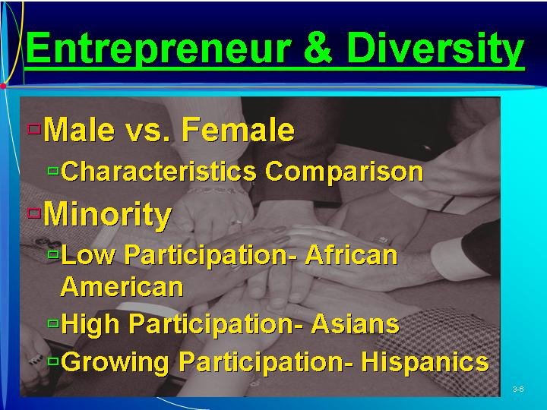  Departure points.  The activities occurring when the venture is started.  PowerPoint Slide 3-7 (Transparency Master 3-4)  “Male Entrepreneur Characteristics” (See PowerPoint slide show beginning on page 96 of this manual. Also included as a transparency master in Section 6 of this manual.)  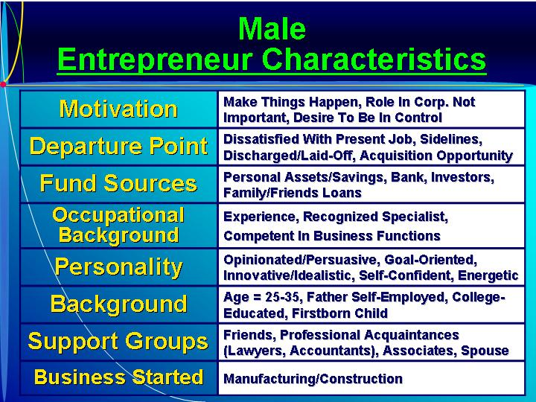  PowerPoint Slide 3-8 (Transparency Master 3-5)  “Female Entrepreneur Characteristics” (See PowerPoint slide show beginning on page 96 of this manual. Also included as a transparency master in Section 6 of this manual.)  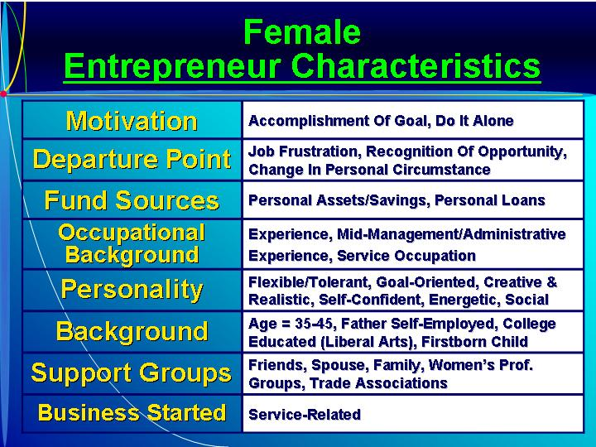  Text Table 3.4 “Comparison Between Male and Female Entrepreneurs” (Text figure on page 72)  As Seen in Entrepreneurship Magazine: Provide Advice to an Entrepreneur about Improving a Business Through Certification as a Woman-Owned Business.  In order to qualify for preferred procurement programs, women-owned businesses need to be certified as a Women’s Business Enterprise. (Box in text on page 72)
VI. MINORITY ENTREPRENEURSHIP  A. The differences in behavior of various groups must be understood in the context of the environment and economic opportunities available, making research difficult.  B. Most literature dealing with minority entrepreneurship has focused on the characteristics of the group under study.  1. In terms of ownership, one study found:  a. The lowest participation rate is for African-Americans.  b. The second highest but fastest growing rate is for Hispanics.  c. The highest rate is for Asians.  2. Studies have also found differences in education, family background, and age when starting the venture.  C. Studies have found differences between ethnic groups in benefiting from community resources.  D. Entrepreneurship has increased among Asians, African Americans, Hispanics, and Native Americans.  1. Hispanic-owned businesses make up 5.8% of businesses.  2. Asian-American owners make up 4.4%.  3. African-Americans own 4.0% and American Indians 1%.  4. This 15.8% minority share is up from 6.8% in 1982. | PowerPoint Slide 3-9  “U.S. Minority Business Ownership” (See PowerPoint slide show beginning on page 96 of this manual.)  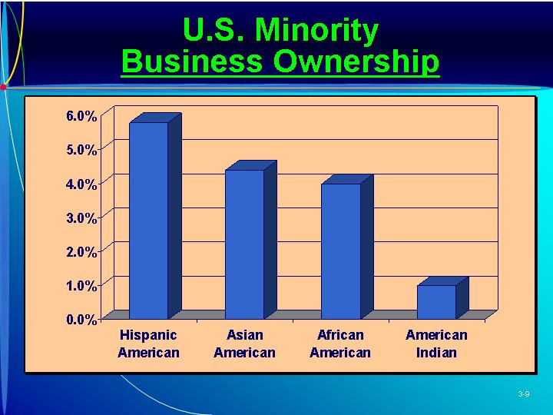  PowerPoint Slide 3-10 (Transparency Master 3-6)  “Growth of Minority Ownership” (See PowerPoint slide show beginning on page 96 of this manual. Also presented as a transparency master in Section 6 of this manual.)  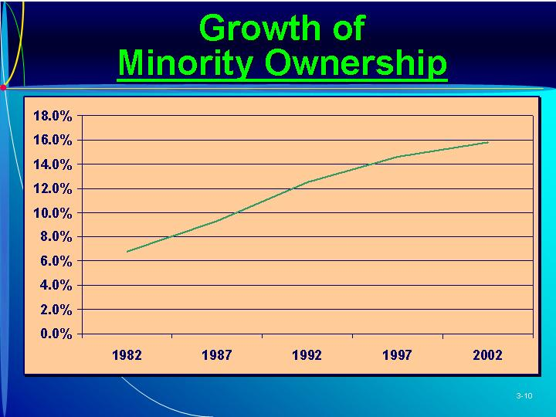
VII. ENTREPRENEURS VERSUS INVENTORS  A. An inventor, an individual who creates something for the first time, is a highly driven individual motivated by his or her own work and personal ideas.  1. An inventor:  a. Tends to be well-educated.  b. Has family, educational, and occupational experiences that contribute to free thinking.  c. Is a problem solver.  d. Has a high level of self-confidence.  e. Is willing to take risks.  f. Has the ability to tolerate ambiguity and uncertainty.  2. A typical inventor places a high premium on being an achiever, and is not likely to view monetary benefits as a measure of success.  B. An inventor differs from an entrepreneur.  1. An entrepreneur falls in love with the new venture, while the inventor falls in love with the invention.  2. The development of a new venture based on an inventor’s work often requires the expertise of an entrepreneur to commercialize it. | Inventor  An individual who creates something new.  Learning Objective 5.  To explain the differences between inventors and entrepreneurs.  PowerPoint Slide 3-11  “Entrepreneur vs. Inventor” (See PowerPoint slide show beginning on page 96 of this manual.)  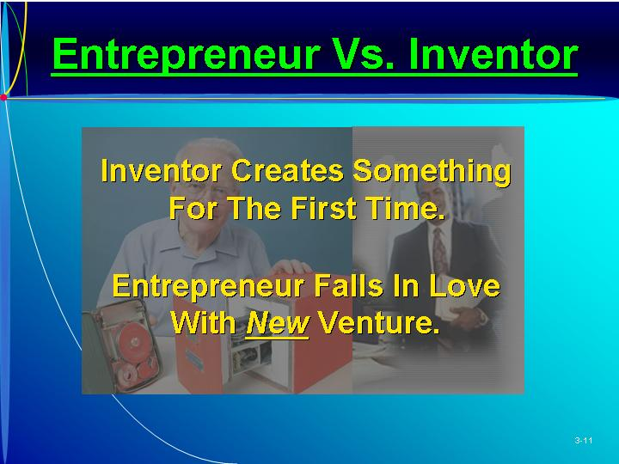  As Seen in Entrepreneurship Magazine: Provide Advice to an Entrepreneur about Government Policy on Entrepreneurial Businesses.  What should the government do to help small business? Advocates on either side present their opinions. (Box in text on page 74)  PowerPoint Slide 3-12  “Difficult Personality Types” (See PowerPoint slide show beginning on page 96 of this manual.)  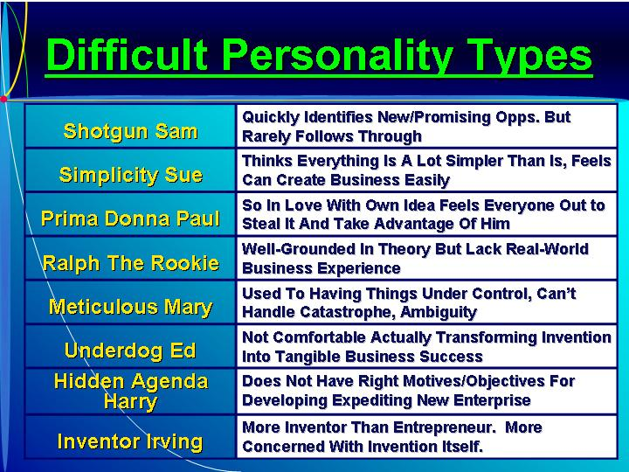
VIII. IN REVIEW: SUMMARY.
See “Learning Objectives Revisited” below.

learning objectives revisited

Learning Objective 1. To identify the key entrepreneurial feelings and motivations.
- Entrepreneurs come from many educational backgrounds, family situations, and work experiences.
- Internal control seems to be a characteristic of entrepreneurs.
- The entrepreneur has a need for independence and a need for achievement.
- Risk taking is part of the entrepreneurial process.

Learning Objective 2. To identify key elements in an entrepreneur’s background.
- Childhood family environment, including the impact of birth order and parental influence, helps establish the desirability of entrepreneurship.
- Formal education is not necessary; the ability to communicate clearly in written and spoken word is more important.
- Studies have shown that the entrepreneur has a different set of attitudes about the management process.
- Entrepreneurial chronological age and entrepreneurial experience are good predictors of success.
- Work history, such as dissatisfaction with one’s job, often motivates the launching of a new venture.

Learning Objective 3. To discuss the importance of role models and support systems.
- Role models such as parents, relatives, or successful entrepreneurs in the community influence career choices.
- Role models can also serve in a supportive capacity as mentors.
- The entrepreneur should establish a moral support network of family and friends.
- He or she also needs advice and counsel from members of a professional support network, including mentors, business associates, customers, and suppliers.

Learning Objective 4. To identify the similarities and differences between male and female entrepreneurs.
- Men are motivated by the drive to control their own destinies; women tend to be more motivated by the need for achievement.
- Departure points and reasons for starting the business are similar for both men and women.
- Males often have better access to investors, bank loans, or personal loans.
- Both groups tend to have experience in the field of their ventures.
- Both men and women tend to be energetic, goal-oriented, and independent.
- The backgrounds of male and female entrepreneurs tend to be similar.
- Men usually list outside advisors as most important supporters, while women list their spouses first, close friends second, and business associates third.
- Women are more likely to start a business in a service-related area; men in manufacturing, construction, or high-technology fields.

Learning Objective 5. To explain the differences between inventors and entrepreneurs.
- An inventor tends to:
    - Be well-educated; has experiences that contribute to free thinking.
    - Is a problem solver.
    - Has a high level of self-confidence.
    - Is willing to take risks.
    - Has the ability to tolerate ambiguity and uncertainty.
- An entrepreneur falls in love with the new venture while the inventor falls in love with the invention.
- An inventor’s business venture often requires the expertise of an entrepreneur to commercialize it.

key terms

Departure points. The activities occurring when the venture is started.
Inventor. An individual who creates something new.
Locus of control. An attribute indicating the sense of control that a person has over life.
Moral-support network. Individuals who give psychological support to an entrepreneur.
Motivations. What causes people to do something.
Need for achievement. An individual’s need to be recognized.
Need for independence. Being one’s own bossCone of the strongest needs of an entrepreneur.
Professional-support network. Individuals who help the entrepreneur in business activities.
Role models. Individuals influencing an entrepreneur’s career choice and style.
Social status. The level at which an individual in viewed by society.
Work history. The past work experiences of an individual.

research tasks and class discussions

The text includes several topics for student research and class discussions. These questions are open-ended, and the answers will be different for each student. There are no “correct” answers.

Research tasks:
- Interview two women entrepreneurs and find out whether they believe that the tasks of being an entrepreneur are different for them than for their male counterparts. What are the advantages of being a female entrepreneur? What are the disadvantages of being a female entrepreneur? Are these differences substantial or minor?
- Interview two minority entrepreneurs and find out whether they believe that the tasks of being an entrepreneur are different for them than for their “nonminority” counterparts. What are the advantages of being a minority entrepreneur? What are the disadvantages? Are these differences substantial or minor?
- Are female entrepreneurs more likely to start certain businesses than male entrepreneurs? Are minority entrepreneurs more likely to start certain businesses than nonminority entrepreneurs? Provide evidence (including statistics) to support your answer.
- Speak to three entrepreneurs and find out what motivated them to become entrepreneurs. Also find one person who, at one time, considered becoming an entrepreneur but did not do so. Find out why this person did not become an entrepreneur.
- Research the biographical/personal accounts of five entrepreneurs. What do they say are the key factors that led them to pursue an entrepreneurial career?

Class Discussions
- We know that people with high IQ scores, or even high SATs or high GMATs, do not necessarily do any better than others in school. How predictive do you believe personality tests are in predicting success as an entrepreneur? What is more predictive? What are the dangers of classifying people using personality tests as “not very entrepreneurial” or “very entrepreneurial”? What are the potential benefits?
- Why do role models impact the decision of people to become entrepreneurs? Do you think that a person whose parent was an entrepreneur of a failed business is more or less likely to start his or her own business than a person whose parents were managers of large, established companies?
- To what extent do men and women differ as entrepreneurs in terms of the types of companies they create and manage, the industries in which they operate, the challenges faced, and their sources of competitive advantage? Are these differences greater or less than they were five years ago? Are we going to soon find that there are no differences between women and men entrepreneurs?
- To what extent do minority entrepreneurs differ from nonminority entrepreneurs in terms of the types of companies they create and manage, the industries in which they operate, the challenges faced, and their source of competitive advantage? Are these differences greater or less than they were five years ago? Are we going to soon find that there are no differences between minority and nonminority entrepreneurs?

Visual Resources

The PowerPoint presentation for this chapter, shown on the following pages, includes the following slides.
Slide 3-1 Entrepreneurship Title
Slide 3-2 Chapter Title
Slide 3-3 Entrepreneurial Feelings *
Slide 3-4 Background/Characteristics *
Slide 3-5 Motivation/Support Systems *
Slide 3-6 Entrepreneur and Diversity
Slide 3-7 Male Entrepreneur Characteristics *
Slide 3-8 Female Entrepreneur Characteristics *
Slide 3-9 U.S. Minority Business Ownership
Slide 3-10 Growth of Minority Ownership *
Slide 3-11 Entrepreneur vs. Inventor
Slide 3-12 Difficult Personality Types
* Also included as a Transparency Master.

The following are included as transparency masters in Section 6 of this manual.
Transparency Master 3-1 Entrepreneurial Feelings
Transparency Master 3-2 Background/Characteristics
Transparency Master 3-3 Motivation/Support Systems
Transparency Master 3-4 Male Entrepreneur Characteristics
Transparency Master 3-5 Female Entrepreneur Characteristics
Transparency Master 3-6 Growth of Minority Ownership

powerpoint slide show

Slide 3-1  Entrepreneurship Title   | Slide 3-2  Chapter Title

Slide 3-3  Entrepreneurial Feelings (Also included as Transparency Master 3-1 in Section 6 of this manual.) | Slide 3-4  Background/Characteristics (Also included as Transparency Master 3-2 in Section 6 of this manual.)
Slide 3-5  Motivation/Support Systems (Also included as Transparency Master 3-3 in Section 6 of this manual.) | Slide 3-6  Entrepreneur and Diversity
Slide 3-7  Male Entrepreneur Characteristics (Also included as Transparency Master 3-4 in Section 6 of this manual.) | Slide 3-8  Female Entrepreneur Characteristics (Also included as Transparency Master 3-5 in Section 6 of this manual.)
Slide 3-9  U.S. Minority Business Ownership | Slide 3-10  Growth of Minority Ownership (Also included as Transparency Master 3-6 in Section 6 of this manual.)
Slide 3-11  Entrepreneur vs. Inventory | Slide 3-12  Difficult Personality Types

