9

the organizational plan

Learning Objectives

1
To understand the importance of the management team in launching a new venture.

2
To understand the advantages and disadvantages of the alternative
legal forms of incorporation.

3
To explain and compare the S Corporation and limited liability company
as alternative forms of incorporation.

4
To learn the importance of both the formal and informal organization.

5
To illustrate how the board of directors or board of advisors can be used
to support the management of a new venture.

CHAPTER OUTlINE AND TEACHING NOTES
OPENING PROFILECStarbucks  I. DEVELOPING THE MANAGEMENT TEAM  A. Potential investors are interested in the management team and its ability and commitment to the new venture.  1. Investors usually demand that the management team not operate the business part-time while employed full time elsewhere.  2. It is also unacceptable for the entrepreneurs to draw a large salary.  B. The entrepreneur should consider the role of the board of directors and/or a board of advisors in supporting the management of the new venture. | PowerPoint Slide 9-1  “Entrepreneurship Title” (See PowerPoint slide show beginning on page 230 of this manual.)    PowerPoint Slide 9-2  “Chapter Title” (See PowerPoint slide show beginning on page 230 of this manual.)  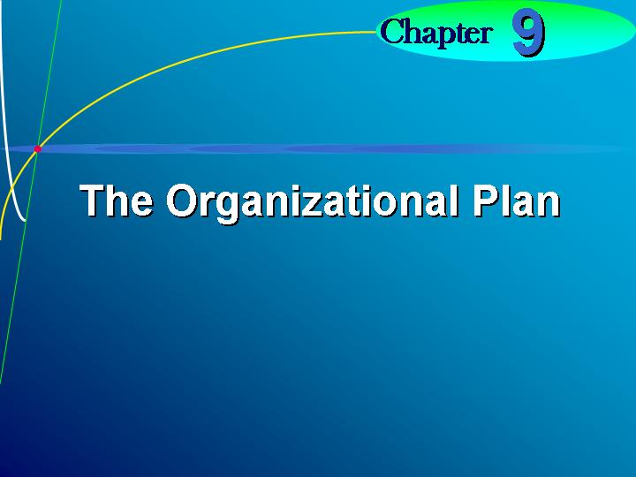  Learning Objective 1.  To understand the importance of the management team in launching a new venture.
II. LEGAL FORMS OF BUSINESS  A. There are three basic legal forms and one new form.  1. The three basic forms are:  a. Proprietorship.  b. Partnership.  c. Corporation (C corporation.)  2. The newest form is the limited liability company, which are now possible in most states.  3. The entrepreneur should evaluate the pros and cons of is of the legal forms prior to submitting a business plan.  4. The entrepreneur should determine the priority of several factors discussed below, as well as tax factors.  5. It is also necessary to consider intangibles such as image to suppliers, existing clients, and prospective customers.  B. Ownership.  1. In the proprietorship, the owner has full responsibility for operations.  2. In a partnership, there may be owners with general or with limited ownership.  3. In the corporation, ownership is reflected by ownership of shares of stock.  C. Liability of Owners.  1. The proprietor and general partners are liable for all aspects of the business.  2. Since the corporation is a legal entity which is taxable and absorbs liability, the owners are liable only for the amount of their investment.  3. To satisfy any outstanding debts of the business, creditors may seize personal assets of the owners in proprietorships or regular partnerships.  4. In a partnership the general partners share the amount of personal liability equally, regardless of their capital contribution, unless there is a specific agreement.  5. In a limited partnership, the limited partners are liable only for their capital contributions.  D. Costs of Starting a Business.  1. The more complex the organization, the more expensive it is to start.  2. The least expensive is the proprietorship, where the only costs may be for filing for a business name.  3. In a partnership, a partnership agreement is needed, in addition.  a. This requires legal advice and should explicitly convey all parties’ responsibilities, rights, and duties.  b. A limited partnership may be more complex to form because it must comply strictly with statutory requirements.  4. The corporation can be created only by statute.  a. The owners are required to register the name and articles of incorporation and meet state statutory requirements.  b. Filing fees and an organization tax may be incurred.  c. Legal advice is necessary to meet the statutory requirements.  E. Continuity of Business.  1. In a sole proprietorship, the death of the owner results in the termination of the business.  2. In a limited partnership, the death or withdrawal of a limited partner has no effect on the existence of the partnership.  a. A limited partner may be replaced, depending on the partnership agreement.  b. If a general partner in a limited partnership dies or withdraws, the limited partnership is terminated unless the partnership agreement specifies otherwise.  3. In a partnership, the death or withdrawal of one of the partners results in termination of the partnership, but this can be overcome by the partnership agreement.  a. Usually the partnership will buy out the withdrawn partner’s share at a predetermined price.  b. Another option is to have a member of the withdrawn partner’s family take over as partner.  4. The corporation has the most continuity, as the owner’s death or withdrawal has no impact on continuity of the business, unless it is a closely held corporation.  F. Transferability of Interest.  1. Each of the forms of business offers different advantages as to the transferability of interest.  2. In a sole proprietorship, the entrepreneur has the right to sell or transfer any assets.  3. In the limited partnership, the limited partners can sell their interests at any time without consent of the general partners.  4. A general partner cannot sell any interest unless specified in the partnership agreement.  5. In a corporation shareholders may transfer their shares at any time.  6. Existing shareholders are sometimes given the right of first refusal when stock is issued.  7. In the S Corporation, the transfer of interest can occur only as long as the buyer is an individual.  G. Capital Requirements.  1. The need for capital during the early months can become one of the most critical factors in keeping a new venture alive.  2. For a proprietorship, any new capital can only come from loans or by additional personal contributions from the entrepreneur.  a. Often an entrepreneur will take a second mortgage as a source of capital.  b. Any borrowing from an outside investor may require giving up some equity.  c. Failure to make payments can result in foreclosure and liquidation of the business.  d. However, the proprietorship is not likely to need large sums of money.  3. In the partnership, loans may be obtained from banks or additional funds may be contributed by each partner, but both methods require change in the partnership agreement.  4. In the corporation, new capital can be raised in a number of ways:  a. Stock may be sold as either voting or nonvoting.  b. Bonds may be sold.  c. Money may also be borrowed in the name of the corporation.  H. Management Control.  1. The entrepreneur will want to retain as much control as possible over the business.  2. In the proprietorship, the entrepreneur has the most control and flexibility in making business decisions.  3. In a partnership the majority usually rules unless the partnership agreement states otherwise.  4. In a limited partnership the limited partners have no control over business decision.  5. Day-to-day control of the business is in the hands of management.  a. Major long-term decisions may require a vote of the major stockholders.  b. As the corporation increases in size, separation of management and control is probable.  6. Stockholders can indirectly affect the operation by electing someone to the board of directors who reflect their philosophy.  I. Distribution of Profits and Losses.  1. Proprietors receive all distribution of profits from the business.  2. In the partnership, the distribution of profits and losses depends on the partnership agreement.  3. Corporations distribute profits through dividends to stockholders.  J. Attractiveness for Raising Capital.  1. In both the proprietorship and partnership, the ability to raise capital depends on the success of the business and personal capability of the entrepreneur.  2. Because of its limitations on personal liability, the corporation is the most attractive form for raising capital. |   C corporation.  Most common form of corporation regulated by statutes and treated as a separate legal entity for liability and tax purposes.  PowerPoint Slide 9-3  “Organizational Issues” (See PowerPoint slide show beginning on page 230 of this manual.)  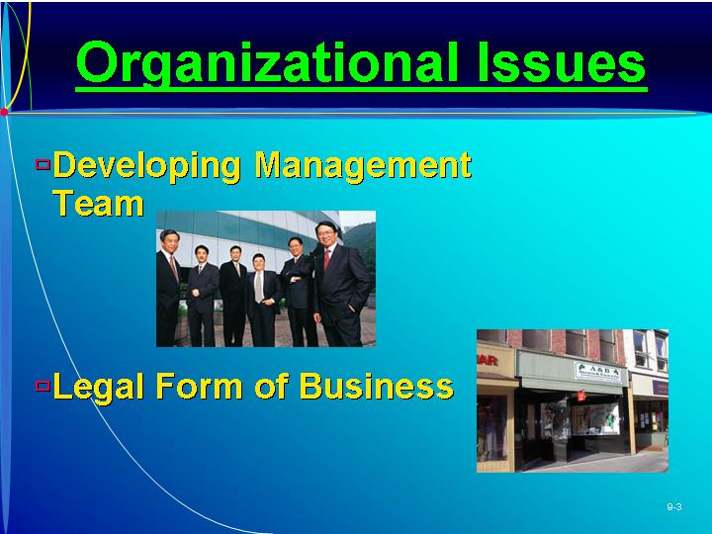  Proprietorship.  Form of business with single owner who has unlimited liability, controls all decisions, and receives all profits.  Partnership.  Two or more individuals having unlimited liability who have pooled resources to own a business.  Corporation.  Separate legal entity that is run by stockholders having limited liability.  PowerPoint Slide 9-4  “Legal Forms” (See PowerPoint slide show beginning on page 230 of this manual.)  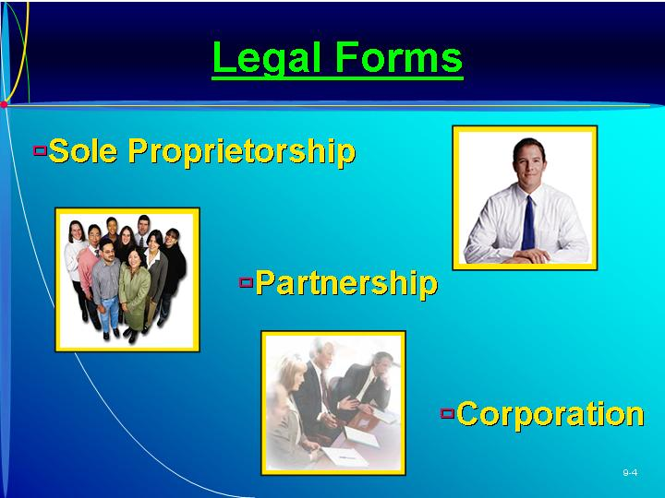  PowerPoint Slide 9-5 (Transparency Master 9-1)  “Ownership” (See PowerPoint slide show beginning on page 230 of this manual. Also presented as a transparency master in Section 6 of this manual.)  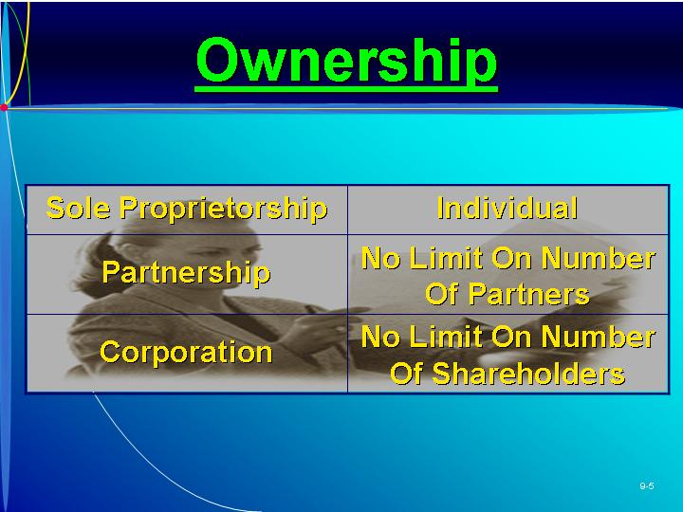  PowerPoint Slide 9-6 (Transparency Master 9-2)  “Liability of Owners” (See PowerPoint slide show beginning on page 230 of this manual. Also presented as a transparency master in Section 6 of this manual.)  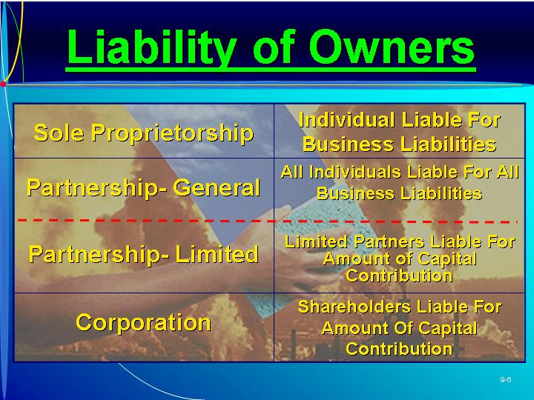  Learning Objective 2.  To understand the advantages and disadvantages of the alternative legal forms for organizing a new venture.  Text Figure 9.1  “Factors in Three Forms of Business Formation” (Text figure on page 252)  PowerPoint Slide 9-7 (Transparency Master 9-3)  “Cost to Start” (See PowerPoint slide show beginning on page 230 of this manual. Also presented as a transparency master in Section 6 of this manual.)  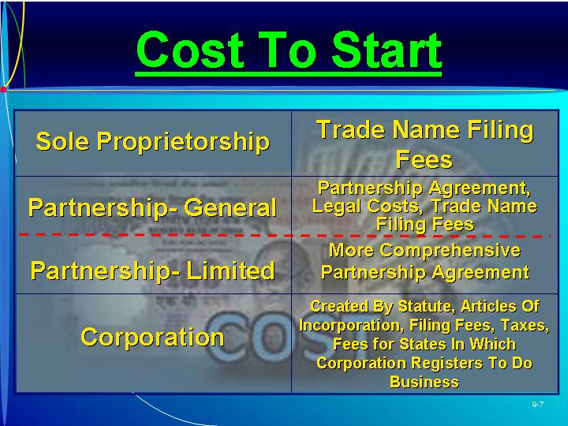  PowerPoint Slide 9-8 (Transparency Master 9-4)  “Continuity of Business” (See PowerPoint slide show beginning on page 230 of this manual. Also presented as a transparency master in Section 6 of this manual.)  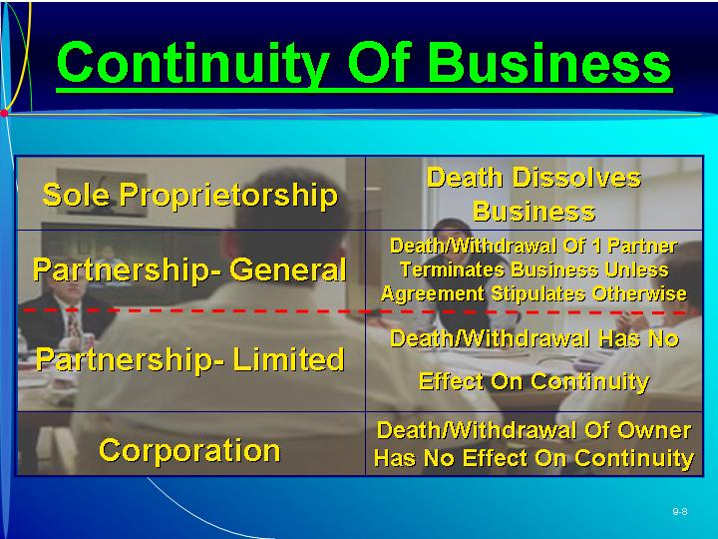  PowerPoint Slide 9-9 (Transparency Master 9-5)  “Transferability of Interest” (See PowerPoint slide show beginning on page 230 of this manual. Also presented as a transparency master in Section 6 of this manual.)  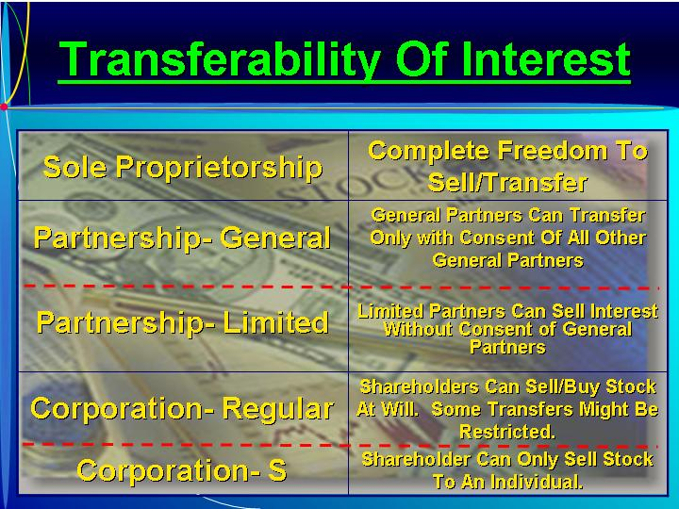  As Seen in Entrepreneur Magazine: Provide Advice to an Entrepreneur About Some Legal Aspects of Starting a Business.  Entrepreneurs need to get good legal advice, especially in important employment issues and in selecting the organizational structure. (Box in text on page 253)  PowerPoint Slide 9-10 (Transparency Master 9-6)  “Capital Requirements” (See PowerPoint slide show beginning on page 230 of this manual. Also presented as a transparency master in Section 6 of this manual.)  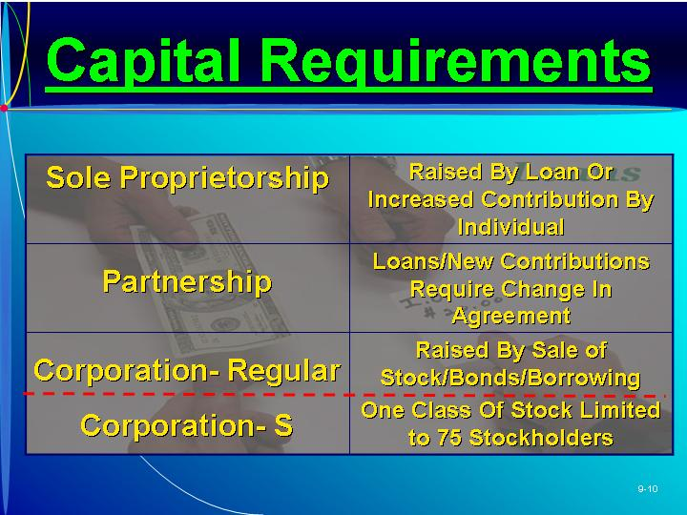  PowerPoint Slide 9-11 (Transparency Master 9-7)  “Management Control” (See PowerPoint slide show beginning on page 230 of this manual. Also presented as a transparency master in Section 6 of this manual.)  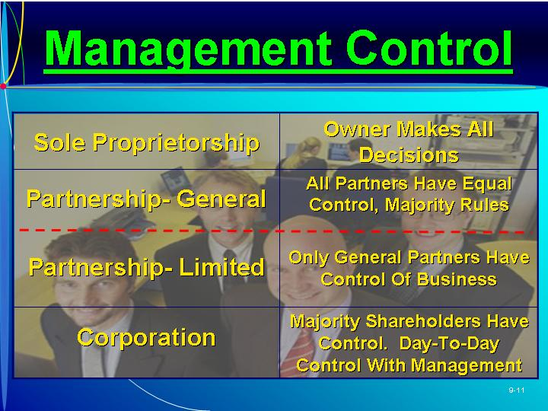  PowerPoint Slide 9-12 (Transparency Master 9-8)  “Distribution of Profits” (See PowerPoint slide show beginning on page 230 of this manual. Also presented as a transparency master in Section 6 of this manual.)  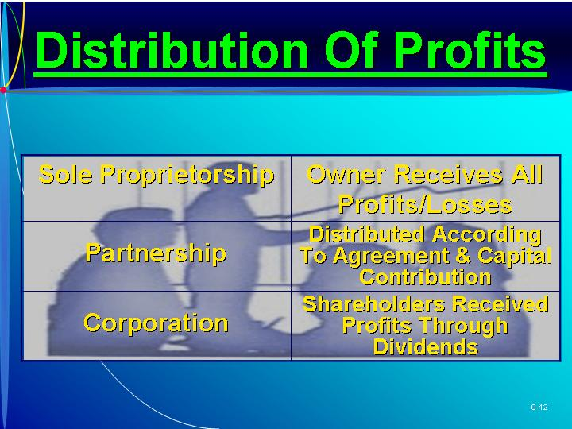  PowerPoint Slide 9-13 (Transparency Master 9-9)  “Ability to Raise Capital” (See PowerPoint slide show beginning on page 230 of this manual. Also presented as a transparency master in Section 6 of this manual.)  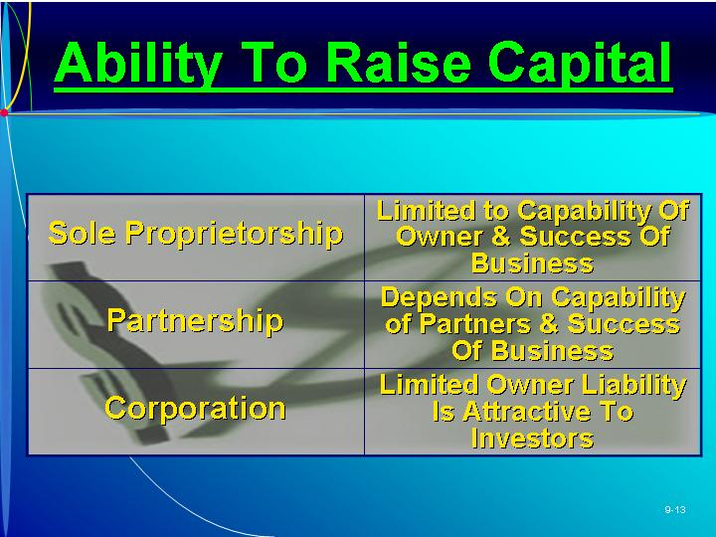
III. TAX ATTRIBUTES OF FORMS OF BUSINESS  A. Tax Issues for Proprietorship.  1. For the proprietorship, the IRS treats the business as the individual owner.  2. All income is personal income, and the business is not taxed as a separate entity.  3. The proprietorship has some tax advantages compared to the corporation.  a. There is no double tax on profits when profits are distributed to the owner.  b. There is no capital stock tax or penalty for retained earnings.  B. Tax Issues for Partnership.  1. The partnership’s tax advantages and disadvantages are similar to the proprietorship.  2. Limited partnerships can provide unique tax advantages.  3. Both the partnership and proprietorship have a legal identity distinct from the partners, but this identity is only for accounting purposes.  4. The income is distributed based on the partnership agreement, and the owners then report their share as personal income.  C. Tax Issues for Corporation.  1. The corporation has the advantage of being able to take many deductions not otherwise available.  2. The disadvantage is that dividends are taxed twice—as income of the corporation and as income of the stockholder.  3. This double taxation can be avoided if the income is distributed to the entrepreneur as salary.  4. The corporation tax may also be lower than the individual rate. |   ETHICS.  Following a devastating fire, Malden Mills’ chairman Aaron Feuerstein announced that he would continue to pay his idle employees while the plant was being rebuilt. However, seven years later the firm was forced to file for bankruptcy. (Box in text on page 258)  PowerPoint Slide 9-14 (Transparency Master 9-10)  “Tax Attributes of Legal Form” (See PowerPoint slide show beginning on page 230 of this manual. Also presented as a transparency master in Section 6 of this manual.)  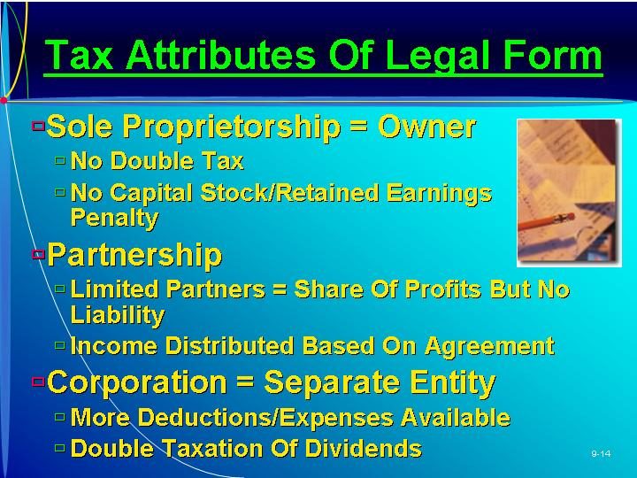  Text Figure 9.2  “Tax Attributes of Various Legal Forms of Business” (Text figure on page 257)
IV. The limited liability company versus the s corporation.
A. The entity that is actually desired by venture capitalists is the LLC or Limited Liability Company.
1. New regulations have made this form more attractive.
2. This new regulation now allows an LLC to be automatically taxed as a partnership, unless the entrepreneur physically makes another choice.
B. Once the most popular organizational structure by new ventures, the growth rate of the S Corporation has leveled off.
C. The treatments of both the S corporation and the LLC are more similar than different.
V. S CORPORATION  A. The S Corporation combines the tax advantages of the partnership and the corporation.  1. It is designed so that the venture income is declared as personal income on a pro rata basis.  2. Shareholders benefit from all of the income and the deductions of the business.  B. Prior to passage of the 1996 Small Business Protection Act, rules governing the S corporation were considered too rigid.  1. The new law provides more flexibility with regard to:  a. Number of shareholders who can be allowed to own shares.  b. The role of trusts as stockholders.  c. The ability of S corporations to own more than 90 percent of stock of another corporation.  d. Distribution of profits.  e. Issuance of different classes of stock.  f. Rules affecting the tax basis of incurred loses.  2. The new law allows existing S corporations to raise capital more easily.  C. The S Corporation status must be carefully monitored and maintained.  . 1. If the S Corporation status is ever lost it usually cannot be reelected for five years.  2. The difference between it and the LLC are generally minimal but should be evaluated on a case by case basis.  D. Advantages of an S Corporation.  1. Capital gains or losses are treated as personal income or losses by the shareholder.  2. Shareholders retain limited liability protection.  3. S Corporations are not subject to a minimum tax, as C corporations are.  4. Stock may be transferred to low-income-bracket family members.  5. Stock may be voting or nonvoting.  6. This form may use the cash method of accounting.  7. Corporate long-term capital gains and losses are deductible by the shareholders.  E. Disadvantages of an S Corporation.  1. Even with the new regulations, there are still some restrictions.  2. There may be a tax advantage to being a C corporation.  3. The S Corporation may not deduct most fringe benefits for shareholders.  4. The S Corporation must adopt a calendar year for tax purposes.  5. Only one class of stock, common stock, is permitted.  6. The net loss of the S Corporation is limited.  7. S corporations cannot have more than 75 shareholders. | S corporation.  Special type of corporation where profits are distributed to stockholders and taxed as personal income.  Learning Objective 3.  To explain and compare the S corporation and limited liability company as alternative forms of incorporation.  PowerPoint Slide 9-15 (Transparency Master 9-11)  “S Corporation—Advantages” (See PowerPoint slide show beginning on page 230 of this manual. Also presented as a transparency master in Section 6 of this manual.)  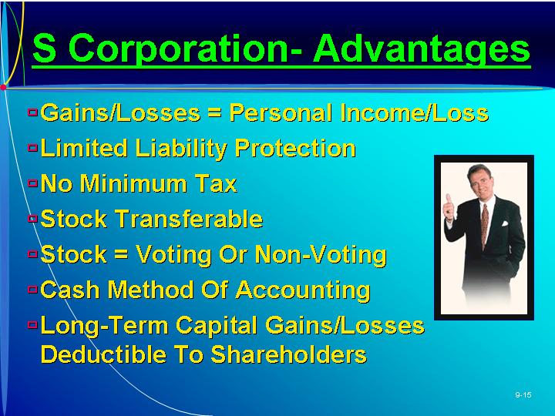  PowerPoint Slide 9-16 (Transparency Master 9-12)  “S Corporations—Disadvantages” (See PowerPoint slide show beginning on page 230 of this manual. Also presented as a transparency master in Section 6 of this manual.)  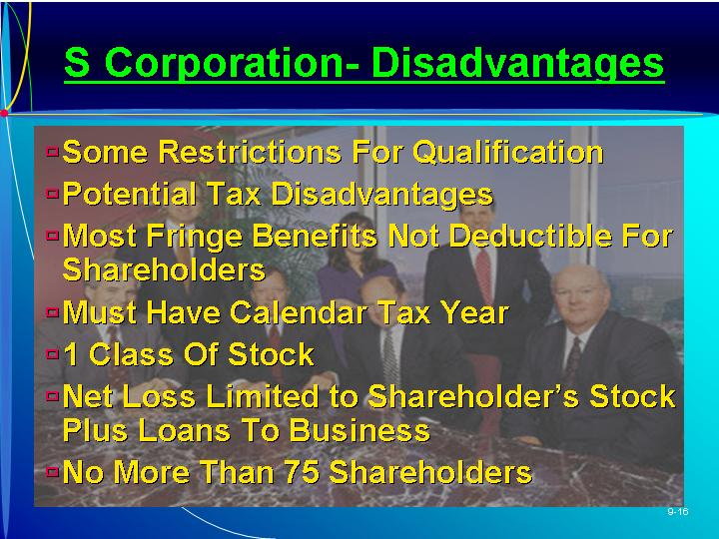
VI. THE LIMITED LIABILITY COMPANY  A. The tax rules for a limited liability company (LLC) fall under subchapter K.  B. This form is a partnership-corporation hybrid with the following characteristics:  1. Where the corporation has shareholders, the LLC has members.  2. No shares are issued, and each member owns an interest in the business.  3. Liability does not extend beyond the member’s capital contribution.  4. Members may transfer their interest only with the unanimous written consent of the remaining members.  5. The standard acceptable term of an LLC is 30 years.  6. The IRS now automatically treats LLCs as partnership for tax purposes.  7. The laws governing formation of the LLCs differ from state to state.  C. Advantages of an LLC.  1. An LLC has advantages over an S Corporation:  a. In a highly leveraged enterprise the LLC offers the partnership a distinct advantage over an S Corporation in the handling of LLC liabilities.  b. With the exception of Texas and Pennsylvania, states do not tax LLCs.  c. One or more individuals, corporations, partnerships, trust, or other entities can join to organize or form an LLC.  d. Members are allowed to share income, profit, expense, deduction, loss and credit, and equity of the LLC among themselves.  2. A major concern with LLCs is in international business, where the context of unlimited liability is still unclear.  3. The LLC is a favorite choice for venture capitalists since it offers more flexibility.  D. With the assistance of a tax attorney, owners should compare alternative forms of ownership. | PowerPoint Slide 9-17 (Transparency Master 9-13)  “Limited Liability Company” (See PowerPoint slide show beginning on page 230 of this manual. Also presented as a transparency master in Section 6 of this manual.)  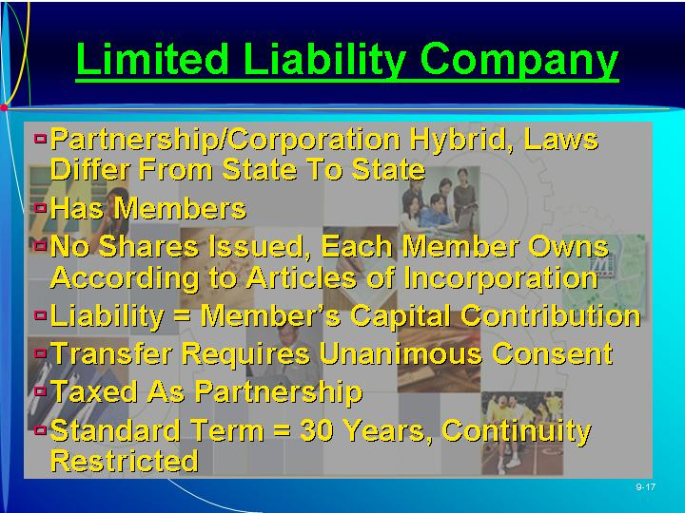  PowerPoint Slide 9-18 (Transparency Master 9-14)  “Advantages of LLC” (See PowerPoint slide show beginning on page 230 of this manual. Also presented as a transparency master in Section 6 of this manual.)  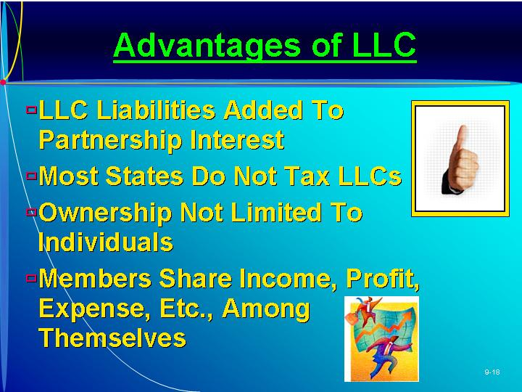
VII. DESIGNING THE ORGANIZATION  A. The design of the initial organization will be simple.  1. The entrepreneur may perform all of the functions alone.  2. He or she sometimes is unwilling to give up responsibility to others.  3. The entrepreneur may have difficulty making the transition from a start-up to a growing well-managed business that maintains its success over a long period of time.  4. As the work load increases the organizational structure will need to expand to include additional employees with defined roles.  5. Effective interviewing and hiring procedures will need to be implemented.  6. In addition to the formal structure there is an informal structure or organizational culture that evolves over time.  7. For many new ventures, part-time employees may be hired, raising commitment and loyalty issues.  B. The organization must identify the major activities required to operate effectively.  1. The design of the organization will indicate to employees what is expected of them in five areas:  a. Organizational structure, which defines members’ jobs and the relationship these jobs have to one another.  b. Planning, measurement, and evaluation schemes, which reflect the goals and objectives of the venture.  c. Rewards, in the form of bonuses, promotion, and praise.  d. Selection criteria, the set of guidelines for selecting individuals for each position.  e. Training, on or off the job.  2. The organization’s design can be simple or complex.  C. There are two stages of development in an organization.  1. Stage 1: The new venture is operated by one person, the entrepreneur, with no need for submanagers.  2. Stage 2: As the business expands, the organization may be described as Stage 2.  a. Submanagers are hired to coordinate, organize, and control aspects of the business.  b. Measurement, evaluation, rewards, selection, and training become necessary.  3. A third stage may exist when the firm achieves a much larger size and a third level of managers is added.  D. As the organization evolves, the manager’s decision roles become more critical.  1. The primary concern of the manager is to adapt to changes in the environment and seek new ideas.  2. When a new idea is found, the manager must initiate development him- or herself or delegate the responsibility.  3. The manager will also need to respond to unexpected pressures, referred to as “putting out fires.”  4. Another role is that of allocator of resources, delegating budgets and responsibility.  5. The final role is that of negotiator, as the entrepreneur can be the only person with the appropriate authority. | PowerPoint Slide 9-19 (Transparency Master 9-15)  “Organizational Design” (See PowerPoint slide show beginning on page 230 of this manual. Also presented as a transparency master in Section 6 of this manual.)  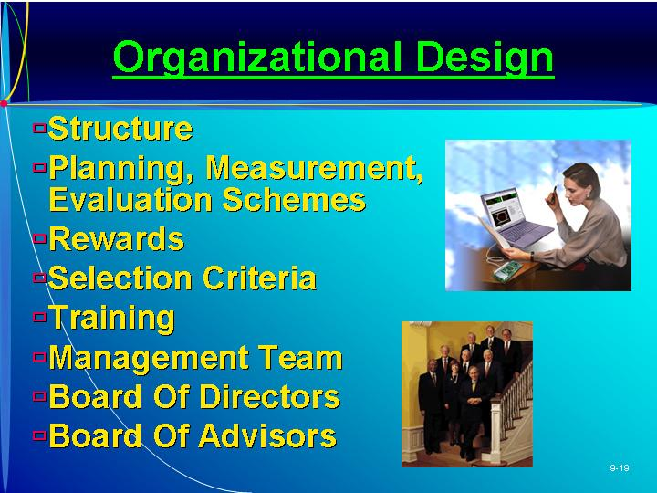  Text Figure 9.3  “Stages in Organizational Design” (Text Figure on page 263)
VIII. BUILDING THE SUCCESSFUL ORGANIZATION  A. In designing the organization the entrepreneur will need to assemble the right mix of people to assume the responsibilities outlined in the organization structure.  B. The team must be able to accomplish three functions:  1. Execute the business plan.  2. Identify fundamental changes in the business as they occur.  3. Make adjustments to the plan based on changes in the environment and market that will maintain profitability.  C. The entrepreneur will first need to assume the responsibility of determining what skills and abilities are needed to meet the goals in the business plan.  1. The personality and character of each individual needs to be considered.  2. The organization culture will be a blend of attitudes, behaviors, dress, and communication styles that make one business different from another.  D. Considerations and strategies to recruit and assemble an effective team and hence result in an effective positive organization culture include:  1. The entrepreneur’s desired culture must match the business strategy outlined in the business plan.  2. The leader(s) of the organization must lead and be role models for their employees.  3. The entrepreneur should be flexible enough to try different things.  4. Extra time needs to be spent in the hiring process.  a. There is more to a person than their skills.  b. A hiring plan should be implemented that establishes the procedure for screening, interviewing, and assessing all candidates.  c. Job descriptions along with specifications of the type of person that will match the desired culture should be documented for this process.  5. Also, remember that it is easier to change a person’s behavior rather than their attitude.  a. Leadership needs to establish core values and provide the appropriate tools so that employees can effectively complete their jobs.  b. A reward system is one tool needed to provide consistent and positive behavior patterns.  E. Finding the most effective team and creating a positive organization culture is as critical as having an innovative, marketable product. | Learning Objective 4.  To learn the importance of both the formal and informal organization.  As Seen in Entrepreneurship Magazine: Provide Advice to an Entrepreneur About Firing Employees.  Firing an employee is a messy business, but holding on to a salesperson who’s not performing is guaranteed to make things worse. (Box in text on page 266)  PowerPoint Slide 9-20  “Effective Team” (See PowerPoint slide show beginning on page 230 of this manual.)  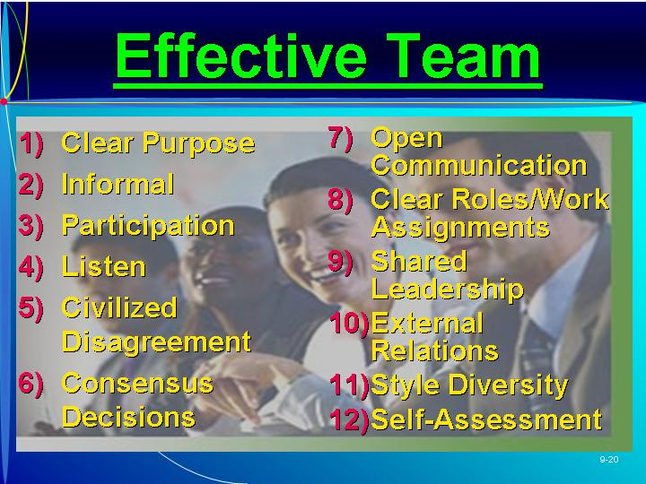
IX. THE ROLE OF A BOARD OF DIRECTORS  A. The board of directors serves a number of functions:  1. Reviewing operating and capital budgets.  2. Developing longer-term strategic plans for growth and expansion.  3. Supporting day-to-day activities.  4. Resolving conflicts amongst owners.  5. Ensuring the proper use of assets.  6. Developing a network of information sources.  B. The Impact of the Sarbanes-Oxley Act of 2002.  1. The Sarbanes-Oxley Act was passed because of widely reported accounting irregularities, fraud, bankruptcy, insider trading, excessive management compensation, and other illegal or unethical acts.  2. The new law’s intent is to establish a more independent functioning board.  a. In public companies board members must represent all shareholders and are now responsible for “blowing the whistle” on any discrepancies that may be suspected.  b. In privately held companies the shareholders may actually represent the board of directors.  3. The board of directors should be carefully chosen to meet the requirements of the Sarbanes-Oxley Act and also the following criteria:  a. Individuals who can work with a diverse group.  b. Candidates who understand the market environment or can contribute importance skills.  c. Candidates who will show good judgment in business decision-making.  4. The board should consist of seven to twelve members with limited terms.  C. Board of director performance should be regularly evaluated by the entrepreneurs.  1. Usually the chairperson provides an appraisal of each member.  2. The chairperson should have a written description of the responsibilities of each member.  3. Often the new venture will tie compensation to the performance of the new venture. | Learning Objective 5.  To illustrate how the board of directors or board of advisors can be used to support the management of a new venture.
X. THE BOARD OF ADVISORS
A. A board of advisors would be more loosely tied to the organization and would serve only in an advisory capacity.
1. It has no legal status, so it is not subject to the regulations of the Sarbanes-Oxley Act.
2. These boards meet less frequently, depending on the need, to discuss important venture decisions.
3. A board of advisors is very useful in a family business where the board of directors may consist entirely of family members.
B. The selection process for advisors can be similar to the process for selecting a board of directors.
1. Advisors may be compensated on a per meeting basis or with stock or stock options.
2. The members should be evaluated as to their contribution to meeting the mission of the new venture.
C. Board of advisors can provide an important reality check for the owner.
XI. THE ORGANIZATION AND USE OF ADVISORS
A. The entrepreneur will usually need to use outside advisors such as accountants, bankers, lawyers, and market researchers.
B. The relationship can be enhanced by seeking out the best advisors and involving them thoroughly.
C. Hiring and managing outside experts can be viewed as hiring advice suppliers.
D. Even after the advisors have been hired, the entrepreneur should question their advice.
XII. IN REVIEW: SUMMARY.
See “Learning Objectives Revisited” below.

learning objectives revisited

Learning Objective 1. To understand the importance of the management team in launching a new venture.
  - Potential investors are interested in the management team and its ability and commitment to the new venture.
  - The entrepreneur should consider the role of the board of directors and/or a board of advisors in supporting the management of the new venture.

Learning Objective 2. To understand the advantages and disadvantages of the alternative legal forms for organizing a new venture.
  - Ownership.
    - In the proprietorship, the owner has full responsibility for operations.
    - In a partnership, there may be owners with general or with limited ownership.
    - In the corporation, ownership is reflected by ownership of shares of stock.
  - Liability of Owners.
    - The proprietor and general partners are liable for all aspects of the business.
    - Since the corporation is a legal entity which is taxable and absorbs liability, the owners are liable only for the amount of their investment.
    - In a partnership the general partners share the amount of personal liability equally, regardless of their capital contribution.
    - In a limited partnership, the limited partners are liable only for their capital contributions.
  - Costs of Starting a Business.
    - The least expensive is the proprietorship, where the only costs may be for filing for a business name.
    - In a partnership a partnership agreement is also needed, requiring legal advice.
    - A limited partnership may be more complex to form because it must comply strictly with statutory requirements.
    - The corporation can be created only by statute, and legal advice is necessary to meet the statutory requirements.
  - Continuity of Business.
    - In a sole proprietorship, the death of the owner results in the termination of the business.
    - In a limited partnership, the death of a limited partner has no effect on the existence of the partnership.
    - In a partnership, the death or withdrawal of one of the partners results in termination of the partnership, but this can be overcome by the partnership agreement.
    - The corporation has the most continuity, as the death or withdrawal has no impact on continuity of the business, unless it is a closely held corporation.
  - Transferability of Interest.
    - In a sole proprietorship, the entrepreneur has the right to sell any assets.
    - In the limited partnership, the limited partners can sell their interests at any time without consent of the general partners.
    - A general partner cannot sell any interest unless specified in the partnership agreement.
    - In a corporation, shareholders may transfer their shares at any time.
    - In the S Corporation, the transfer of interest can occur only as long as the buyer is an individual.
  - Capital Requirements.
    - For a proprietorship, any new capital can only come from loans or by additional personal contributions from the entrepreneur.
    - In the partnership, loans may be obtained from banks or additional funds may be contributed by each partner.
    - In the corporation, new capital can be raised in many ways.
  - Management Control.
    - In the proprietorship, the entrepreneur has the most control and flexibility in making business decisions.
    - In a partnership, the majority usually rules unless the partnership agreement states otherwise.
    - In a limited partnership the limited partners have no control over business decision.
    - In a corporation, the control of day-to-day business is in the hands of management, but major long-term decisions may require a vote of major stockholders.
  - Distribution of Profits and Losses.
    - Proprietors receive distribution of all profits from the business.
    - In the partnership, the distribution of profits and losses depends on the partnership agreement.
    - Corporations distribute profits through dividends to stockholders.
  - Attractiveness for Raising Capital.
    - In both the proprietorship and partnership, the ability to raise capital depends on the success of the business and personal capability of the entrepreneur.
    - The corporation is the most attractive form for raising capital.
  - Tax Issues.
    - For the proprietorship, the IRS treats the business as the individual owner; income is personal income, and the business is not taxed as a separate entity.
    - The partnership’s tax advantages and disadvantages are similar to the proprietorship.
    - The corporation has the advantage of being able to take many deductions not otherwise available, but dividends are taxed twice.

Learning Objective 3. To explain and compare the S corporation and limited liability company as alternative forms of incorporation.
  - The S Corporation combines the tax advantages of the partnership and the corporation.
    - Venture income is declared as personal income on a pro rata basis.
    - The Small Business Protection Act of 1996 provides more flexibility in formation.
    - A firm’s S corporation status must be carefully monitored and maintained.
  - A limited liability company is considered a partnership/corporation hybrid.
    - No shares of stock are issued—each member owns an interest in the business.
    - Liability does not extend beyond the member’s capital contribution.
    - The laws governing formation of the LLCs differ from state to state.
    - New regulations now allow an LLC to be automatically taxed as a partnership.
  - The treatment of both the S corporation and the LLC are more similar than different.

Learning Objective 4. To learn the importance of both the formal and information organizations.
  - The design of the initial organization will be simpleCthe entrepreneur may perform all of the functions alone.
    - As the work load increases the organizational structure will need to expand to include additional employees with defined roles.
    - As the organization evolves, the manager’s decision roles become more critical:
  - The entrepreneur must determine what skills and abilities are needed to meet the business goals then recruit and assemble an effective team.
    - The organization culture will be a blend of attitudes, behaviors, dress, and communication styles that make one business different from another.
    - The leader of the organization must be a role model for their employees and establish core values.

Learning Objective 5. To illustrate how the board of directors or board of advisors can be used to support the management of a new venture.
  - The board of directors serves a number of functions such as reviewing operating and capital budgets and developing longer-term strategic plans for growth and expansion.
  - A board’s involvement has been shown to be positively related to financial performance.
  - The external board of directors with diverse backgrounds can provide objectivity.
  - A board of advisors is more loosely tied to the organization and serves only in an advisory capacity.

key terms

C corporation. Most common form of corporation regulated by statute and treated as a separate legal entity for liability and tax purposes.
Corporation. Separate legal entity that is run by stockholders having limited liability.
Partnership. Two or more individuals having unlimited liability who have pooled resources to own a business.
Proprietorship. Form of business with single owner who has unlimited liability, controls all decisions, and receives all profits.
S corporation. Special type of corporation where profits are distributed to stockholders and taxed as personal income.

research tasks and class discussions

The text includes several topics for student research and class discussions. These questions are open-ended, and the answers will be different for each student. There are no “correct” answers.

Research tasks:
- In this country, what proportion of all businesses are (a) proprietorships, (b) partnerships, (c) private companies, and (d) public companies? Provide an example of an industry that has a large share of proprietorships. Why is this the case? Provide an example of an industry that has a large share of partnerships. Why is this the case? Provide an example of an industry that has a large share of private companies. Why is this the case? Provide an example of an industry that has a large share of public companies. Why is this the case?
- How much does it cost to set up a private company? What are the ongoing costs?
- Study the local newspaper and choose three good examples and three poor examples of job advertisements. Be prepared to explain your choices.
- Interview five entrepreneurs about their use of a board of advisors. Ask who is on the board, how the members were selected, how they were encouraged to join the board, how useful the board has been, and so on.

Class Discussions
- Why would entrepreneurs open themselves up to personal financial losses by using a proprietorship rather than a company?
- Why do suppliers sometimes ask entrepreneurs of small companies to provide personal guarantees for a line of business credit? If an entrepreneur is asked (forced) to provide personal guarantees, then what personal protection does a company as a legal form really provide?
- Does the old saying “You get what you pay for’ apply to a board of directors or a board of advisors?
- Design a structure for the following
  - Stage 1. You are the CEO of a company (“Party On”) that specializes in the sale of party merchandise (e.g. paper cups, plates, and streamers). You have a retail store and three employees, and you serve the local area. A differentiation strategy Is used. What structure (configuration, prime coordinating mechanisms, and type of decentralization) are you going to implement and why? Which is the key part of the organization?
  - Stage 2. After five years, Party On has expanded to 150 stores throughout the United States. The company is still following a differentiation strategy, selling primarily the same range of products in each store. What structure (configuration, prime coordinating mechanisms, and type of decentralization) are you going to implement and why? Which is the key part of the organization?
  - Stage 3: After a further seven years, Party On has expanded to 225 stores in the United States, 57 stores in the UK, 30 in Sweden, 10 stores in France, 8 stores in Mexico, and 5 stores in Germany. The company’s strategy is to sell its range of products through company-owned stores at a premium price. What structure (configuration, prime coordinating mechanisms, and type of decentralization) are you going to implement and why? Which is the key part of the organization?
  - Stage 4. Not long after the new structure ahs been put in place, a consortium of department stores offers you a very lucrative contract to sell Party On’s products in its stores worldwide. Its requirement is that Party On’s current retail stores must be closed over a five-year period (it doesn’t want to compete with Party On), and it wants to offer the products at lower prices. You accept the terms and conditions of the deal. What structure (configuration, prime coordinating mechanisms, and type of decentralization) are you going to implement and mechanisms, and why? Which is the key part of the organization?
  - Stage 5. The contract has been enormously successful. Further, a number of other opportunities have arisen. First, the founder and CEO of your major supplier of party merchandise died and you were able to purchase the company at a very reasonable price. Second, rather than close your outlet stores, which are in excellent positions, you decided to sell sporting collectibles (e.g., baseball cards, signed photographs, and jerseys) at a very nice mark-up indeed. However, while U.S. sporting collectibles are somewhat popular outside the united States, each country is quite different. What structure (configuration, prime coordinating mechanisms, and type of decentralization) are you going to implement and why? Which is the key part of the organization?

Visual Resources

The PowerPoint presentation for this chapter, shown on the following pages, includes the following slides.
Slide 9-1 Entrepreneurship Title
Slide 9-2 Chapter Title
Slide 9-3 Organizational Issues
Slide 9-4 Legal Forms
Slide 9-5 Ownership *
Slide 9-6 Liability of Owners *
Slide 9-7 Cost to Start *
Slide 9-8 Continuity of Business *
Slide 9-9 Transferability of Interest *
Slide 9-10 Capital Requirements *
Slide 9-11 Management Control *
Slide 9-12 Distribution of Profits *
Slide 9-13 Ability to Raise Capital *
Slide 9-14 Tax Attributes of Legal Form *
Slide 9-15 S Corporation—Advantages *
Slide 9-16 S Corporation—Disadvantages *
Slide 9-17 Limited Liability Company *
Slide 9-18 Advantages of LLC *
Slide 9-19 Organizational Design *
Slide 9-20 Effective Team
* Also included as a Transparency Master.

The following are included as transparency masters in Section 6 of this manual.
Transparency Master 9-1 Ownership
Transparency Master 9-2 Liability of Owners
Transparency Master 9-3 Cost to Start
Transparency Master 9-4 Continuity of Business
Transparency Master 9-5 Transferability of Interest
Transparency Master 9-6 Capital Requirements
Transparency Master 9-7 Management Control
Transparency Master 9-8 Distribution of Profits
Transparency Master 9-9 Ability to Raise Capital
Transparency Master 9-10 Tax Attributes of Legal Form
Transparency Master 9-11 S Corporation—Advantages
Transparency Master 9-12 S Corporation—Disadvantages
Transparency Master 9-13 Limited Liability Company
Transparency Master 9-14 Advantages of LLC
Transparency Master 9-15 Organizational Design

powerpoint slide show

Slide 9-1  Entrepreneurship Title   | Slide 9-2  Chapter Title
Slide 9-3  Organizational Issues | Slide 9-4  Legal Forms
Slide 9-5  Ownership (Also presented as Transparency Master 9-1 in Section 6 of this manual.) | Slide 9-6  Liability of Owners (Also presented as Transparency Master 9-2 in Section 6 of this manual.)
Slide 9-7  Cost to Start (Also presented as Transparency Master 9-3 in Section 6 of this manual.) | Slide 9-8  Continuity of Business(Also presented as Transparency Master 9-4 in Section 6 of this manual.)
Slide 9-9  Transferability of Interest (Also presented as Transparency Master 9-5 in Section 6 of this manual.) | Slide 9-10  Capital Requirements (Also presented as Transparency Master 9-6 in Section 6 of this manual.)
Slide 9-11  Management Control (Also presented as Transparency Master 9-7 in Section 6 of this manual.) | Slide 9-12  Distribution of Profits (Also presented as Transparency Master 9-8 in Section 6 of this manual.)
Slide 9-13  Ability to Raise Capital (Also presented as Transparency Master 9-9 in Section 6 of this manual.) | Slide 9-14  Tax Attributes of Legal Form (Also presented as Transparency Master 9-10 in Section 6 of this manual.)
Slide 9-15  S Corporation—Advantages (Also presented as Transparency Master 9-11 in Section 6 of this manual.) | Slide 9-16  S Corporation—Disadvantages (Also presented as Transparency Master 9-12 in Section 6 of this manual.)
Slide 9-17  Limited Liability Company (Also presented as Transparency Master 9-13 in Section 6 of this manual.) | Slide 9-18  Advantages of LLC (Also presented as Transparency Master 9-14 in Section 6 of this manual.)
Slide 9-19  Organizational Design (Also presented as Transparency Master 9-15 in Section 6 of this manual.) | Slide 9-20  Effective Team

