13

Entrepreneurial Strategy:
Generating and Exploiting New Entries

Learning Objectives

1
To understand that the essential act of entrepreneurship involves new entry.

2
To be able to think about how an entrepreneurial strategy can first generate,
and then exploit over time, a new entry.

3
To understand how resources are involved in the generation of opportunities.

4
To be able to assess the attractiveness of a new entry opportunity.

5
To acknowledge that entrepreneurship involves making decisions
under conditions of uncertainty.

6
To be able to assess the extent of first-mover advantages
and weigh them against first-mover disadvantages.

7
To understand that risk is associated with newness but there are strategies
that the entrepreneur can use to reduce risk.

CHAPTER OUTlINE AND TEACHING NOTES
OPENING PROFILE—Justin Parer  I. NEW ENTRY  A. New entry refers to:  1. Offering a new product to an established or new market.  2. Offering an established product to a new market.  3. Creating a new organization.  B. Newness is both positive and negative.  1. Newness can help differentiate a firm from its competitors.  2. However, newness creates a number of challenges for entrepreneurs.  C. Entrepreneurial strategy represents the set of decisions, actions, and reactions that first generate, and then exploit over time, a new entry in a way that maximizes the benefits of newness and minimizes its costs.  D. The elements of an entrepreneurial strategy are:  1. The generation of a new entry opportunity, the result of a combination of knowledge and other resources into a bundle that will be valuable, rare, and difficult for others to imitate.  2. The exploitation of a new entry opportunity.  3. A feedback loop.  E. If the entry warrants exploitation, then firm performance depends on  1. The entry strategy; the risk reduction strategy.  2. The way the firm is organized.  3. The competence of the entrepreneur and the management team.  F. Long-run performance is dependent upon the ability to generate and exploit numerous new entries. | PowerPoint Slide 13-1  “Entrepreneurship Title” (See PowerPoint slide show beginning on page 327 of this manual.)  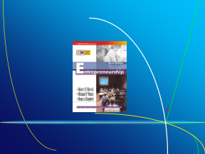  PowerPoint Slide 13-2  “Chapter Title” (See PowerPoint slide show beginning on page 327 of this manual.)  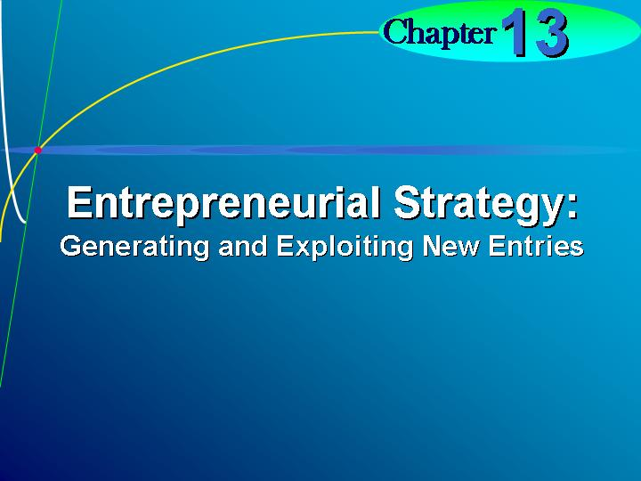  Learning Objective 1.  To understand that the essential act of entrepreneurship involves new entry.    New entry.  Offering a new product to an established or new market, an established product to a new market, or creating a new organization.  Entrepreneurial strategy.  The set of decisions, actions, and reactions that first generate, and then exploit over time, a new entry.  PowerPoint Slide 13-3  “What Is a New Entry?” (See PowerPoint slide show beginning on page 327 of this manual.)  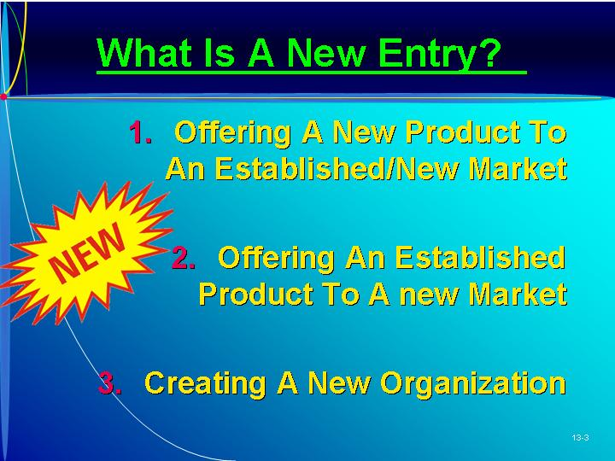  Text Figure 13.1  “Entrepreneurial Strategy: The Generation and Exploitation of New Entry Opportunities” (Text Figure on page 425)
II. GENERATION OF A NEW ENTRY OPPORTUNITY  A. Resources as a Source of Competitive Advantage.  1. Resources are the basic building blocks to a firm’s performance.  a. These resources are the inputs into the production process.  b. These can be combined in different ways to achieve superior performance.  2. These resources need to be considered as a bundle rather than just the resources that make up the bundle.  3. In order for a bundle of resources to be the basis of a firm’s superior performance, the resources must be valuable, rare, and inimitable.  4. A bundle of resources is:  a. Valuable when it enables the firm to pursue opportunities, neutralize threats, and to offer products and services that are valued by customers.  b. Rare when it is possessed by few, if any, competitors.  c. Inimitable when replication of this combination of resources would be difficulty and/or costly for competitors.  5. The text uses the example of Breeze Technology, Inc., which invented a technology that could be applied to the ventilation of athletic shoes to reduce foot temperature.  a. The product was valuable because it provided the means of entering into a large, lucrative market.  b. This technology also appeared to be rare and inimitable.  c. The process was also novel and obvious.  d. A patent protects the owner of the technology from people imitating the technology.  B. Creating a Resource Bundle That Is Valuable, Rare, and Inimitable.  1. The ability to obtain, and then recombine, resources into a bundle that is valuable, rare, and inimitable represents an important entrepreneurial resource.  a. The basis of this resource is knowledge, built up over time through experience.  b. Experience is idiosyncratic–unique to the life of the individual–and therefore can be considered rare.  c. Knowledge is important for generating a bundle of resources that enables the firm to prosper.  d. The text discusses the impact of mountain bikers in causing innovation in the industry.  e. This sort of knowledge is unlikely to be learned in a textbook or in class.  2. Market knowledge refers to the entrepreneur’s possession of information, technology, know-how, and skills that provide insight into a market and its customers.  a. The entrepreneur shares some of the same knowledge that customers have about the use and performance of products.  b. The entrepreneur’s market knowledge is deeper than the knowledge that could be gained through market research.  c. Entrepreneurs who lack this intimate knowledge are less likely to recognize or create attractive opportunities for new products and/or new markets.  d. The text again uses the example of mountain bikers who were aware of the problems that they personally encountered.  e. Because these bike enthusiasts had an intimate knowledge of the market, they were able to bring together resources in a way that provided a solution to customers’ dissatisfaction.  3. Technological knowledge refers to the entrepreneur’s possession of information, technology, know-how, and skills that provide insight into ways to create new knowledge.  a. The text uses the example of laser technology–those with expertise in the industry are more able to adapt and improve the technology and open up a potentially attractive market.  b. Another example is the new markets that have arisen from the development of computer technology.  c. Technological knowledge has led to technological advancement that creates new markets rather than generating a technology to satisfy an unmet market need.  4. The resource bundle is created from the entrepreneur’s market knowledge, technological knowledge, and other resources. | Learning Objective 2.  To be able to think about how an entrepreneurial strategy can first generate, and then exploit over time, a new entry.  Resources.  The inputs into the production process.  PowerPoint Slide 13-4 (Transparency Master 13-1)  “Resources as Competitive Advantage” (See PowerPoint slide show beginning on page 327 of this manual. Also presented as a transparency master in Section 6 of this manual.)  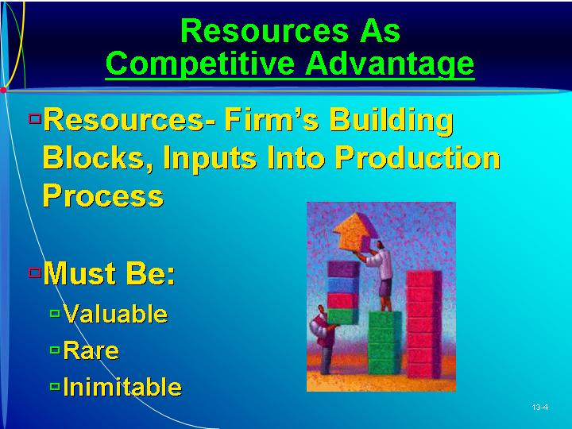  PowerPoint Slide 13-5  “Creating Resource Bundle” (See PowerPoint slide show beginning on page 327 of this manual.)  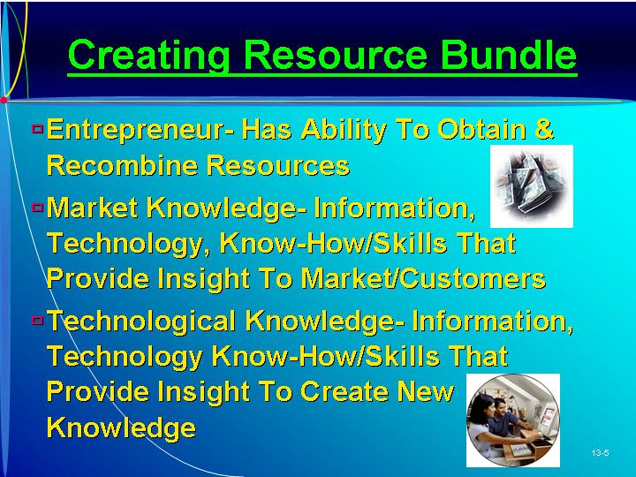  Learning Objective 3.  To understand how resources are involved in the generation of opportunities.  Entrepreneurial resource.  An important entrepreneurial resource is the ability to obtain, and then recombine, resources into a bundle that is valuable, rare, and inimitable.  As Seen in Entrepreneur Magazine: Elevator Pitch for Project Alabama.  Project Alabama is a clothing company with two focuses: the use of recycled materials and the quality of handwork. (Box in text on page 427)  Market knowledge.  Possession of information, technology, know-how, and skills that provide insight into a market and its customers.  Technological knowledge.  Possession of information, technology, know-how, and skills that provide insight into ways to create new knowledge.
III. ASSESSING THE ATTRACTIVENESS OF A NEW ENTRY OPPORTUNITY  A. The entrepreneur needs to determine whether a new product is in fact valuable, rare, and inimitable.  B. Information on a New Entry.  1. Prior knowledge and information search can also help assess the attractiveness of an opportunity.  a. More prior knowledge means the entrepreneur starts from a position of less ignorance.  b. Knowledge can be increased by searching for information on the attractiveness of the new entry opportunity.  c. A longer search period gives the entrepreneur more time to gain more information about customer demand and protection from imitation.  d. However, there are costs associated with this search in terms of money and time.  2. Window of Opportunity.  a. When the window of opportunity is open, the environment is favorable for entrepreneurs to exploit a new product.  b. However, the window of opportunity may close.  c. The time spent in collecting additional information increases the likelihood that the window of opportunity will close.  C. Comfort with Making a Decision under Uncertainty.  1. The trade-off between more information and the window of opportunity’s closing presents a dilemma.  2. The entrepreneur can commit an error of commission over an error of omission, or vice versa.  3. An error of commission occurs from the decision to pursue the new entry opportunity only to find that the entrepreneur overestimated his or her ability to create customer demand.  4. An error of omission occurs from the decision not to act on the new entry opportunity, only to find out later that the entrepreneur underestimated his or her ability to create customer demand.  D. Decision to Exploit or Not to Exploit the New Entry.  1. The decision on whether to exploit or not to exploit the new entry opportunity depends on whether the entrepreneur has sufficient information to make a decision and whether the window is still open.  2. This decision depends on the stock of information and on the entrepreneur’s level of comfort with making a decision without perfect knowledge.  3. The assessment of a new entry’ attractiveness is less about whether the opportunity “really” exists and more about whether the entrepreneur believes he or she can make it work. | Learning Objective 4.  To be able to assess the attractiveness of a new entry opportunity.  PowerPoint Slide 13-6 (Transparency Master 13-2)  “Assessing New Entry Opportunity” (See PowerPoint slide show beginning on page 327 of this manual. Also presented as a transparency master in Section 6 of this manual.)  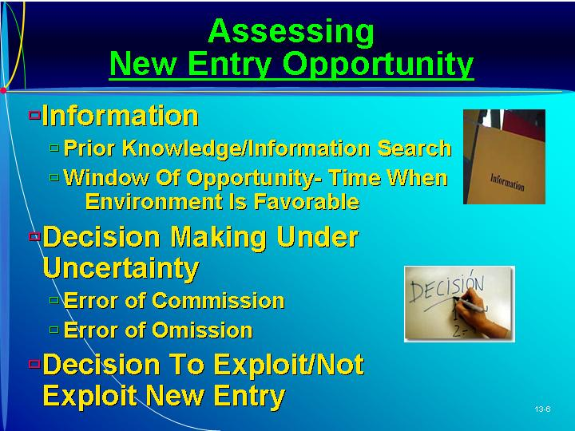  Window of opportunity.  The period of time when the environment is favorable for entrepreneurs to exploit a particular entry.  Error of commission.  Negative outcome from acting.  Error of omission.  Negative outcome from not acting.  Text Figure 13.2  “The Decision to Exploit or Not to Exploit The New Entry Opportunity” (Text figure on page 430)  Assessment of a new entry’s attractiveness.  Determining whether the entrepreneur believes she or he can make the proposed new entry work.
IV. ENTRY STRATEGY FOR NEW ENTRY EXPLOITATION  A. Being first can create advantages that can enhance performance.  1. First movers develop a cost advantage.  a. The first mover is also able to move down the “experience curve.”  b. The firm can spread its fixed costs over a greater number of units (economies of scale) as well as learn by trial and error (learning curve.)  2. First movers face less competitive rivalry.  a. First movers enjoy a rapidly growing market.  b. In the growth stage, firms are more concerned with keeping up with demand than they are with taking market share from others.  3. First movers can secure important channels.  a. First movers can select and develop strong relationships with the most important suppliers and distribution channels.  b. This may represent a barrier to those considering entry.  4. First movers are better positioned to satisfy customers: They have the chance to:  a. Select and secure the most attractive segments of a market.  b. Position themselves at the center of the market.  c. Establish their product as the industry standard.  5. First movers gain expertise through participation: They can:  a. Learn from the first generation of products and improve.  b. Monitor changes in the market that might be difficult to detect for firms not in the market.  c. Build up their networks.  6. Many first movers with new products in new markets have been surpassed by firms that entered later.  7. When considering whether to be the first to enter a market, entrepreneurs must determine whether the first-mover advantages outweigh the first-mover disadvantages.  B. Environmental Instability and First-Mover (Dis)Advantages.  1. The performance of a firm depends on the fit between its bundle of resources and the external environment.  a. If there is a good fit, then the firm will be rewarded with superior performance.  b. If the fit is poor, then performance will also be poor.  2. To obtain a good fit with the external environment, the entrepreneur must determine key success factors, requirements that any firm must meet to successfully compete.  a. The first mover will not know these key success factors and must commit resources based on his or her best guess of what these factors might be.  b. If the environment remains stable, the firm has a good chance for success.  c. If the environment changes, so too will the key success factors.  d. Environmental changes are highly likely in emerging industries, those that have been newly formed and in which the rules of the game have not yet been set.  e. In these industries the entrepreneur has the freedom to establish the rules of the game for the industry, a competitive advantage.  f. Entrepreneurs face considerable demand uncertainty and technological uncertainty.  3. Demand Uncertainty.  a. First movers have little information on the potential size of the market and how fast it will grow.  b. Demand uncertainty makes it difficult to estimate future demand.  (i) By overestimating demand, the entrepreneur will suffer the costs of overcapacity.  (ii) By underestimating market demand, the entrepreneur will suffer the costs of undercapacity.  c. Demand uncertainty also makes it difficult to predict key dimensions such as how customers’ needs and tastes may change.  d. Entrepreneurs that delay entry have the opportunity to learn from first movers without incurring the same costs.  e. Followers have the advantage of more information about market demand.  f. When demand is unstable, first-mover advantages may be outweighed by first-mover disadvantages.  4. Technological Uncertainty.  a. First movers often must make a commitment to a new technology.  b. New technology may not perform as expected or superior alternate technology may be introduced.  c. A superior technology might be introduced that provides later entrants a competitive advantage.  d. Delayed entry can reduce technological uncertainty by learning from the first mover’s R&D program.  e. When technological uncertainty is high, first-mover advantages may be outweighed by first-mover disadvantages.  5. Adaptation.  a. Changes in market demand and technology mean the entrepreneur must adapt to new environmental conditions.  b. Such change is difficult; the organization has an inertia that resists change.  c. The entrepreneurial attributes of persistence and determination can inhibit the entrepreneur’s ability to detect and implement change.  C. Customers, Uncertainty, and First-Mover (Dis)Advantages.  1. Introducing a new product or entering a new market both involve an element of newness.  2. Uncertainty for customers: They may be uncertain about how to use the product or about its benefits over current products.  a. Customers are uncertainty adverse and may still not switch from old to new.  b. Even with a superior product the entrepreneur must reduce customer uncertainties.  3. To reduce this uncertainty, the entrepreneur can:  a. Offer informational advertising about how the product performs.  b. Use comparison marketing to highlight a product’s benefits over those of other products.  4. When the new product is highly innovative, the customer may lack a frame of reference for processing this information.  5. Customers are unlikely to purchase a product until they are convinced it is consistent with enabling products, systems and knowledge–possibly through demonstration and documentation.  6. By entering a market later, customers’ uncertainties have already been reduced by the first movers.  7. Being the first mover can be an advantage.  a. Education may direct customer preferences to give the firm a competitive advantage.  b. The entrepreneur can build a reputation as “founder,” encouraging customer loyalty.  c. The firm can erect barriers to entry and imitation.  D. Lead Time and First-Mover (Dis)Advantages.  1. Entry barriers let the first mover operate for a grace period of limited competition.  2. The lead time gives the entrepreneur a period to prepare for when competition does increase.  3. Lead time can be extended if the first mover can erect barriers to entry such as:  a. Building customer loyalties.  b. Build customer’s switching costs.  c. Protecting product uniqueness.  d. Securing access to important sources of supply and distribution.  4. Barriers to entry can reduce competition which would put downward pressure on prices and increase marketing costs.  a. Competition within an industry can have a positive effect on industry growth.  b. Such competition encourages firms to become efficient and innovative.  5. If not enough customers are willing to change, the first mover should consider allowing competitors into the industry to share the pioneering costs. | Learning Objective 6.  To be able to assess the extent of first-mover advantages and weigh them against first-mover disadvantages.  As Seen in Entrepreneur Magazine: Provide Advice to an Entrepreneur About Being More Innovative.  Using an approach called the “portfolio of initiatives” strategy, the firm always has a number of efforts underway to offer new products and services. (Box in text on page 432)  PowerPoint Slide 13-7  “Strategy for New Entry—First Movers” (See PowerPoint slide show beginning on page 327 of this manual.)  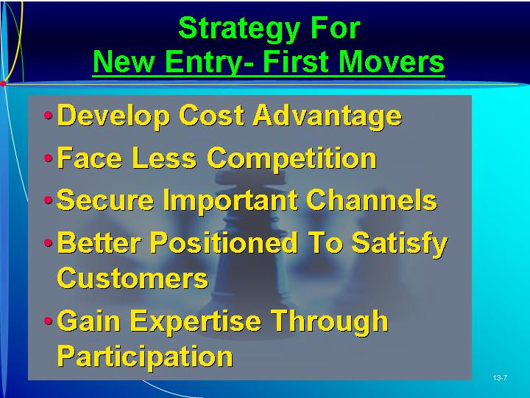  Text Figure 13.3  “Factors That Influence the Decision to Enter the Market Now or to Delay Entry” (Text figure on page 433)  PowerPoint Slide 13-8  “First Mover Disadvantages” (See PowerPoint slide show beginning on page 327 of this manual.)  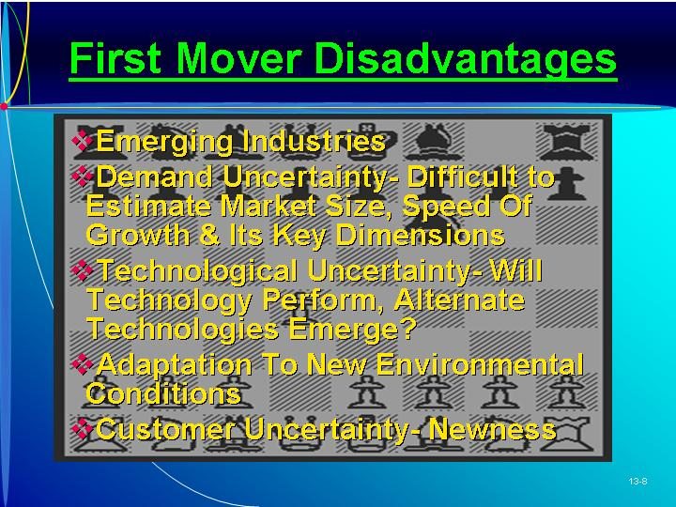  Key success factors.  The requirements that any firm must meet in order to successfully compete in a particular industry.  Emerging industries.  Industries that have been newly formed and are growing.  Learning Objective 5.  To acknowledge that entrepreneurship involves making decisions under conditions of uncertainty.  Demand uncertainty.  Considerable difficulty in accurately estimating the potential size of the market, how fast it will grow, and the key dimensions along which it will grow.  Technological uncertainty.  Considerable difficulty in accurately assessing whether the technology will perform and whether alternate technologies will emerge and leap-frog over current technologies.  Uncertainty for customers.  Customers may have considerable difficulty in accurately assessing whether the new product or service provides value for them.  PowerPoint Slide 13-9  “Overcoming Customer Uncertainty” (See PowerPoint slide show beginning on page 327 of this manual.)  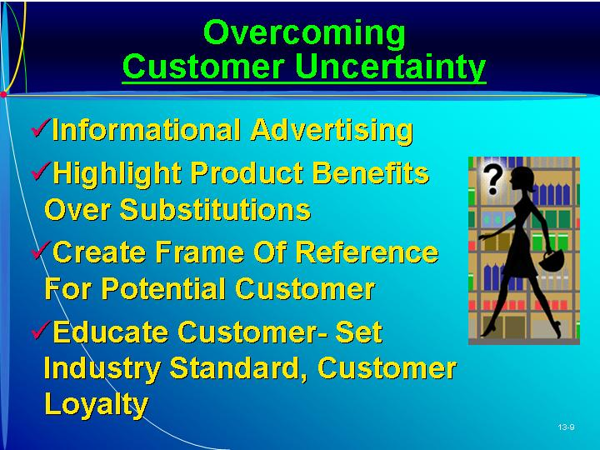    ETHICS.  Do The Right Thing.  Many entrepreneurs are giving considerable thought to improving their ethics, with hopes that doing good business will be good for business as well. (Box in text on page 438)  Lead time.  The grace period in which the first mover operates in the industry under conditions of limited competition.  Customers’ switching costs.  The costs that must be borne by customers if they are to stop purchasing from the current supplier and begin purchasing from another.  PowerPoint Slide 13-10 (Transparency Master 13-3)  “Lead Time and First Mover” (See PowerPoint slide show beginning on page 327 of this manual. Also presented as a transparency master in Section 6 of this manual.)  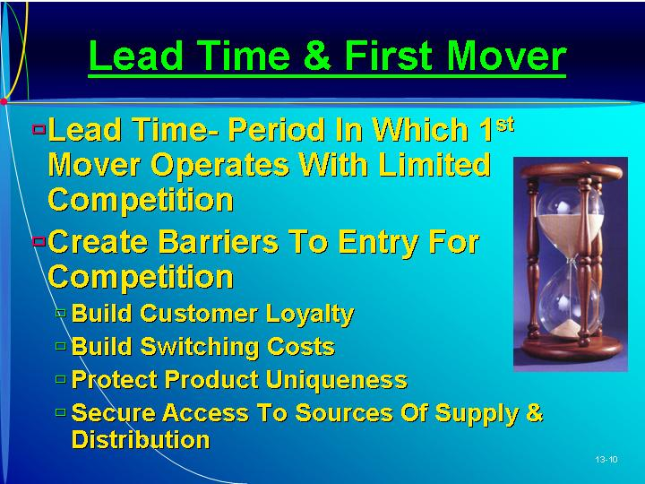
V. RISK REDUCTION STRATEGIES FOR NEW ENTRY EXPLOITATION  A. A new entry involves considerable risk for the entrepreneur.  1. Risk refers to the probability and magnitude of downside loss.  2. The risk comes from uncertainty over market demand, technological development, and the actions of competitors.  B. Market Scope Strategy.  1. Scope is a choice by the entrepreneur about which customer groups to serve and how to serve them.  2. Narrow-scope strategy offers a small product range to a small number of customer groups.  a. The narrow scope can reduce the risk that the firm will face competition with larger firms.  (i) A narrow-scope strategy focuses the firm on producing customized products, localized business operations, and high levels of craftsmanship.  (ii) By focusing on a specific group of customers, the entrepreneur can build up specialized expertise and knowledge.  (iii) The high end of the market is usually a highly profitable niche well suited to firms that produce customized products, localized business operations, and high levels of craftsmanship.  b. If customers don’t value product qualities or are unwilling to pay a premium price for it, the narrow scope strategy provides little protection against competition.  c. Larger established firms can develop products targeted at an attractive market niche.  d. A narrow-scope strategy is vulnerable to the risk that market demand does not materialize as expected.  e. Having a narrow-scope strategy is like putting all your eggs in one basket.  3. A broad-scope strategy can be thought of as taking a “portfolio” approach to dealing with uncertainties.  a. By offering a range of products the entrepreneur gains an understanding of the whole market through a process of trial and error.  b. A narrow-scope strategy requires the entrepreneur to be certain about the market.  c. A broad-scope strategy is opening the firm up to many different “fronts” of competition.  d. A narrow-scope strategy reduces some competition-related risks but increases the risks associated with market uncertainties.  e. A broad-scope strategy reduces risks from market uncertainties, but increases exposure to competition.  f. When the risk of competition is great and market uncertainties are minimal, a narrow-scope strategy is more effective at reducing risk.  g. But if new entry involves creation of a new market, a broad-scope strategy reduces the major risk–uncertainties over customer preferences.  C. Imitation Strategies.  1. Why Do It?  a. Imitation strategy, copying the practices of other firms, is another strategy for minimizing risk.  b. In this strategy, a successful new entry does not need to be valuable, rare, and inimitable on every aspect.  c. Entrepreneurs may simply find it easier to imitate the practices of a successful firm than conduct a systematic and expensive search.  d. Imitating some of the practices of established successful firms can help the entrepreneur develop the skills necessary to be successful in the industry.  e. Imitation also provides organizational legitimacy and is a means of gaining status and prestige.  2. Types of Imitation Strategies.  a. Franchising is a type of new entry that focuses on imitation to reduce the risk of downside loss for the franchisee.  (i) A franchisee gets the use of a “proven formula” for new entry from a franchisor.  (ii). The entrepreneur benefits from an established market demand, intellectual property-protected name and products, and access to expertise.  (iii) The text uses the example of a McDonald’s franchise.  b. New entry can involve copying products that already exist and attempting to build an advantage through minor variations: a “me-too” strategy.  (i) Variations can take the form of making minor changes to the product, taking an existing product to a new market, or delivering the product to customers in a different way.  (ii) Ice cream shops are an example of a me-too imitation strategy.  (iii) A me-too imitation strategy might be difficult to successfully implement.  c. An imitation strategy has the potential to:  (i) Reduce the entrepreneur’s costs associated with R&D.  (ii) Reduce customer uncertainty over the firm.  (iii) Make the new entry look legitimate from day 1.  D. Managing Newness.  1. The creation of a new organization offers some liabilities of newness.  a. New organizations face costs in learning new tasks.  b. As people are assigned to the roles of the new organization, there will be some overlap or gaps in responsibilities.  c. Informal structure, necessary for communication, takes time to establish.  2. If these liabilities can be overcome, then the entrepreneur can benefit form some assets of newness, the advantages that a new organization has over a mature one.  a. Established routines, systems, and processes can be a liability when the firm needs to adapt to changes in its environment.  b. New firms find that their lack of established routines, systems, and processes means that they have a clean slate, giving them learning advantages over older firms.  3. A heightened ability to learn new knowledge needs to be fostered by the entrepreneur.  4. New ventures have strategic advantage over mature competitors, particularly in dynamic, changing environments. | Learning Objective 7.  To understand that risk is associated with newness but there are strategies that the entrepreneur can use to reduce risk.  Risk.  The probability of, and magnitude of, downside loss.  Scope.  A choice about which customer groups to serve and how to serve them.  PowerPoint Slide 13-11 (Transparency Master 13-4)  “Risk Reduction Strategies” (See PowerPoint slide show beginning on page 327 of this manual. Also presented as a transparency master in Section 6 of this manual.)  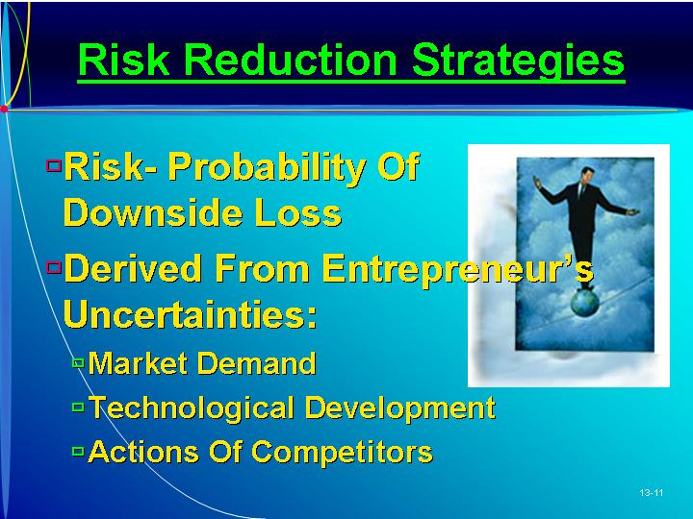  PowerPoint Slide 13-12 (Transparency Master 13-5)  “Market Scope Strategy” (See PowerPoint slide show beginning on page 327 of this manual. Also presented as a transparency master in Section 6 of this manual.)  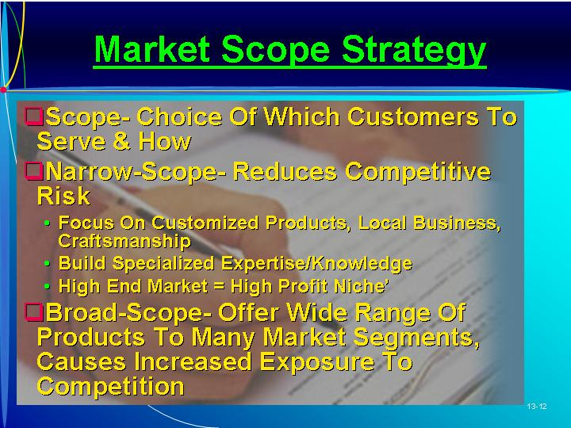  Imitation strategies.  Copying the practices of other firms.  PowerPoint Slide 13-13  “Imitation Strategy” (See PowerPoint slide show beginning on page 327 of this manual.)  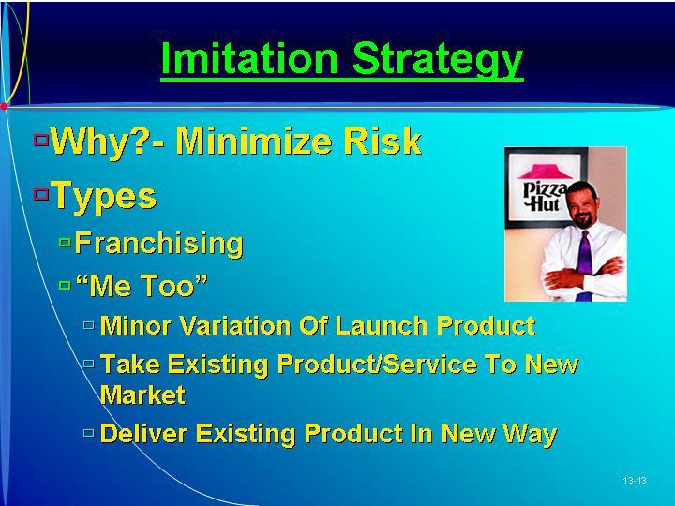  “Me-too” strategy.  Copying products that already exist and attempting to build an advantage through minor variations.  Liabilities of newness.  Negative implications arising from an organization’s newness.  PowerPoint Slide 13-14 (Transparency Master 13-6)  “Liabilities of Newness” (See PowerPoint slide show beginning on page 327 of this manual. Also presented as a transparency master in Section 6 of this manual.)  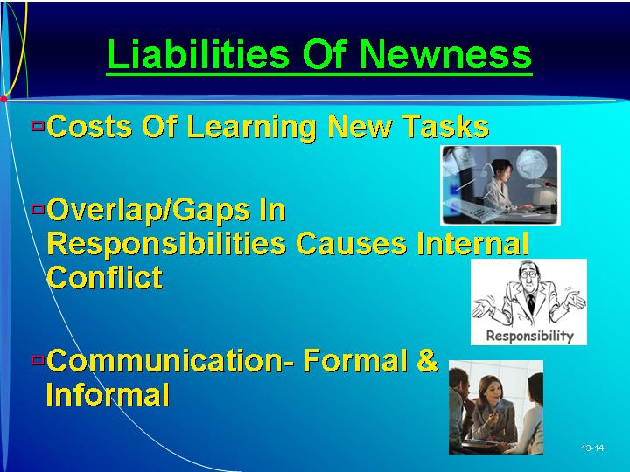  PowerPoint Slide 13-15 (Transparency Master 13-7)  “Assets of Newness” (See PowerPoint slide show beginning on page 327 of this manual. Also presented as a transparency master in Section 6 of this manual.)  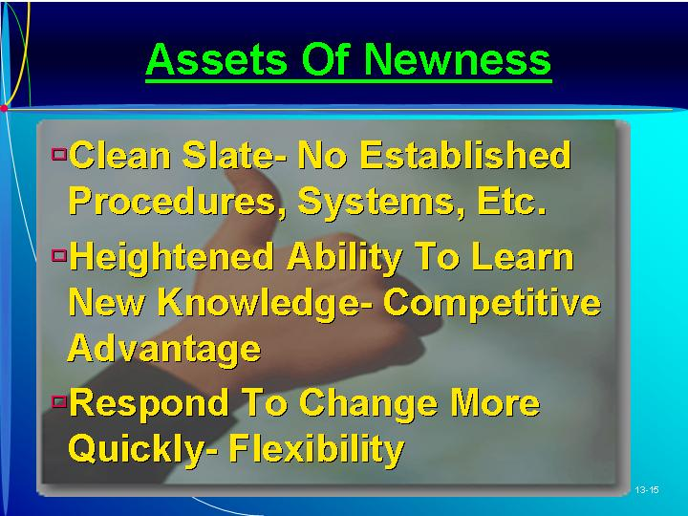
VI. IN REVIEW: SUMMARY.
See “Learning Objectives Revisited” below.

learning objectives revisited

Learning Objective 1. To understand that the essential act of entrepreneurship involves new entry.
  - Newness is both positive and negative.
  - Entrepreneurial strategy represents the set of decisions, actions, and reactions that first generate, and then exploit over time, a new entry in a way that maximizes the benefits of newness and minimizes its costs.
  - Long-run performance is dependent upon the ability to generate and exploit numerous new entries.

Learning Objective 2. To be able to think about how an entrepreneurial strategy can first generate, and then exploit over time, a new entry.
  - The elements of an entrepreneurial strategy are:
    - The generation of a new entry opportunity, the result of a combination of knowledge and other resources into a bundle that will be valuable, rare, and difficult for others to imitate.
    - The exploitation of a new entry opportunity.
    - A feedback loop.
  - If the entry warrants exploitation, then firm performance depends on
    - The entry strategy; the risk reduction strategy.
    - The way the firm is organized.
    - The competence of the entrepreneur and the management team.

Learning Objective 3. To understand how resources are involved in the generation of opportunities.
  - Resources are the basic building blocks to a firm’s performance.
  - In order for a bundle of resources to be the basis of a firm’s superior performance, the resources must be valuable, rare, and inimitable.
  - Key resources:
    - The ability to obtain, and then recombine, resources into a bundle that is valuable, rare, and inimitable represents an important entrepreneurial resource.
    - Market knowledge is the entrepreneur’s possession of information, technology, know-how, and skills that provide insight into a market and its customers.
    - Technological knowledge is the entrepreneur’s possession of information, technology, know-how, and skills that provide insight into ways to create new knowledge.

Learning Objective 4. To be able to assess the attractiveness of a new entry opportunity.
  - The entrepreneur needs to determine whether a new product is in fact valuable, rare, and inimitable.
  - Key information is needed to assess the attractiveness of an opportunity, including prior knowledge and window of opportunity.
  - The decision to exploit or not to exploit the new entry is based on whether the entrepreneur feels he or she has sufficient information and whether the window is still open.
Learning Objective 5. To acknowledge that entrepreneurship involves making decisions under conditions of uncertainty.
  - The performance of a firm depends on the fit between its bundle of resources and the external environment.
  - Entrepreneurs face considerable demand uncertainty and technological uncertainty.
  - Changes in market demand and technology mean the entrepreneur must adapt to new environmental conditions.
  - Introducing a new product or entering a new market both involve an element of newness.

Learning Objective 6. To be able to assess the extent of first-mover advantages and weigh them against first-mover disadvantages.
  - Being first can create advantages that can enhance performance through cost savings, less competition, securing important channels, selection of market segment, and opportunity to gain expertise.,
  - The performance of a firm depends on the fit between its bundle of resources and the external environment.
  - However first movers face demand uncertainty and technological uncertainty.
  - Introducing a new product or entering a new market both involve an element of newness.
  - The first mover gains lead time and the ability to erect barriers to entry.

Learning Objective 7. To understand that risk is associated with newness but there are strategies that the entrepreneur can use to reduce risk.
  - The new entry involves risk from uncertainty over market demand, technological development, and the actions of competitors.
  - A narrow scope strategy can reduce the risk that the firm will face competition from large firms, but increases the demand risk.
  - A broad-scope strategy reduces risks from market uncertainties, but increases exposure to competition.
  - Imitation strategies can reduce risks:
    - Franchising can reduce the risk of downside loss for the franchisee.
    - The “me-too” strategy involves copying products that already exist and attempting to build an advantage through minor variations.
  - The creation of a new organization offers both liabilities of newness and assets of newness.

key terms

Assessment of a new entry’s attractiveness. Determining whether the entrepreneur believes she or he can make the proposed new entry work.
Customers’ switching costs. The costs that must be borne by customers if they are to stop purchasing from the current supplier and begin purchasing from another.
Demand uncertainty. Considerable difficulty in accurately estimating the potential size of the market, how fast it will grow, and the key dimensions along which it will grow.
Emerging industries. Industries that have been newly formed and are growing.
Entrepreneurial resource. An important entrepreneurial resource is the ability to obtain, and then recombine, resources into a bundle that is valuable, rare, and inimitable.
Entrepreneurial strategy. The set of decisions, actions, and reactions that first generate, and then exploit over time, a new entry.
Error of commission. Negative outcome from acting.
Error of omission. Negative outcome from not acting.
Imitation strategies. Copying the practices of other firms.
Key success factors. The requirements that any firm must meet in order to successfully compete in a particular industry.
Lead time. The grace period in which the first mover operates in the industry under conditions of limited competition.
Liabilities of newness. Negative implications arising from an organization’s newness.
Market knowledge. Possession of information, technology, know-how, and skills that provide insight into a market and its customers.
“Me-too” strategy. Copying products that already exist and attempting to build an advantage through minor variations.
New entry. Offering a new product to an established or new market, an established product to a new market, or creating a new organization.
Resources. The inputs into the production process.
Risk. The probability of, and magnitude of, downside loss.
Scope. A choice about which customer groups to serve and how to serve them.
Technological uncertainty. Considerable difficulty in accurately assessing whether the technology will perform and whether alternate technologies will emerge and leap-frog over current technologies.
Technological knowledge. Possession of information, technology, know-how, and skills that provide insight into ways to create new knowledge.
Uncertainty for customers. Customers may have considerable difficulty in accurately assessing whether the new product or service provides value for them.
Window of opportunity. The period of time when the environment is favorable for entrepreneurs to exploit a particular new entry.

research tasks and class discussions

The text includes several topics for student research and class discussions. These questions are open-ended, and the answers will be different for each student. There are no “correct” answers.

Research tasks:
- Choose three major inventions that have lead to successful products. Who were the inventors? How did they invent the technology? Why do you believe they were the first to invent this technology?
- Find three examples of firms that pioneered a new product in a new market and were able to achieve long-run success based on that entry. Find three examples of firms that were not the pioneers but entered later to eventually overtake the pioneer as market leader. In you opinion, why were the successful pioneers successful, and why were the unsuccessful ones unsuccessful?
- What is the failure rate of all entrepreneurs? What is the failure rate of entrepreneurs who choose to be franchisees? What inferences can you make from these numbers?

Class Discussions
- Come up with five examples of firms that have used imitation as a way of reducing the risk of entry. What aspects of risk was it meant to reduce? Was it successful? What aspects of the firm were not generated by imitation, made the firm unique, and were a potential source of advantage over competitors?
- Provide two examples of firms with a broad scope, two with a narrow scope, and two that started narrow and became broader over time.
- Is it a waste of time to detail the firm’s strategy in the business plan when the audience for that plan (e.g., venture capitalist) knows that things are not going to turn out as expected and, as a result, place considerable importance on the quality of the management team? Why not submit only the resumes of those in the management team? If you were a venture capitalist, would you want to see the business plan? How would you assess the quality of one management team relative to another?

Visual Resources

The PowerPoint presentation for this chapter, shown on the following pages, includes the following slides.
Slide 13-1 Entrepreneurship Title
Slide 13-2 Chapter Title
Slide 13-3 What Is a New Entry?
Slide 13-4 Resources as Competitive Advantage *
Slide 13-5 Creating Resource Bundle
Slide 13-6 Assessing New Entry Opportunity *
Slide 13-7 Strategy for New Entry—First Movers
Slide 13-8 First Mover Disadvantages
Slide 13-9 Overcoming Customer Uncertainty
Slide 13-10 Lead Time and First Mover *
Slide 13-11 Risk Reduction Strategies *
Slide 13-12 Market Scope Strategy *
Slide 13-13 Imitation Strategy
Slide 13-14 Liabilities of Newness *
Slide 13-15 Assets of Newness *
* Also included as a Transparency Master.

The following are included as transparency masters in Section 6 of this manual.
Transparency Master 13-1 Resources as Competitive Advantage
Transparency Master 13-2 Assessing New Entry Opportunity
Transparency Master 13-3 Lead Time and First Mover
Transparency Master 13-4 Risk Reduction Strategies
Transparency Master 13-5 Market Scope Strategy
Transparency Master 13-6 Liabilities of Newness
Transparency Master 13-7 Assets of Newness

powerpoint slide show

Slide 13-1  Entrepreneurship Title  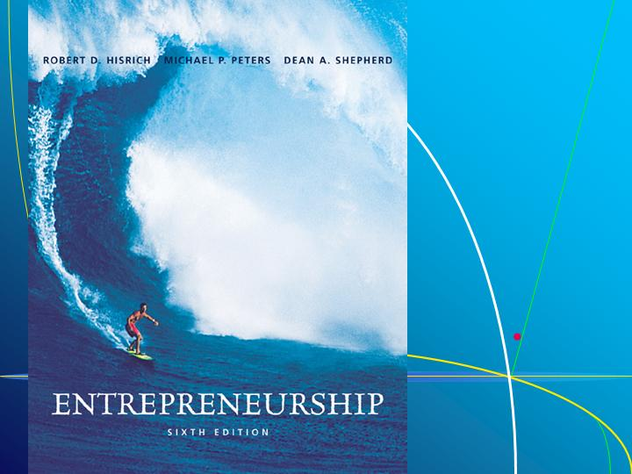 | Slide 13-2  Chapter Title
Slide 13-3  What Is a New Entry? | Slide 13-4  Resources as Competitive Advantage (Also presented as Transparency Master 13-1 in Section 6 of this manual.)

Slide 13-5  Creating Resource Bundle | Slide 13-6  Assessing New Entry Opportunity (Also presented as Transparency Master 13-2 in Section 6 of this manual.)
Slide 13-7  Strategy for New Entry—First Movers | Slide 13-8  First Mover Disadvantages
Slide 13-9  Overcoming Customer Uncertainty | Slide 13-10  Lead Time and First Mover (Also presented as Transparency Master 13-3 in Section 6 of this manual.)
Slide 13-11  Risk Reduction Strategies (Also presented as Transparency Master 13-4 in Section 6 of this manual.) | Slide 13-12  Market Scope Strategy (Also presented as Transparency Master 13-5 in Section 6 of this manual.)
Slide 13-13  Imitation Strategy | Slide 13-14  Liabilities of Newness (Also presented as Transparency Master 13-6 in Section 6 of this manual.)
Slide 13-15
Assets of Newness (Also presented as Transparency Master 13-7 in Section 6 of this manual.)

