15

accessing resources for growth from external sources

Learning Objectives

1
To understand franchising from the perspective of both the entrepreneur looking
to reduce the risk of new entry and from the entrepreneur looking
for a way to grow his or her business.

2
To understand how joint ventures can help an entrepreneur grow his or her business and acknowledge the challenges of finding, and maintaining,
an effective joint venture relationship.

3
To be aware of the pros and cons of using acquisitions to grow a business
and to know what to look for in an acquisition candidate.

4
To understand the possibilities of achieving growth through mergers
and leveraged buyouts and the challenges associated with each.

5
To understand the tasks of negotiation and develop the skills
to more effectively conduct these tasks.

CHAPTER OUTlINE AND TEACHING NOTES
OPENING PROFILE—Bill Gross  I. Using External Parties to Help Grow of Business  A. Franchising is an alternative way an entrepreneur may expand his or her business by having others pay for the use of the name, process, product, service, and so on.  B. Other external options include joint ventures, acquisitions, and mergers. | PowerPoint Slide 15-1  “Entrepreneurship Title” (See PowerPoint slide show beginning on page 378 of this manual.)    PowerPoint Slide 15-2  Chapter Title (See PowerPoint slide show beginning on page 378 of this manual.)    PowerPoint Slide 15-1 (Transparency Master 15-1)  “External Parties for Business Growth” (See PowerPoint slide show beginning on page 378 of this manual. Also presented as a transparency master in Section 6 of this manual.)  
II. FRANCHISING  A. Definition of Franchising.  1. Franchising is “an arrangement whereby the manufacturer of a trademarked product or service gives exclusive rights of local distribution to independent retailers in return for payment of royalties and conformance to standardized operating procedures.”  2. The person offering the franchise is the franchisor.  3. The franchisee is the person who purchases the franchise.  B. Advantages of Franchising—to the Franchisee.  1. The entrepreneur does not have to incur all the risks associated with staring a business from scratch.  2. Product acceptance.  a. The franchisee usually enters into a business that has an accepted name, product, or service.  b. The franchisee does not have to spend resources establishing the credibility of the business.  c. That credibility already exists based on the years of existence of the franchise.  3. Management expertise.  a. Another advantage is the managerial assistance provided by the franchisor.  b. New franchisees are required to enter a training program to educate them in all aspects of operating the franchise.  c. Some franchisors require their new franchisees to actually work with an existing franchise owner to get on-the-job training.  d. Most franchisors offer managerial assistance to owners on a need basis.  e. The training and education is an important criteria in evaluating any franchise opportunity.  4. Capital requirements.  a. The franchise offers an opportunity to start a new venture with up-front support that can save the entrepreneur time and capital.  b. Some franchisors will conduct location analysis and market research of the area.  c. The franchisor may also finance the initial investment, including a fee for the franchise, construction costs, and purchase of equipment.  d. The layout of the facility, control of stock and inventory, and potential buying power of the franchise operation can save the entrepreneur significant funds.  e. Purchasing health care and business insurance may be easier, since the entrepreneur would be considered a participant of the entire franchise organization.  f. Monies are pooled by individual franchisees for advertising and sales promotion allowing advertising on both a local and national scale.  5. Knowledge of the market.  a. A franchise business offers years of experience and knowledge of the market.  b. This is reflected in a plan that details the profile of the target customer and the strategies that should be implemented.  c. Franchisors can provide advice and assistance to accommodate differences in competition and tastes.  d. Most franchisors will constantly evaluate market conditions and determine effective strategies.  6. Operating and structural controls.  a. Two problems in starting a new venture are maintaining quality control and establishing effective managerial controls.  b. The franchisor will identify suppliers who meet the quality standards.  c. Standardization in supplies and services provided help the entrepreneur maintain quality standards.  d. Administrative controls, usually involving financial decisions and personnel issues, are outlined in a manual.  7. An entrepreneur who is considering selling franchises will need to offer all the above services in order to succeed.  C. Advantages of Franchising—to the Franchisor.  1. Expansion risk.  a. The most obvious advantage is that you can expand a venture quickly, with little capital.  b. The capital needed to expand nationally is much less than it would be without franchising.  c. The value of the franchise depends on the to-date track record of the franchisor and on the services offered.  d. Operating a franchised business requires fewer employees than if the business were not franchised.  2. Cost advantages.  a. The size of a franchised company means that the franchisor can purchase supplies in large quantities, achieving economies of scale.  b. Some franchises produce parts and raw materials in large quantities and sell these to the franchisees at lower prices.  c. A big cost advantage is the ability to commit larger sums of money to advertising through an advertising pool.  D. Disadvantages of Franchising.  1. Problems between franchisor and franchisee are common and have received attention from the government and trade associations.  2. The disadvantages to the franchisee center on the inability of the franchisor to provide services, advertising, and location.  a. When promises made in the franchise agreement are not kept, the franchisee may be left without support.  b. The franchise may face the risk of a franchisor that fails or is bought out by another company.  3. The franchisor also incurs risks.  a. The franchisor may find it difficult to find qualified franchisees.  b. Poor management can lead to individual franchise failures, which reflect negatively on the entire system.  E. Types of Franchises.  1. There are three types of franchises available, but variations exist.  a. Dealerships.  (i) Manufacturers use franchises to distribute their product lines.  (ii) The dealers are required to meet quotas set by the manufacturers, but they benefit from the support provided by the franchisor, such as McDonalds or Holiday Inn.  b. The most common type of franchise is the type that offers a name, image, or method of doing business.  c. A third type offers services, such as tax preparation companies.  2. Recent franchising opportunities have evolved because of changes in the environment such as:  a. Good health and emphasis on keeping fit.  b. Time savings or convenience.  c. Environmental consciousness.  d. The second baby boom. | Learning Objective 1.  To understand franchising from the perspective of both the entrepreneur looking to reduce the risk of new entry and from the entrepreneur looking for a way to grow his or her business.  PowerPoint Slide 15-4 “Fastest Growing Franchises” (See PowerPoint slide show beginning on page 378 of this manual.)  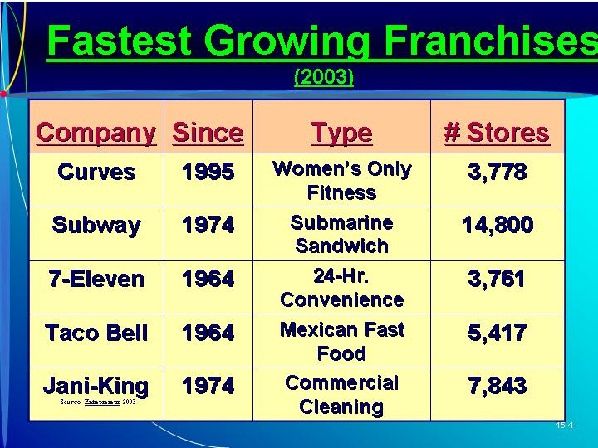  PowerPoint Slide 15-5 “Franchise System” (See PowerPoint slide show beginning on page 378 of this manual.)  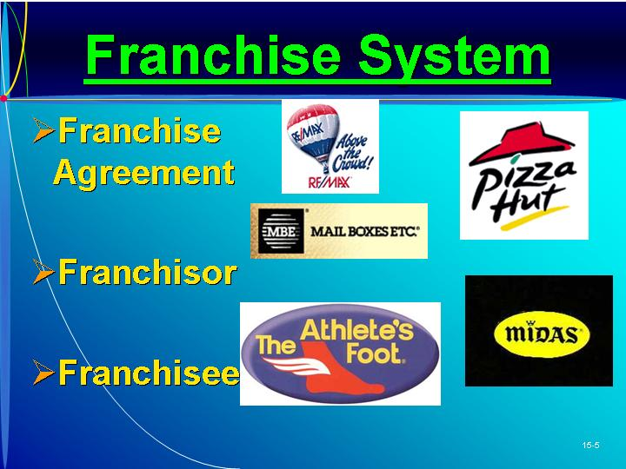  Text Table 15.1  “What You May Buy in a Franchise” (Text Table on page 485)  PowerPoint Slide 15-6 (Transparency Master 15-2)  “Franchising and Franchisee” (See PowerPoint slide show beginning on page 378 of this manual. Also presented as a transparency master in Section 6 of this manual.)  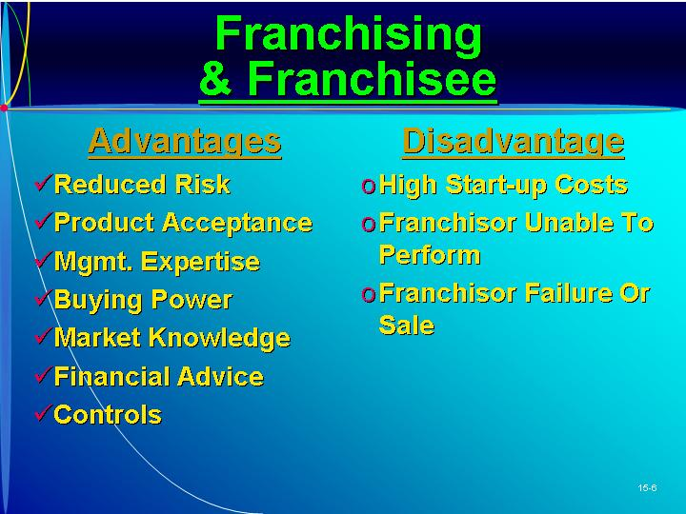  PowerPoint Slide 15-7 (Transparency Master 15-3)  “Franchising and Franchisor” (See PowerPoint slide show beginning on page 378 of this manual. Also presented as a transparency master in Section 6 of this manual.)  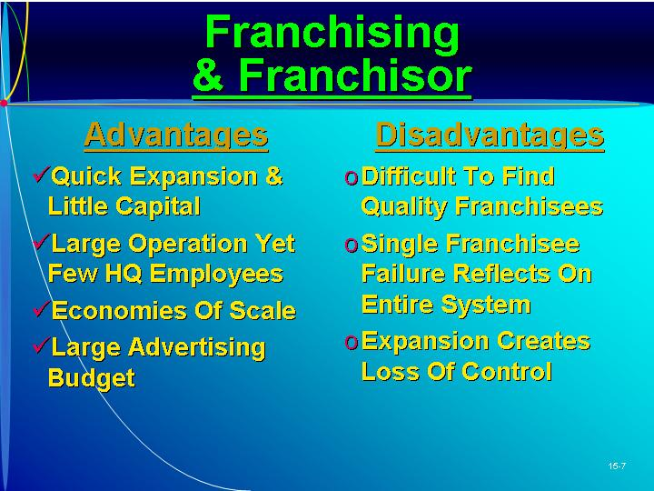  PowerPoint Slide 15-8 (  “Franchise Capital Requirements” (See PowerPoint slide show beginning on page 378 of this manual.)  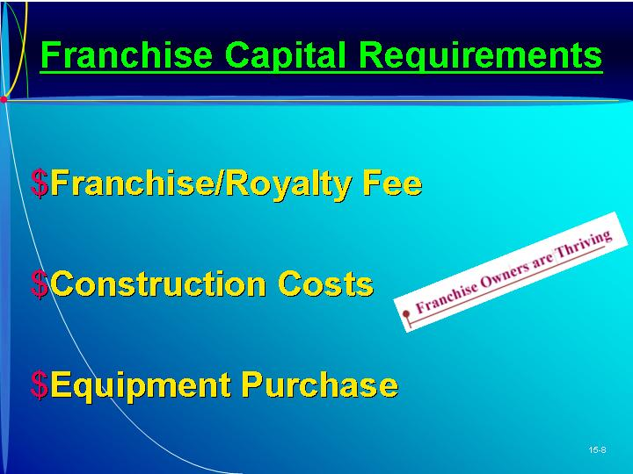  PowerPoint Slide 15-9  “Franchisor Provides” (See PowerPoint slide show beginning on page 378 of this manual.)  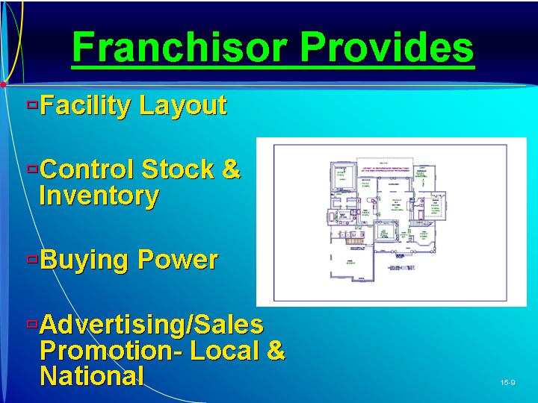  PowerPoint Slide 15-10 “Franchise Types” (See PowerPoint slide show beginning on page 378 of this manual.)  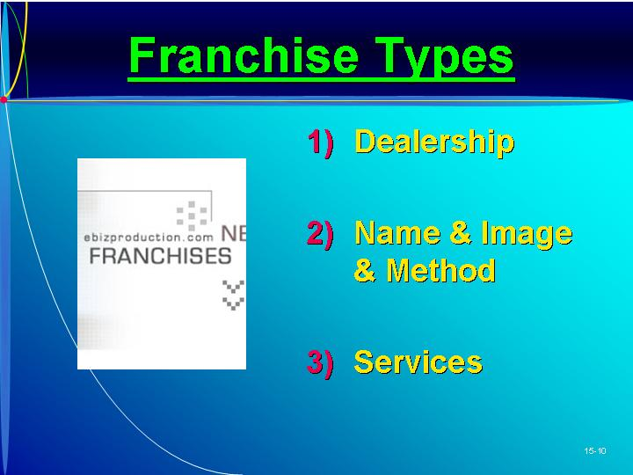  PowerPoint Slide 15-11 “Franchising Opportunities” (See PowerPoint slide show beginning on page 378 of this manual.)  
III. INVESTING IN A FRANCHISE  A. Franchising involves many potential risks to an entrepreneur.  B. Investigate the Franchise.  1. Several factors should be assessed before making the final decision:  a. Unproven versus proven franchise.  (i) An unproven franchise will be less expensive, but the lower investment is offset by substantial risk.  (ii) The unproven franchisor is likely to make mistakes as the business grows.  (iii) However, a new franchise can offer more excitement and can lead to opportunities for large profits.  (iv) A proven franchise offers lower risk of failure but requires a substantial financial investment.  b. Financial stability of franchise.  (i) Some information can be obtained from profit-and-loss statements.  (ii) It may be worthwhile to contact some of the franchisees directly.  (iii) If financial information of the franchisor is unavailable, the entrepreneur may purchase a financial rating from a source such as Dun & Bradstreet.  (iv) Other sources of information are franchise association, government, accountants and lawyers, franchise directories and journals, and business exhibitions.  c. Potential market for the new franchise.  (i) A simple starting point is to take a map of the community and try to evaluate the traffic flow and demographics of the area.  (ii) Direction of traffic flow, ease of entry, and amount of business may be estimated from observation.  (iii) Market research in the market area is helpful.  (iv) The franchisor may conduct a market study as a selling point.  d. Profit potential for new franchise.  (i) It is important to develop pro forma income and cash flow statements.  (ii) The franchisor should provide projections in order to calculate the needed information.  2. Most information is provided in the disclosure statement or prospectus.  a. The Federal Trade Commission’s Franchise Rule requires franchisors to make full presale disclosure in a document providing information in 20 aspects of a franchise offering.  b. Some of the information in the prospectus will be poorly written and sketchy.  c. There are always weaknesses that must be evaluated prior to making a commitment.  3. Front-end procedure fees, royalty payments, and expenses should be compared.  4. The entrepreneur may request a franchise package from the franchisor for a deposit for $300 to $500.  C. The contract or franchise agreement is the final step in establishing a franchise agreement.  1. This contains all the specific requirements and obligations of the franchisee.  2. Renewal terms, financial requirements, and termination requirements are stipulated. | PowerPoint Slide 15-12 (Transparency Master 15-4)  “Franchising Risks” (See PowerPoint slide show beginning on page 378 of this manual. Also presented as a transparency master in Section 6 of this manual.)  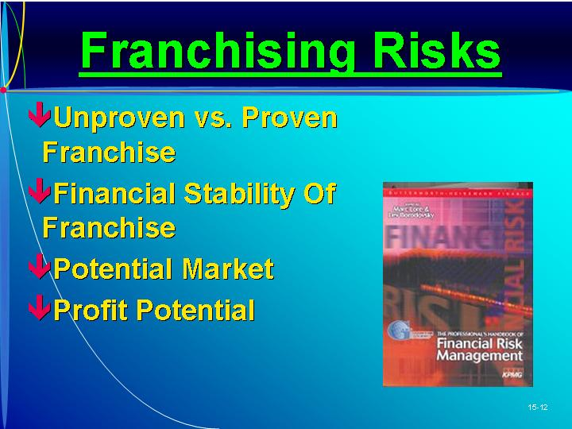  PowerPoint Slide 15-13 “Franchise Contract” (See PowerPoint slide show beginning on page 378 of this manual.)  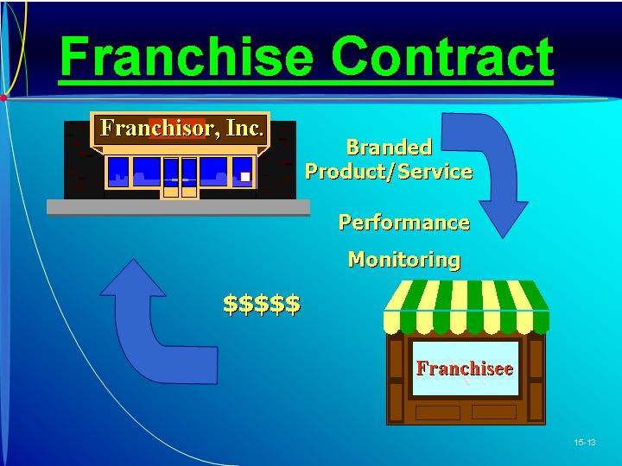  PowerPoint Slide 15-14 “Franchisor” (See PowerPoint slide show beginning on page 378 of this manual.)  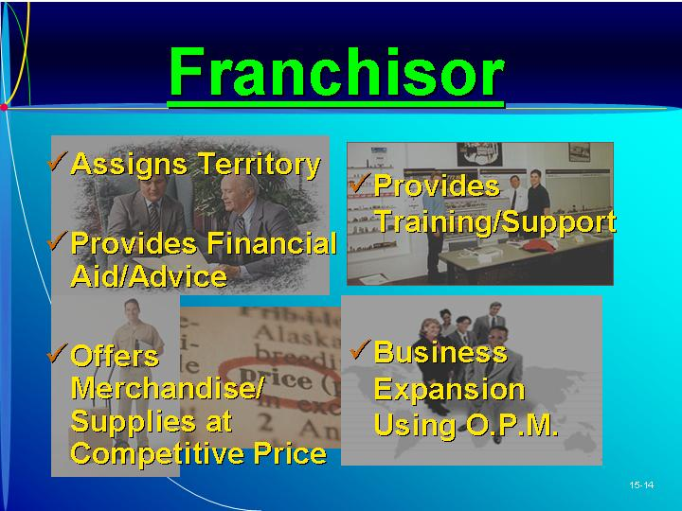  PowerPoint Slide 15-15 “Franchisee” (See PowerPoint slide show beginning on page 378 of this manual.)  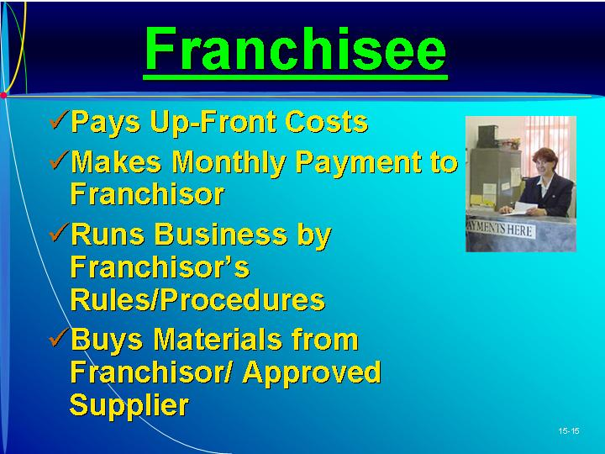  Text Table 15.2  “Information Required in Disclosure Statement” (Text figure on page 491)  As Seen in Entrepreneurship Magazine: Provide Advice To An Entrepreneur About Franchising.  Curves for Women is the fastest growing franchise for 2003. Total investment required is $25,000 to $31,100. (Box in text on page 492)
IV. JOINT VENTURES  A. With the increase in business risks, hyper-competition, and failures, the use of joint ventures has increased.  1. A joint venture is a separate entity involving two or more participants as partners.  2. They involve a wide range of partners, including universities, businesses, and the public sector.  B. Types of Joint Ventures.  1. The most common type is that between two or more private-sector companies.  2. Some joint ventures are formed to do cooperative research.  3. Industry-university agreements for the purpose of doing research are also increasing.  a. Two problems have kept this type venture from increasing even faster.  b. A profit corporation wants to obtain tangible results—such as a patent—from its research investment, and universities want to share in the returns.  c. The corporation usually wants to retain all proprietary data while university researchers want to make the knowledge available.  d. Joint ventures between universities and corporations take many forms, depending on the parties involved and the subject of the research.  4. International joint ventures are increasing rapidly due to their relative advantages.  a. Both companies can share in the earnings and growth.  b. The joint venture can have a low cash requirement.  c. Also, the joint venture provides ready access to new international markets.  d. Such a venture causes less drain on a company’s managerial and financial resources than a wholly owned subsidiary.  5. There are drawbacks in establishing international joint ventures.  a. The business objectives of the partners can be quite different.  b. Cultural differences can create managerial difficulties.  c. Government policies sometimes can have a negative impact on the venture.  6. The benefits usually outweigh the drawbacks.  C. Factors in Joint Venture Success.  1. The critical factors for success are the accurate assessment of the parties involved and how best to manage the new entity.  2. A second factor involves the symmetry between the partners.  3. The expectations about the results of the joint venture must be reasonable.  4. The timing must be right.  D. A joint venture should be considered as one of many options for supplementing the resources of the firm. | Learning Objective 2.  To understand how joint ventures can help an entrepreneur grow his or her business and acknowledge the challenges of finding, and maintaining, an effective joint venture relationship.    Joint venture.  Two or more companies forming a new company.  PowerPoint Slide 15-16 (Transparency Master 15-5)  “Joint Ventures” (See PowerPoint slide show beginning on page 378 of this manual. Also presented as a transparency master in Section 6 of this manual.)  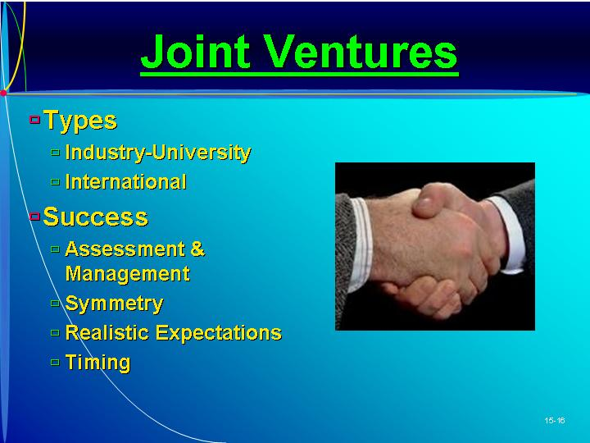
V. ACQUISITIONS  A. An acquisition is the purchase of a company or a part of it in such a way that the acquired company is completely absorbed and no longer exists.  1. Acquisitions can provide an excellent way to grow a business and enter new markets.  2. A key issue is agreeing on a price.  3. Often the structure of the deal can be more important to the parties than the actual price.  4. A prime concern is to ensure that the acquisition fits into the overall direction of the strategic plan of the present venture.  B. Advantages of an Acquisition.  1. Established business.  a. The acquired firm has an established image and track record.  b. The entrepreneur would only need to continue the existing strategy to be successful.  2. Location is already established.  3. Established marketing structure.  a. The acquired firm has its existing marketing channel and sales structure.  b. With this structure already in place, the entrepreneur can concentrate on expanding to new target markets.  4. The total cost of acquiring a business could be lower than trying to buy a franchise.  5. Existing employees.  a. The employees of an existing business can be an important asset.  b. They know the business and can help the business continue.  c. Employees already have established relationships with customers, suppliers, and channel members.  6. More opportunity to be creative: More time can be spent assessing opportunities to expand or strengthen the business.  C. Disadvantages of an Acquisition.  1. Marginal success record.  a. Most ventures for sale have an erratic, or even unprofitable, record.  b. It is important to review the records and meet important constituents to assess the future potential.  2. Overconfidence in ability.  a. Even though the entrepreneur brings new ideas, the venture may never be successful for reasons not possible to resolve.  b. Managers are often overconfident about their ability to overcome cultural differences between the current business and the one being acquired.  3. Key employee loss.  a. Often when a business changes hands key employees also leave.  b. In a service business, it is difficult to separate the actual service from the person who performs it.  c. Incentives can sometimes be used to assure that key employees will remain with the business.  4. Overvalued.  a. If the entrepreneur has to pay too much for a business, the return on investment will not be acceptable.  b. The entrepreneur will need to establish a reasonable payback to justify the investment.  D. Synergy is “the whole is greater than the sum of the parts.”  1. An acquisition should positively impact the bottom line.  2. Lack of synergy is a frequent cause of the acquisition failing to meet goals.  E. Structuring the Deal.  1. There are many techniques for structuring an acquisition, each having advantages to both the buyer and seller.  2. The deal structure involves the parties, the assets, the payment form, and the timing of the payment.  3. One common means of acquisition is the entrepreneur’s direct purchase of the firm’s entire stock or assets or the bootstrap purchase of these assets.  a. The entrepreneur often obtains funds from an outside lender or the seller of the company.  b. The money is repaid over time from the operation’s cash flow.  4. The entrepreneur can make a bootstrap purchase, acquiring a small amount of the firm for cash.  a. He or she then purchases the remainder of the company with a long-term note that is paid off over time out of the acquired company’s earnings.  b. This type of deal often has tax advantages to both the buyer and the seller.  F. Locating Acquisition Candidates.  1. There are professional business brokers, operating similarly to real estate brokers, that represent the seller.  2. Accountants, attorneys, bankers, business associates, and consultants may be aware of good candidates.  3. It is also possible to find opportunities in the classified sections of the newspaper or trade magazine. | Acquisitions.  Purchasing all or part of a company.  Learning Objective 3.  To be aware of the pros and cons of using acquisitions to grow a business and to know what to look for in an acquisition candidate.  PowerPoint Slide 15-17 (Transparency Master 15-6)  “Acquisitions” (See PowerPoint slide show beginning on page 378 of this manual. Also presented as a transparency master in Section 6 of this manual.)  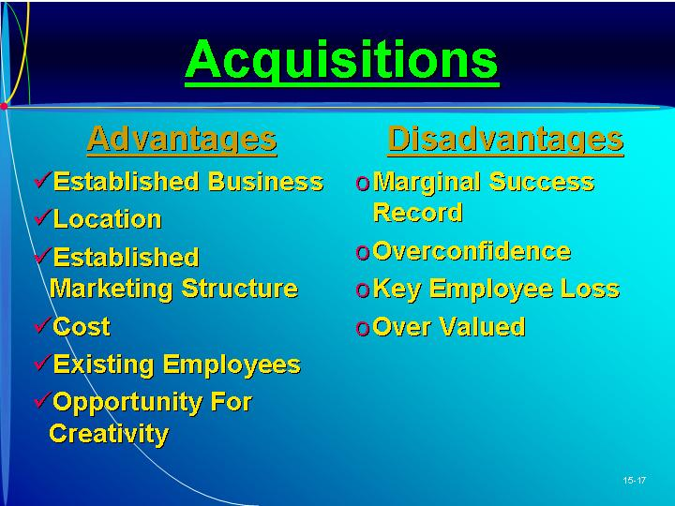  PowerPoint Slide 15-18 “Acquisition Process” (See PowerPoint slide show beginning on page 378 of this manual.)  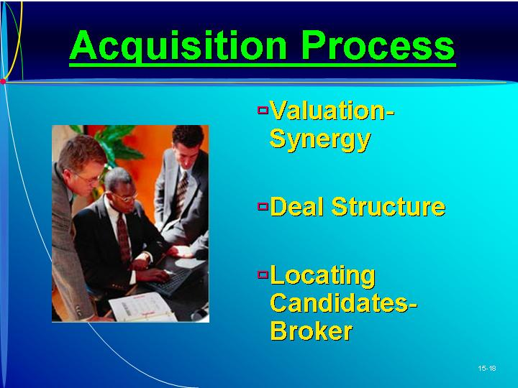  Brokers.  People who sell companies.
VI. MERGERS  A. A merger is a transaction involving two or more companies in which only one company survives.  1. Acquisitions are similar to mergers, and the terms are often used interchangeably.  2. A key concern in any merger or acquisition is the legality of the purchase.  3. The Department of Justice frequently issues guidelines for horizontal, vertical, and conglomerate mergers.  B. Merger motivations range from survival to protection to diversification to growth.  C. A merger requires sound planning by the entrepreneur.  1. Merger objectives must be spelled out with the resulting gains for the owners of both companies delineated.  2. The entrepreneur must evaluate the other company’s management and resources to ensure that the weaknesses of one do not compound those of the other.  3. The entrepreneur should establish a climate of mutual trust.  D. The same methods for valuing the entrepreneur’s company can be used to determine the value of a merger candidate.  1. The process involves looking at the synergistic product/market position, the new market position, and undervalued financial strength.  2. A common procedure is to estimate the present value of discounted cash flows and the expected after-tax earnings attributable to the merger. | Merger.  Joining two or more companies.  Learning Objective 4.  To understand the possibilities of achieving growth through mergers and leveraged buyouts and the challenges associated with each.  PowerPoint Slide 15-19 (Transparency Master 15-7)  “Merger” (See PowerPoint slide show beginning on page 378 of this manual. Also presented as a transparency master in Section 6 of this manual.)  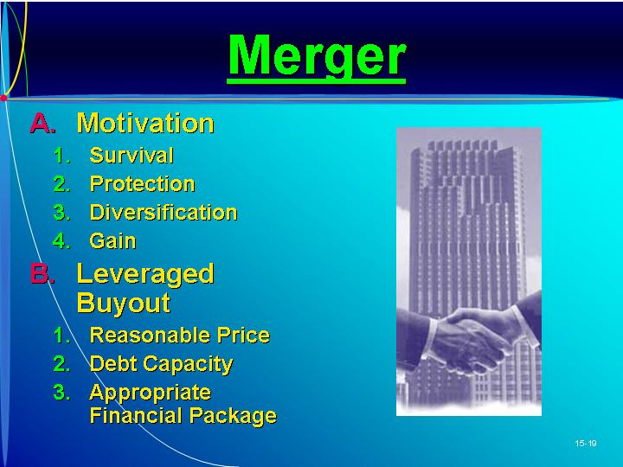  Text Figure 15.1  “Merger Motivations”  (Text figure on page 498)
VII. LEVERAGED BUYOUTS  A. A leveraged buyout occurs when an entrepreneur uses borrowed funds to purchase an existing venture for cash.  1. Most LBOs occur because the entrepreneur believes that he or she could run the company more efficiently than the owners.  2. The purchaser needs a large amount of external funding.  3. The capital needed is usually in the form of long-term debt financing with the assets of the firm being acquired used as collateral.  4. Banks, venture capitalists, and insurance companies provide long-term debt for LBOs.  5. The repayment plan must be in line with the expected cash flows.  6. In most LBOs the debt capital usually exceeds equity by 5:1, some as high at 10:1.  a. This is significantly more debt relative to equity than in a typical firm’s capital structure.  b. The key to a successful LBO is the ability of the entrepreneur to cover the principal and interest payments through increased profits.  B. How to determine whether a company is a good opportunity for an LBO?  1. The entrepreneur must determine whether the present owner’s asking price is reasonable.  a. Subjective evaluations should be made of the competitiveness of the industry.  b. The stage in the product life cycle and the abilities of management are considerations.  c. Quantitative techniques are also needed, such a price-earnings ratio and the present value of future earnings of the prospect.  2. The entrepreneur must assess the firm’s debt capacity, which depends on the business risk and the stability of future cash flows.  3. The entrepreneur must develop the appropriate financial package to meet the needs of fund providers as well as the entrepreneur. | .  Leveraged buyout (LBO).  Purchasing an existing venture by any employee group.
VIII. Overcoming constraints by negotiating for more resources  A. There are two primary tasks for an entrepreneur negotiating with another party for access to an external growth mechanism.  1. The distribution task is how the benefits of the relationship are distributed between the parties.  2. In the integration task, mutual benefits from the relationship are explored, increasing the “size of the pie.”  a. Making the pie bigger increases the likelihood of an agreement being reached.  b. Collaboration is more beneficial than a conflict resolution approach.  3. Negotiation requires the use of strategies to gain more information during the negotiation interactions.  4. Bazerman and Neale have identified a number of assessments that should be made when negotiating with a growth partner.  B. Assessments That Need to Be Made.  1. Assessment 1: What will you do if an agreement is not reached?  a. The answer represents the entrepreneur’s “best alternative to a negotiated agreement.”  b. The reservation price is the price (the bundle of resources from the agreement) at which the entrepreneur is indifferent about whether to accept the agreement or choose the alternative.  2. Assessment 2: What will the other party to the negotiation do if an agreement is not reached?  a. If the entrepreneur knows the negotiating partner’s reservation price, he or she has a good idea of the bargaining zone.  b. Knowing the partner’s bargaining zone lets the entrepreneur negotiate an outcome that is largely beneficial to the entrepreneur and only marginally beneficial to the other party.  3. Assessment 3: What are the underlying issues of this negotiation? How important is each issue to you?  a. This involves focusing on the most desirable aspects by trading off aspects of less importance.  4. Assessment 4: What are the underlying issues of this negotiation? How important is each issue to the other party?  a. By understanding more about the other party, the entrepreneur has a better opportunity to achieve integration.  b. If this information is known to both parties, then it is likely that the outcome will be mutually beneficial.  c. This awareness requires strategies to get information from the other party.  d. The following strategies are tools in this process.  e. The entrepreneur might experiment with different strategies to find which one works best for the current negotiation.  C. Strategies to Elicit Information.  1. Strategy 1: Build trust and share information.  a. Achieving the best negotiated outcome requires both parties to have information about each other’s underlying issues and their relative importance.  b. Releasing information requires trust—a belief that the other party will not act opportunistically to the detriment of the entrepreneur.  c. One way to start this process is to share information and see if it is reciprocated.  d. If possible, the entrepreneur should assess the other party’s trustworthiness.  2. Strategy 2: Ask lots of questions.  a. Asking questions provides an opportunity to learn more about the preferences of the other party.  b. Even a nonanswer might provide some information.  3. Strategy 3: Make multiple offers simultaneously.  a. There can be numerous possible offers based on combinations of different levels on different dimensions.  b. The entrepreneur can make multiple offers simultaneously.  c. This can help determine which issues are of greatest importance to the other party.  4. Strategy 4: Use differences to create trade-offs that are sources of mutually beneficial outcomes.  a. Differences between the parties in expectations, risk preferences, and time preferences all provide opportunities to reach an integrative agreement. | Learning Objective 5.  To understand the tasks of negotiation and develop the skills to more effectively conduct these tasks.  Distribution task.  Negotiating how the benefits of the relationship will be allocated between the parties.  Integration task.  Exploring possible mutual benefits from the relationship so that the “size of the pie” can be increased.  PowerPoint Slide 15-20 “Resource Negotiation” (See PowerPoint slide show beginning on page 378 of this manual.)  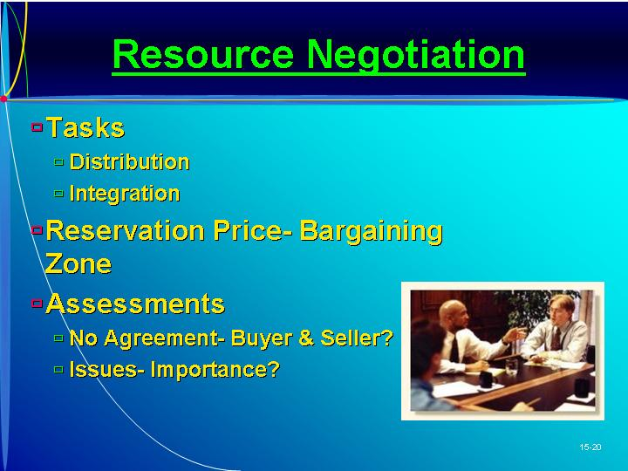  Reservation price.  The price (the bundle of resources from the agreement) at which the entrepreneur is indifferent about whether to accept the agreement or choose the alternative.  Bargaining zone.  The range of outcomes between the entrepreneur’s reservation price and the reservation price of the other party.    ETHICS:  Fair Enough  Negotiation is built on ethical quicksand. The savvy negotiator must learn what is acceptable and what is out of bounds. (Box in text on page 501)  As Seen in Entrepreneurship Magazine: Provide Advice To An Entrepreneur About Entering Into Agreements.  Two entrepreneurs, James Tiscione and Anthony Tiscione, developed a product idea and face the challenge of bringing a new product to market with a limited market budget. (Box in text on page 502)  PowerPoint Slide 15-21 (Transparency Master 15-8)  “Negotiation Strategies” (See PowerPoint slide show beginning on page 378 of this manual. Also presented as a transparency master in Section 6 of this manual.)  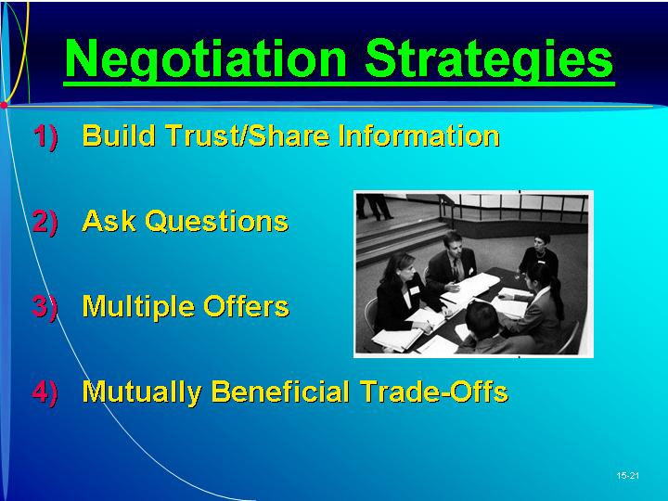
IX. IN REVIEW: SUMMARY.
See “Learning Objectives Revisited” below.

learning objectives revisited

Learning Objective 1. To understand franchising from the perspective of both the entrepreneur looking to reduce the risk of new entry and from the entrepreneur looking for a way to grow his or her business.
  - Franchising is an alternative way an entrepreneur may expand his or her business by having others pay for the use of the name, process, product, service, and so on.
  - The entrepreneur receives benefits from reduced risks, product acceptance, management expertise, reduced capital requirements, knowledge of the market, and operating and structural controls.
  - The franchisor is able to expand quickly, with little capital; reduce costs of supplies; and increase advertising.
  - The disadvantages to the franchisee center on the inability of the franchisor to provide services, advertising, and location.
  - The franchisor may find it difficult to find qualified franchisees.

Learning Objective 2. To understand how joint ventures can help an entrepreneur grows his or her business and acknowledge the challenges of finding, and maintaining, an effective joint venture relationship.
  - The most common type of joint venture is that between two or more private-sector companies.
  - Joint ventures are also formed to do cooperative research.
  - International joint ventures have advantages and disadvantages, but the benefits usually outweigh the drawbacks.
  - Factors in joint venture success include an accurate assessment of the parties involved, symmetry between the partners, reasonable expectations, and good timing.

Learning Objective 3. To be aware of the pros and cons of using acquisitions to grow a business and to know what to look for in an acquisition candidate.
  - Acquisitions can provide an excellent way to grow a business and enter new markets.
  - The advantages are obtaining an established business, established location, and established marketing structure; existing employees; and the opportunity to be more creative.
  - Disadvantages include the marginal success record, overconfidence in the entrepreneur’s ability, key employee loss, and overvalued investment.

Learning Objective 4. To understand the possibilities of achieving growth through mergers and leveraged buyouts and the challenges associated with each.
  - Merger motivations range from survival to protection to diversification to growth.
    - A successful merger requires careful planning and evaluation.
    - The process involves looking at the synergistic product/market position, the new market position, and undervalued financial strength.
  - Most leverages buyouts (LBOs) occur because the entrepreneur believes that he or she could run the company more efficiently than the owners.
    - In most LBOs the debt relative to equity is quite high.
    - The key to a successful LBO is the ability of the entrepreneur to cover the principal and interest payments through increased profits.

Learning Objective 5. To understand the tasks of negotiation and develop the skills to more effectively conduct these tasks.
  - Negotiation involves both the distribution task and the integration task.
  - Numerous assessments should be made when negotiating with a growth partner.
    - Assessment 1: What will you do if an agreement is not reached?
    - Assessment 2: What will the other party to the negotiation do if an agreement is not reached?
    - Assessment 3: What are the underlying issues of this negotiation? How important is each issue to you?
    - Assessment 4: What are the underlying issues of this negotiation? How important is each issue to the other party?
  - Negotiation requires the use of strategies to gain more information during the negotiation interactions.
    - Strategy 1: Build trust and share information.
    - Strategy 2: Ask lots of questions.
    - Strategy 3: Make multiple offers simultaneously.
    - Strategy 4: Use differences to create trade-offs that are sources of mutually beneficial outcomes.

key terms

Acquisitions. Purchasing all or part of a company.
Bargaining zone. The range of outcomes between the entrepreneur’s reservation price and the reservation price of the other party.
Brokers. People who sell companies.
Distribution task. Negotiating how the benefits of the relationship will be allocated between the parties.
Integration task. Exploring possible mutual benefits from the relationship so that the “size of the pie” can be increased.
Joint venture. Two or more companies forming a new company.
Leveraged buyout (LBO). Purchasing an existing venture by any employee group.
Merger. Joining two or more companies.
Reservation price. The price (the bundle of resources from the agreement) at which the entrepreneur is indifferent about whether to accept the agreement or choose the alternative.

research tasks and class discussions

The text includes several topics for student research and class discussions. These questions are open-ended, and the answers will be different for each student. There are no “correct” answers.

Research tasks:
- Find information about three joint ventures that were failures, and be prepared to discuss the underlying reasons for the failure in each case.
- Search on the Internet for franchises for sale. Choose three. What commonalities are there across the businesses and the information provided? What differences? For one of these businesses, obtain all franchise information. For this business, what are the benefits of being a franchisee rather than setting up an independent business? What are all the associated costs of being a franchisee for this business?
- Interview three franchises to better understand their relationship with the franchisor.
- Find three types of business license agreements (only one of these should be a software license agreement). In what ways are these license agreements the same and in what ways are they different? Why have these companies decided to license their product or technology rather than simply sell it?
- Find three reports and acquisitions that were unsuccessful. Why were these acquisitions deemed to be unsuccessful?

Class Discussions
- Being a franchisor seems to be a mechanism for growth, but what are the growth prospects for entrepreneurs that are franchisees? Isn’t the entrepreneur limited in his or her ability to pursue all the different types of growth strategies? Is being a franchisee simply substituting one type of employment for another type of employment? How can a franchisee grow his or her business(es)?
- Recently the Chinese government has been encouraging foreign firms to enter into joint venture relationships with local (Chinese) firms. What are the benefits to the Chinese economy from these joint venture relationships? What are the benefits to the local Chinese firm? What are the benefits to the foreign firm? What is the impact of the joint venture on the foreign firm’s domestic economy?
- Identify a local franchise in your area, and determine where the competitors are located and where other franchises from the same organization are located. Evaluate the existing potential for the franchise.
- Why are there so many different techniques for determining the worth of a firm? In any given situation, is there one “right answer” for a company’s value? What effects do your answers to these questions have on the entrepreneur making an acquisition?

Visual Resources

The PowerPoint presentation for this chapter, shown on the following pages, includes the following slides.
Slide 15-1 Entrepreneurship Title
Slide 15-2 Chapter Title
Slide 15-3 External Parties for Business Growth *
Slide 15-4 Fastest Growing Franchises
Slide 15-5 Franchise System
Slide 15-6 Franchising and Franchisee *
Slide 15-7 Franchising and Franchisor *
Slide 15-8 Franchise Capital Requirements
Slide 15-9 Franchisor Provides
Slide 15-10 Franchise Types
Slide 15-11 Franchising Opportunities
Slide 15-12 Franchising Risks *
Slide 15-13 Franchise Contract
Slide 15-14 Franchisor
Slide 15-15 Franchisee
Slide 15-16 Joint Ventures *
Slide 15-17 Acquisitions *
Slide 15-18 Acquisition Process
Slide 15-19 Merger *
Slide 15-20 Resource Negotiation
Slide 15-21 Negotiation Strategies *
* Also included as a Transparency Master.

The following are included as transparency masters in Section 6 of this manual.
Transparency Master 15-1 External Parties for Business Growth
Transparency Master 15-2 Franchising and Franchisee
Transparency Master 15-3 Franchising and Franchisor
Transparency Master 15-4 Franchising Risks
Transparency Master 15-5 Joint Ventures
Transparency Master 15-6 Acquisitions
Transparency Master 15-7 Merger
Transparency Master 15-8 Negotiation Strategies

powerpoint slide show

Slide 15-1  Entrepreneurship Title   | Slide 15-2  Chapter Title
Slide 15-3  External Parties for Business Growth (Also presented as Transparency Master 15-1 in Section 6 of this manual.) | Slide 15-4  Fastest Growing Franchises
Slide 15-5  Franchise System | Slide 15-6  Franchising and Franchisee (Also presented as Transparency Master 15-2 in Section 6 of this manual.)
Slide 15-7  Franchising and Franchisor (Also presented as Transparency Master 15-3 in Section 6 of this manual.) | Slide 15-8  Franchise Capital Requirements
Slide 15-9  Franchisor Provides | Slide 15-10  Franchise Types
Slide 15-11  Franchising Opportunities | Slide 15-12  Franchising Risks (Also presented as Transparency Master 15-4 in Section 6 of this manual.)
Slide 15-13  Franchise Contract | Slide 15-14  Franchisor
Slide 15-15  Franchisee | Slide 15-16  Joint Ventures (Also presented as Transparency Master 15-5 in Section 6 of this manual.)
Slide 15-17  Acquisitions (Also presented as Transparency Master 15-6 in Section 6 of this manual.) | Slide 15-18  Acquisition Process
Slide 15-19  Merger (Also presented as Transparency Master 15-7 in Section 6 of this manual.) | Slide 15-20  Resource Negotiation
Slide 15-21
Negotiation Strategies (Also presented as Transparency Master 15-8 in Section 6 of this manual.)

