Page # | Problem: | Correction:
EX1.37 | The second to last step says: Click OK on the Task Pane to close it. | It should read Click ok on the Insert Paste dialog box.
EX1.34 | Concept 6, nonadjacent range should use commas. | A10:B12:C14 should read A10,B12,C14
EX1.46 | Instruction is, “Select B12 through D17.” | It should read, “Select B12 through E17.”
EX1.86 | Percent Change numbers are incorrect. | B16 should be 12.36%.
EX2.? | In the lab exercise 3, e. The formula given is =(b14-b15)/b15. | The formula should be =(b14-b5)/b5.
EX2. | Step by Step #2 the book shows the maximum tigers as 3,075. | The file provided as a data file is 3,705.
EX3.31 | Missing a step. | ‘Press Enter’
EX3.63-6.64 | The illustration on page 3.63 show cumulative total points as 177 and a cumulative total GPA as 2.95. If you use the figures from the data file on the text's web site the cumulative points should be 189 and the GPA 3.15.  Instruction h on page 3.64 also tells the students that the GPA at the end of  Spring 2002 is 2.95. The correct answer is 3.15. | New figure Ex03pe4.bmp  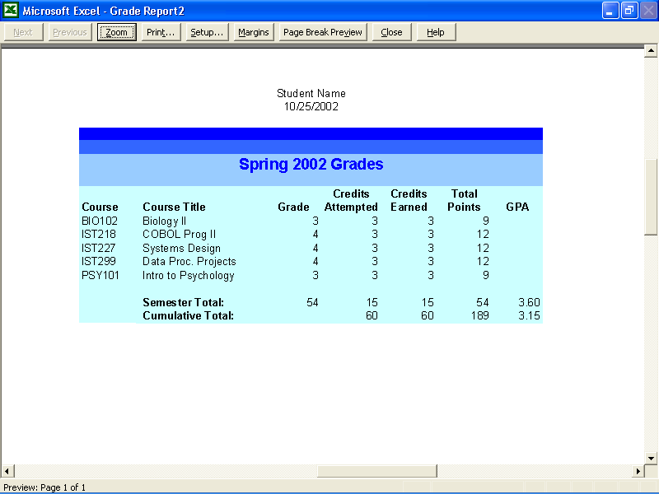
EX3. | Lab Exercises 3. Tracking Hours Worked. The values shown do not represent the values the students should get. | A. Regular Pay to-date should be the regular pay for week 1 at the week 1 rate with the week 2 total added at the new week 2 rate.  B. Overtime to-date should be the regular pay for week 2 at the week 2 rate added to the overtime pay for week 2 calculated using the new week 2 rate
EX4.17 | Incorrect graphic inserted (WORD General Templates…) | Change from WORD general templates icon to one for EXCEL
EX5.58 | e. Total cost formula can’t be  =b14-b14 | Formula should be =(-b18+b14)
EX6.7 | The even numbered pages are correctly identified as 6.6 etc. but the odd numbered pages have 1.7 etc | Page number should be 6.7
EX6.8 | Step 2, Box. Lines of information are missing for City, Zip, Jan | Add City Red Bank; Zip 07730; Jan 120
EX6.9 | Last instruction says Move to G. | Change to Move to G6.
EX6.11 | Having Trouble? Box  ….different than shown… | ….different than from that shown…
EX6.17 | Instructions: Copy G12:G15. Paste cells into K7:K10. Students will have pasted the cells before they read the next instruction to use the Paste Options. | Change the Paste instruction to  Click on cell K7. Right click and choose Paste Special, Values, OK.
EX6.52 | Residential is misspelled on all entries | Residential to replace Residental
Excel Folder misspelled | Folder for extended set two misspelled as Excell | Excel_WT02sdf
Exwt2.11 | Spelling | Poughkipisie should be spelled Poughkeepsie

