E1. The use of colchicine would make a one-step process more feasible. Müntzing could have crossed G. pubescens and G. speciosa to produce an alloploid. At high doses, colchicine can cause complete nondisjunction. To produce an allotetraploid, Müntzing could have treated the alloploid with colchicine to obtain a segment of the plant that would be allotetraploid. This allotetraploid segment could be removed to regenerate an entire plant that is an allotetraploid.
E2. Since the artificial and natural G. tetrahit strains can produce fertile offspring, it means that the chromosomes in these strains form homologous sets. When the offspring make gametes, each chromosome has a homologous partner to pair with. Therefore, the offspring are able to make gametes that have a complete set of chromosomes rather than making highly aneuploid gametes that would be inviable. If the two strains had not produced fertile offspring, it would mean that reproductive isolating mechanisms exist between them. Such mechanisms could have been due to mutations that occurred after the formation of the natural species. Alternatively, it could suggest that the natural species was not really an allotetraploid of G. speciosa and G. pubescens.
E3. Not necessarily. The G. tetrahit species may have been created a very long time ago. If this were the case, the G. tetrahit species and the G. pubescens and G. speciosa species would have had lots of time to accumulate different mutations. Therefore, using modern-day G. pubescens and G. speciosa species to create a G. tetrahit species may not have yielded the same results. This is because the modern-day G. pubescens and G. speciosa species could have accumulated mutations that would not be found in the naturally made G. tetrahit species, and/or the natural G. tetrahit species may have accumulated mutations that would not be found in the modern-day G. pubescens and G. speciosa species. These mutations could have affected the phenotype so that the natural and artificial G. tetrahit may not be entirely similar. Actually, this did not happen, so it appears that the three species have not accumulated mutations that dramatically affect the phenotype of the artificial G. tetrahit species. Perhaps the natural G. tetrahit arose fairly recently on an evolutionary timescale.
E4. Some possible experimental approaches are listed here.
1. You could karyotype some members of each population. Different species can often be distinguished by changes in chromosome structure and number.
2. You could see if eastern and western snakes could mate with each other in captivity. If they cannot, this would suggest reproductive isolation. If they can, they still might be different species, if mating never occurs in nature.
3. You could sit in a blind (a box where someone cannot be seen by animals) and watch both populations to see if eastern and western snakes ever mate with each other in nature.
E5. Perhaps the easiest way to determine allotetraploidy is by the chromosomal examination of closely related species. A researcher could karyotype the chromosomes from many different species and look for homeologous chromosomes that have similar banding patterns. This may enable them to identify allotetraploids that contain a diploid set of chromosomes from two different species.
E6. If we compare the percentages of sequence identity among the five genes, we see that A1 is very similar to B2, and A2 is very similar to B1 and B3. This suggests that the most recent ancestor had two copies of the gene prior to the formation of these two species. After the formation of species A and B, one of the B genes must have duplicated again in species B to form B1 and B3.
E7. We begin by identifying the pair that is the most closely related. In this case, it is species B and D, because they have the fewest nucleotide differences. We divide 423 by 2 to yield the average number of substitutions, which equals 211.5. The percentage of nucleotide differences between species B and D is
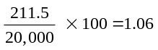
Species A is the next most closely related species to B and D. The percentage of nucleotide difference between species A compared to B and D is computed as follows:
There are 465 differences between A and D, and 443 differences between A and B. So the average number of differences is:
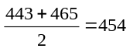
We divide 454 by 2, which equals 227 to yield the number of nucleotide differences that occur in species A and B or D. The average percentage of nucleotide differences between species A compared to B and D is
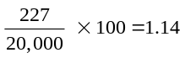
Finally, we consider species C. The percentage of nucleotide difference between species C compared to A, B, and D is computed as follows. There are 719 differences between C and A, 744 differences between C and B, and 723 differences between C and D. So the average number of differences is
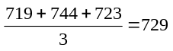

We divide 729 by 2, which equals 364.5, to yield the number of nucleotide differences that occurred in C or A, B, or D. The average percentage of nucleotide differences between species C compared to A, B, and D is
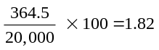
With these data, we can construct the phylogenetic tree shown here.
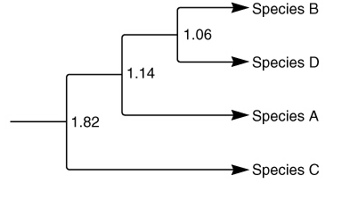
E8. The mutations that have occurred in this sequence are neutral mutations. In all cases, the wobble base has changed, and this change would not affect the amino acid sequence of the encoded polypeptide. Therefore, a reasonable explanation is that the gene has accumulated random neutral mutations over the course of many generations. This observation would be consistent with the neutral theory of evolution. A second explanation would be that one of these two researchers made a few experimental mistakes when determining the sequence of this region.
E9. Two closely related species oftentimes carry the same kinds of genes and a similar total genetic complement of DNA. Therefore, interspecies F1 hybrids are frequently viable. However, due to changes in the arrangement of the genetic material within the chromosomes, the F1 offspring may not be fertile. For example, the two species may have different numbers and types of chromosomes. If this is the case, the chromosomes of the F1 offspring will not be able to pair properly during meiosis, and this will create highly aneuploid gametes. When these gametes participate in fertilization, the embryos will either not develop, or they will result in offspring that are not very healthy. Similarly, the chromosomes of closely related species may differ with regard to inversions and translocations. As discussed in Chapter 8, these changes in chromosome structure are likely to produce gametes that have imbalances in their genetic material. This will also result in embryos that do not survive or have detrimental consequences.
E10. Inversions do not affect the total amount of genetic material. Usually, inversions do not affect the phenotype of the organism. Therefore, if members of the two populations were to interbreed, the offspring would probably be viable because they would have inherited a normal amount of genetic material from each parent. However, such offspring would be inversion heterozygotes. As described in Chapter 8 (see Figure 8.12), crossing over during meiosis may create chromosomes that have too much or too little genetic material. If these unbalanced chromosomes are passed to the next generation of offspring, the offspring may not survive. For this reason, inversion heterozygotes (that are phenotypically normal) may not be very fertile because many of their offspring will die. Since inversion heterozygotes are less fertile, this would tend to keep the eastern and western populations reproductively isolated. Over time, this would aid in the independent evolution of the two populations and would ultimately promote the evolution of the two populations into separate species.
E11. If a mutation is neutral, it will have no effect on the phenotype of the organism. Therefore, you cannot look at the traits of an organism and conclude that it carries neutral mutations. However, molecular techniques can determine if a group of individuals have genetic variation due to the accumulation of neutral mutations. For example, allozymes can be detected by gel electrophoresis, as discussed in chapter 25. The best method to detect genetic variation (both neutral and nonneutral) is DNA sequencing. By analyzing the DNA sequences from different individuals, it is possible to identify changes that are likely to be phenotypically neutral. For example, changes in the wobble base that do not affect the polypeptide sequence would be expected to be neutral.
E12. The technique of PCR is used to amplify the amount of DNA in a sample. To accomplish this, one must use oligonucleotide primers that are complementary to the region that is to be amplified. For example, as described in the experiment of Figure 26.14, PCR primers that were complementary to and flank the 12S rRNA gene can be used to amplify the 12S rRNA gene. The technique of PCR is described in Chapter 18.
E13. As shown here, regions are boxed where the kiwis and cassowary are more similar to each other compared to the moas.
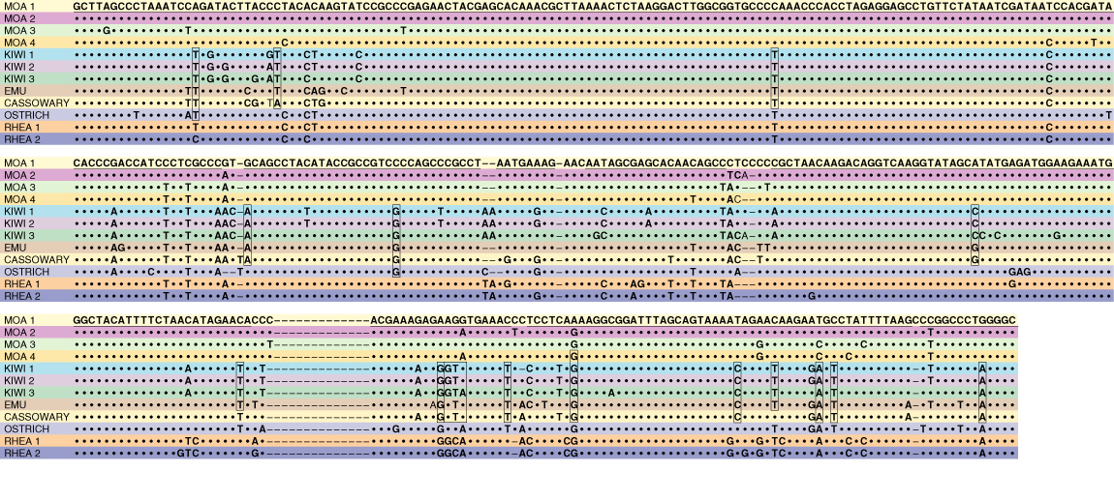
E14. We would expect the probe to hybridize to the natural G. tetrahit and also the artificial G. tetrahit since both of these strains contain two sets of chromosomes from G. pubescens. We would expect two bright spots in the in situ experiment. Depending on how closely related G. pubescens and G. speciosa are, the probe may also hybridize (to two sites) in the G. speciosa genome, but this is difficult to predict a priori. If so, the G. tetrahit species would show four spots.
E15. One way to establish credibility would be to analyze Tyrannosaurus rex DNA from samples that have been obtained from different locations. Samples from different locations would be less likely to be contaminated with the same kind of DNA.

