Chapter 16
Respiratory Physiology

Chapter Scope
The respiratory system regulates the process of breathing and monitors the movements of oxygen (O₂) and carbon dioxide (CO₂) gases in the body. The thoracic cavity is the ideal sealed enclosure for the lungs (and the heart, in between) playing an important role in the mechanics of breathing. Of primary importance is the exchange of O₂ and CO₂ both in the air sacs (alveoli) of the lungs and around the body at the various tissue cells. Within all cells, metabolic reactions are consuming oxygen and producing carbon dioxide. Can you describe these metabolic reactions? Perhaps, a review of metabolism in chapter 5 would help.
Since breathing continues with or without our conscious thought there must be nerve endings or sensors sensitive to the gases and other chemicals in the blood plasma that signal the respiratory centers in the control of ventilation. These nerve sensors or chemoreceptors are located primarily in the carotid sinus and aortic arch blood vessel walls, sending nerve impulses to the brainstem region. Respiratory centers located in the medulla oblongata interpret this incoming sensory information and respond most vigorously to a rise in plasma carbon dioxide concentrations or a fall in acid-base or pH levels. Interestingly, your brain is more sensitive to rising CO₂ levels than it is to falling O₂ levels! Furthermore, since we can voluntarily alter our breathing there must be some conscious control that descends from higher cortical regions of our brain to affect the rate and depth of our respirations.
Perhaps the most remarkable molecule in the body is hemoglobin. Featuring an iron atom core that attracts oxygen, thousands of hemoglobin-O₂ molecules are transported in the cytoplasm of each erythrocyte (red blood cell) past every tissue cell in the body. As erythrocytes tumble single file through the tissue capillaries, the rate of oxygen release or dissociation from the flexible framework of hemoglobin is determined by the unique influence of the surrounding interstitial pH, temperature, and concentration of 2,3-DPG.
Carbon dioxide is produced within the cytoplasm and mitochondria of cells during the catabolism (breakdown) of fuels such as glucose and triglyceride molecules. Considered a waste product of metabolism, CO₂ is delivered to the lungs for exhalation. (Do you remember glycolysis, the Krebs cycle, and oxidative phosphorylation — chapter 5?) Blood transports CO₂ in three different forms — let’s see if you can find them. Since carbon dioxide concentration is directly related to H⁺ formation, the act of ventilation and subsequent changes in the CO₂ levels in the blood play a major role in the overall acid-base balance of the body. Under conditions of exercise and acclimatization to high altitudes, the normal exchange of oxygen and carbon dioxide becomes altered in unusual, but predictable ways.

I. The Respiratory System
The respiratory system is divided into a respiratory zone, which is the site of gas exchange between air and blood, and a conducting zone, which conducts the air to the respiratory zone. The exchange of gases between air and blood occurs across the walls of respiratory alveoli. These tiny air sacs, only a single cell layer thick, permit rapid rates of gas diffusion.

A. Multiple Choice
- Which function is not part of respiration?
a. ventilation of air into and out of the lungs (breathing)
b. gas exchange at the lungs and at the tissues
c. oxygen utilization by the tissue mitochondria
d. immune defense against the invasion of foreign pathogens
- Which of the following characteristics does not describe the type I alveolar cell of the lung?
a. These cells secrete a pulmonary surfactant that enables inflation to occur.
b. These cells make up 95% to 97% of the total surface area of the lung.
c. These cells are flat and very thin.
d. These cells are located very close to nearby capillary blood vessels.
e. These cells are responsible for most of the gas exchange with blood.
- Gas exchange between the air and blood occurs entirely by the process of
a. simple diffusion.
b. facilitated diffusion.
c. active transport.
d. co-transport (secondary active transport).
- Which of the following locations is not part of the conducting zone of the respiratory system?
a. pharynx
b. larynx
c. trachea
d. terminal bronchiole
e. alveolus
- Which of the following is not a function of the respiratory system?
a. air conduction into the respiratory zone
b. air warming
c. air humidification (moistening the air)
d. air filtration and cleaning
e. All of these are functions of the respiratory system.
- Which structure is not located within the thoracic cavity?
a. heart
b. spleen
c. esophagus
d. thymus gland
e. large blood vessels

B. True or False/Edit
- Respiration is the mechanical process that moves air into and out of the lungs.
- The diffusion rate of gases is very fast partly because only two thin cells separate the air swirling in the alveoli from the blood that flows in the nearby capillary.
- In order to maximize the rate of gas diffusion between the air and blood, the air-blood barrier provided by the alveoli is extremely thin, and has a very small surface area.
- Gas exchanges can occur anywhere along the conducting passageways of the respiratory system.
- Air enters the terminal bronchioles from respiratory bronchioles, which are the narrowest of airways that do not have alveoli and do not contribute to gas exchange.
- Both the visceral and the parietal pleural membranes are wet epithelial membranes that come together in the central region of the thoracic cavity and surround the heart.
- Under normal conditions of ventilation, there exists only a “potential” space, known as the intrapleural space that exists between the two wet pleural membranes.

C. Label the Figure —The Thoracic Cavity
Study the cross section of the thoracic cavity shown in figure 16.1. In the spaces provided, identify and label the following important thoracic cavity structures: parietal pericardium, visceral pericardium, lung, bronchus, anterior mediastinum, posterior mediastinum, parietal pleura, and visceral pleura.
When finished, check your work with figure 16.8 in the text.

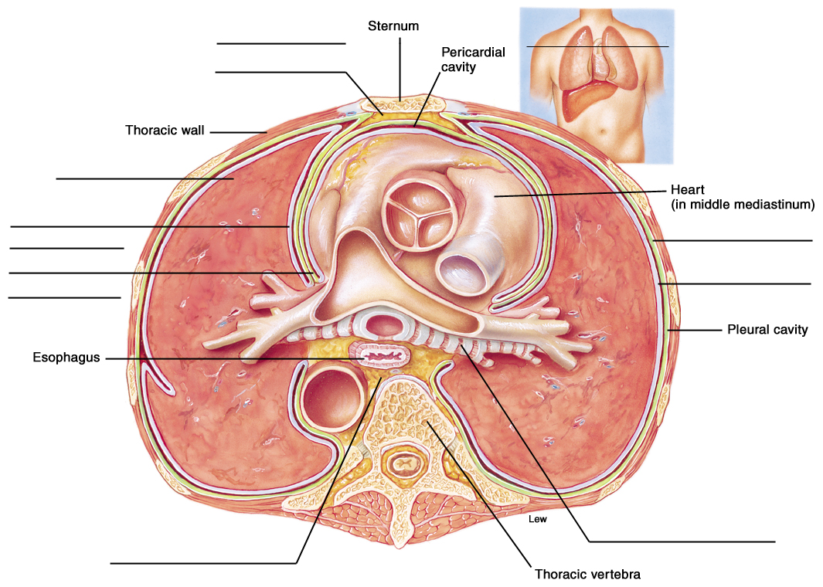
Figure 16.1 A cross section of the thoracic cavity showing the mediastinum and pleural membranes.

II. Physical Aspects of Ventilation
The movement of air into and out of the lungs occurs as a result of pressure differences induced by changes in lung volumes. Ventilation is thus influenced by the physical properties of the lungs, including their compliance, elasticity, and surface tension.

A. Multiple Choice
- Air flow through the bronchioles, like blood flow through arterioles, is inversely proportional to the
a. frictional resistance to air flow.
b. volume of air in the lungs.
c. pressure difference upstream versus downstream.
d. diameter of the airway.
- The transpulmonary pressure can best be described as
a. the pressure measured within the lungs during inhalation only.
b. the pressure in the intrapleural space that rises during expiration only.
c. the difference between the intrapulmonary pressure and the intrapleural pressures.
d. the difference between the intrapleural pressure and the atmospheric pressure.
- Boyle’s law states that for a given quantity of gas, the gas.
a. volume is directly proportional to gas temperature.
b. pressure is inversely proportional to gas volume.
c. solubility is directly proportional to gas pressure.
d. pressure is inversely proportional to gas temperature.

- Which statement about lung compliance is false?
a. Compliance can be measured as the change in lung volume per unit change in transpulmonary pressure.
b. Compliance can also be described as lung distensibility (capable of being stretched).
c. Compliance decreases in abnormal conditions such as pulmonary fibrosis.
d. During ventilation, compliance is aided by the property of fluid in the alveoli, known as surface tension.
e. All of these statements regarding compliance are true.
- Which statement about lung elasticity is false?
a. Elasticity describes the physical recoil property of lung tissue.
b. Since the lungs are normally stuck to the chest wall, they are always under a state of elastic tension.
c. Elasticity aids in pushing the air out of the lung during expiration.
d. Elasticity is abnormal due to a genetic defect in patients with cystic fibrosis.
e. All of these statements regarding elasticity are true.
- The law demonstrating that the pressure in an alveolus is directly proportional to the surface tension of its fluid lining the alveolus and inversely proportional to the size (radius) of that alveolus, is known as
a. the Law of LaPlace.
b. Boyle’s law.
c. Graham’s law.
d. Dalton’s law.
e. Henry’s law.
- Which statement about respiratory distress syndrome (RDS) is false?
a. It is normally seen in premature infants born before their eighth month.
b. It can result in the collapse of the alveoli.
c. In this condition the surface tension within the alveoli is abnormally low.
d. In this condition the type II alveolar cells are not yet functioning properly.
e. This condition can be treated with the help of a mechanical ventilator and by administering exogenous surfactant.

B. True or False/Edit
- Air flow through lung bronchioles follows the same basic principles as blood flow through arteriole blood vessels.
- Inspiration occurs when the intrapulmonary (intra-alveolar) pressure is greater than the atmospheric pressure outside the body.
- The intrapleural pressure can be described as the subatmospheric pressure caused by the stiff thoracic wall “pulling” against the “tendency” of the enclosed lungs to collapse.
- The intrapleural pressure is normally higher than the intrapulmonary pressure during both inspiration and expiration.
- Compliance and elasticity refer to the same physical property of the lungs.
- Lung elasticity is the primary force that exists to return the lungs to their original shape during exhalation.
- Surface tension exerted by the thin film of water lining all alveoli opposes the expansion (or compliance) of alveoli during inspiration.
- Surfactant molecules secreted from type II alveolar cells are composed mostly of phospholipid molecules together with hydrophobic surfactant proteins that serve to raise the surface tension of fluids lining the alveoli.

III. Mechanics of Breathing
Normal, quiet inspiration results from muscle contraction, and normal expiration from muscle relaxation and elastic recoil. These actions can be forced by contractions of the accessory respiratory muscles. The amount of air inspired and expired can be measured in a number of ways to test pulmonary function.

A. Multiple Choice
- Which of the following statements best describes the vital capacity of the lung?
a. the volume of gas inspired or expired in an unforced respiratory cycle
b. the volume of gas remaining in the lungs after a maximum expiration
c. the total amount of gas in the lungs at the end of a maximum inspiration
d. the maximum amount of gas that can be expired after a maximum inspiration
e. the maximum amount of gas that can be inspired at the end of a tidal expiration
- Which of the following statements best describes the tidal volume of the lung?
a. the volume of gas inspired or expired in an unforced respiratory cycle
b. the volume of gas remaining in the lungs after a maximum expiration
c. the total amount of gas in the lungs at the end of a maximum inspiration
d. the maximum amount of gas that can be expired after a maximum inspiration
e. the maximum amount of gas that can be inspired at the end of a tidal expiration
- Multiplying the tidal volume at rest by the number of breaths per minute, yields a number called the
a. residual volume.
b. inspiratory reserve volume.
c. total lung capacity.
d. total minute volume.
e. vital capacity.
- Which statement about asthma is false?
a. It is an obstructive lung disease.
b. Damage to the lung tissues does not normally occur.
c. Inspiration becomes relatively more difficult than expiration.
d. The vital capacity is usually measured as normal.
e. Bronchoconstriction increases the resistance to air flow.
- Which statement about epinephrine and related compounds used in the treatment of asthma, is false?
a. Epinephrine acts on beta-adrenergic receptors in the bronchioles.
b. Epinephrine causes bronchoconstriction.
c. Epinephrine can help relieve the symptoms of asthma.
d. Epinephrine is released during “fight-or-flight” reactions.
e. All of these statements regarding epinephrine are true.
- The disease in which alveolar tissue is destroyed, resulting in fewer but larger alveoli and collapse of the bronchioles, is known as
a. emphysema.
b. asthma.
c. respiratory distress syndrome (RDS).
d. pulmonary fibrosis.
e. coal miner’s disease.

B. True or False/Edit
- The elastic properties of the rib cage structure, associated cartilages, and of the lungs themselves, operate to oppose inspiratory movements and to facilitate expiratory movements.
- Unforced or quiet inspiration is a passive process.
- Contraction of the internal intercostal muscles and the abdominal muscles is seen in forced inspiration.
- The residual volume is the volume of air you cannot expire, even after a maximum forced expiration, because the alveoli do not collapse.
- The sum of the residual volume and the expiratory reserve volume is known as the vital capacity.
- In restrictive disorders, such as pulmonary fibrosis, the vital capacity is reduced below normal.
- Forced expiratory volume (FEV) is a diagnostic test for obstructive disorders, such as asthma, during which the rate of expiration is measured.
- Dyspnea is term describing the subjective, yet uncomfortable feeling of “shortness of breath.”

C. Sequencer — One Normal Ventilation Cycle
43. Number the following events 1-9 as they would occur during one normal inspiration and expiration cycle. Note: The last one (9) has been done for you.
Alveolar pressure falls below atmospheric pressure.
Intrapulmonary pressure rises above atmospheric pressure.
Neurons stop firing, intercostal and diaphragm muscles relax.
Air flows from high to low pressure into the lungs.
Intercostal and diaphragm muscles contract when stimulated.
Air volume in the lung alveoli increases.
Elastic structures of rib cage and lungs passively recoil.
Intrapleural pressure falls below atmospheric pressure.
9 Air volume in the lung alveoli decreases.
Good work! Now practice this sequence verbally on someone nearby (brother, sister, parent, or friend) until this concept becomes easy for you to recall. (This is a favorite essay question!)

D. Label the Figure — Spirogram of Lung Volumes and Capacities
Study the sample spirogram in figure 16.2. Complete the figure by writing the names of the following volumes and capacities within the correct answer space provided. Notice that a lung capacity is the sum of two or more lung volumes. Expiratory reserve volume (ERV), Inspiratory reserve volume (IRV), Vital capacity (VC), Residual volume (RV), Functional residual volume (FRC), Total lung capacity (TLC), and Tidal volume (TV). If you get stuck and need help, study figure 16.16 in the text. Good luck!

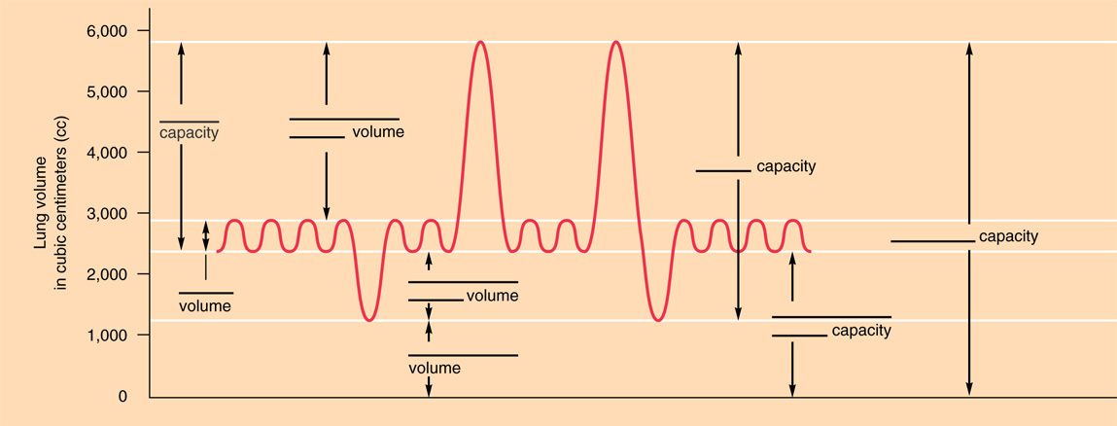
Figure 16.2 A spirogram showing lung volumes and capacities.

IV. Gas Exchange in the Lungs
Gas exchange between the alveolar air and the blood in pulmonary capillaries results in an increased oxygen concentration and a decreased carbon dioxide concentration in the blood leaving the lungs. This blood enters the systemic arteries, where blood gas measurements are taken to assess the effectiveness of lung function.

A. Multiple Choice
- The total pressure exerted by the atmosphere around us at sea level, is
a. 760 mmHg.
b. 760 torr.
c. one atmosphere.
d. All of these pressures are correct.
- Which two gases exert about 99% of the total atmospheric pressure at sea level?
a. CO₂ and O₂
b. CO₂ and N₂
c. N₂ and O₂
d. O₂ and H₂O
- Which factor does not contribute to the rapid exchange of gases that takes place between the alveoli and the blood capillaries?
a. a very large surface area present in the alveoli
b. a very steep temperature gradient between the outside atmosphere and the alveoli
c. a very short distance required for gases to diffuse
d. a very extensive supply of capillary blood
- The PO₂ of the blood is
a. equal to the total oxygen content minus the hemoglobin-bound oxygen.
b. not affected by breathing pure oxygen.
c. a value greater than the PO₂ measured in the atmosphere.
d. higher in venous blood and lower in arterial blood.
- In the adult, the rate of blood flow through the pulmonary circulation is ___________the rate of blood flow through the systemic circulation.
a. greater than
b. equal to
c. less than
d. not related to
- The ventilation (air flow) to perfusion (blood flow) ratio, written as the V/P ratio
a. results in a ratio with a higher number at the base of the lung than that measured at the apex.
b. usually indicates that blood flow at the base of the lung is greater than that at the apex.
c. is not affected by body position, such as standing or lying down.
d. can never be a number equal to one (1.0).
e. usually indicates that ventilation at the base of the lung is greater than that at the apex.
- The gas responsible for decompression sickness or the bends (in deep-sea divers) is
a. oxygen.
b. carbon dioxide.
c. nitrogen.
d. helium.

B. True or False/Edit
- At higher altitudes the partial pressures (P) of the individual gases decrease which result in a corresponding decrease in the total atmospheric pressure.
- Although water vapor is considered a gas, it does not exert a partial pressure and therefore does not contribute to the total atmospheric pressure.
- Henry's law states that the concentration of a gas in the body that is dissolved in blood plasma is dependent directly on its partial pressure found in the alveolar gas mixture.
- When using the oxygen electrode to measure partial pressure of oxygen dissolved in the plasma, only the free or unbound oxygen molecules exert measurable pressure.
- Almost all the oxygen gas in blood is dissolved in the plasma, while only a small “reserve” of oxygen is found inside the red blood cells.
- Clinically, the only blood gas values of importance are those taken from venous blood rather than from arterial blood.
- In the pulmonary circulation the resistance to blood flow and its average pressure is lower than the resistance and average pressure found in the systemic circulation.
- The smooth muscle of the pulmonary arterioles constricts when the PO₂ in the alveolus is low, thus sending blood away from these alveoli that are poorly ventilated.
- Oxygen toxicity following hyperbaric oxygen treatment can result in the oxidation of normal enzymes in the nervous system — causing damage to the retina of the eye and blindness (as demonstrated in retrolental fibroplasias).

V. Regulation of Breathing
The motor neurons that stimulate the respiratory muscles are controlled by two major descending pathways: one that controls voluntary breathing and another that controls involuntary breathing. The unconscious, rhythmic control of breathing is influenced by sensory feedback from receptors sensitive to the PCO₂, pH, and PO₂ of arterial blood.

A. Multiple Choice
- Which statement about the rhythmicity center of the brain stem is false?
a. It is an aggregation of neurons located in the reticular formation of the medulla oblongata.
b. It controls breathing involuntarily, such as when we are asleep.
c. It forms interacting collections of both inspiratory (I) neurons and expiratory (E) neurons.
d. Using spinal motor neurons it controls both the diaphragm and the rib cage respiratory muscles.
e. All of these statements about the rhythmicity center of the brain stem are true.
- The pons region of the brainstem
a. has an area called the apneustic center promotes inspiration by stimulating I neurons of the medulla oblongata.
b. has an area called the pneumotaxic center inhibits inspiration by antagonizing the apneustic center.
c. influences the medulla oblongata in the automatic, rhythmic control of breathing.
d. has no direct control over the muscles of respiration.
e. All of these statements about the pons are correct.
- Which statement about the chemoreceptors of the respiratory system is false?
a. Peripheral chemoreceptors are located in the carotid and aortic sinuses.
b. Chemoreceptors input to the brain stem modifies both the rate and the depth of breathing.
c. Central chemoreceptors can be found locally in the medulla oblongata region of the brainstem.
d. Chemoreceptors are sensitive to blood PCO₂, pH, and PO₂.
- The partial pressure of carbon dioxide (PCO₂)
a. rises during hyperventilation.
b. when elevated, will cause a decrease in the pH (become more acidic).
c. has very little effect on the control over the rate and depth of ventilation.
d. is normally about 100 mmHg in arterial blood.
- Which statement about the central chemoreceptor neurons located in the medulla oblongata is false?
a. Central chemoreceptors communicate directly with the neurons of the respiratory control center in the medulla.
b. Central chemoreceptors are stimulated indirectly by the rise in arterial blood CO₂ concentration.
c. When properly stimulated, central chemoreceptors are responsible for 70% to 80% of the increased ventilation response.
d. Central chemoreceptors are stimulated directly by a rise in the pH (fall in H⁺ concentration) of the cerebrospinal fluid.
e. The ventilation response to these chemoreceptors takes several minutes, while that from peripheral chemoreceptors is almost immediate.
- The Hering-Breuer reflex
a. involves irritant receptors that stimulate reflex constriction of the bronchioles.
b. is responsible for the sneezing, sniffling, and coughing response when exposed to noxious substances.
c. is stimulated by pulmonary stretch receptors during inspiration that serve to inhibit further inspiration.
d. plays an important role in the regulation of resting tidal volumes in the normal adult during quiet breathing.

B. True or False/Edit
- The motor neurons that leave the spinal cord to control the skeletal muscles of respiration are known as somatic motor neurons.
- The aortic and carotid artery bodies refer to the same structures as the aortic and carotid artery sinuses.
- Sensory information about blood chemistry from the aortic bodies travels up the vagus nerve to the medulla, while that from the carotid bodies travels along the glossopharyngeal nerve.
- Carbon dioxide can combine with bicarbonate ion in the blood to form carbonic acid that, in turn, lowers the pH.
- During hyperventilation, the oxygen content of the arterial blood does not increase significantly because most of the O₂ (97%) in the blood is bound to hemoglobin molecules inside the red blood cells.
- Hyperventilation results in hypocapnia.
- When stimulated, the peripheral chemoreceptors can produce an immediate increase in ventilation, while the medullary chemoreceptor response is slower, taking minutes.
- Peripheral chemoreceptors in the aortic and carotid bodies are most sensitive to a fall in the oxygen content of the arterial blood.
- The rise in CO₂ during hypoventilation stimulates the medullary chemoreceptors through a lowering of cerebrospinal fluid pH; and stimulates the peripheral chemoreceptors through a lowering of blood pH.

VI. Hemoglobin and Oxygen Transport
Hemoglobin without oxygen, or deoxyhemoglobin, can bond with oxygen to form oxyhemoglobin. This “loading” reaction occurs in the capillaries of the lungs. The dissociation of oxyhemoglobin, or “unloading” reaction, occurs in the tissue capillaries. The bond strength between hemoglobin and oxygen, and thus the extent of the unloading reaction, is adjusted by various factors to ensure an adequate delivery of oxygen to the tissues.

A. Multiple Choice
- If the lungs are functioning properly, the
a. PO₂ of systemic arterial blood is about 100 mmHg.
b. plasma oxygen concentration is about 0.3 ml per 100 ml of blood.
c. total oxygen concentration is calculated to be about 20 ml of O₂ per 100 ml of blood.
d. hemoglobin molecules bind to and transport most of the oxygen inside the red blood cells.
e. All of these statements are correct.
- The central atom of each heme group that combines with one molecule of oxygen (O₂) is
a. Ca²⁺.
b. Fe²⁺.
c. Mg²⁺.
d. Al³⁺.
e. Zn²⁺.
- The unloading reaction
a. describes the combination of deoxyhemoglobin and oxygen.
b. occurs in the lung capillaries.
c. results in the formation of oxyhemoglobin.
d. results in the release of free O₂ molecules to the tissues.
e. All of these statements about the unloading reaction are correct.
- Which of the following statements regarding oxygen loading to and unloading from hemoglobin is false?
a. The percent oxyhemoglobin saturation of the arterial blood is about 97%.
b. About 22% of hemoglobin-bound O₂ will unload as blood flows through the tissues.
c. Aerobic respiration consumes O₂, lowering the venous blood PO₂ to about 40 mmHg and the percent oxygen saturation to 75%.
d. Almost all of the bound oxygen dissociates from hemoglobin as blood flows past oxygen-depleted tissues with a PO₂ of 40 mmHg.
- The Bohr effect describes the specific interaction between oxygen and hemoglobin, whereby hemoglobin molecules
a. unload more O₂ molecules in the tissues where the pH is lower (more acidic) than normal.
b. load more oxygen in the lungs when the body temperature rises.
c. load more oxygen as the red blood cell levels of 2,3-DPG levels fall.
d. unload more O₂ when exposed to high oxygen levels.
- The oxyhemoglobin dissociation curve shifts to the right (resulting in greater unloading of O₂) when hemoglobin molecules experience a
a. fall in the blood pH (becomes more acidic).
b. rise in blood PCO₂.
c. rise in body temperature.
d. rise in 2,3-diphosphoglyceric acid (2,3-DPG) concentration in the red blood cells.
e. All of these conditions will shift the curve to the right.
- Which statement about the hemoglobin S molecules characteristic of sickle-cell anemia is false?
a. The amino acid valine is substituted for glutamic acid in the synthesis of its protein chains.
b. It is due to a single base change in the region of DNA that codes for the beta chains.
c. It comes out of solution when the PO₂ is high, causing the shape of red blood cells to become more flexible.
d. It inhibits the reproduction of the malaria parasite in the red blood cell and thus provides the carriers of sickle-cell anemia with a resistance to this disease.
e. It can be inherited in the homozygous condition (SS) or in the heterozygous condition (AS).

B. True or False/Edit
- The four heme portions of a single hemoglobin molecule are composed of nitrogen-containing, disc-shaped organic pigment molecules.
- Oxidized hemoglobin is known as methemoglobin in which the iron loses an electron (is oxidized to Fe³⁺ or ferric state) and cannot bind or transport oxygen.
- Carboxyhemoglobin is another abnormal form of hemoglobin that binds firmly to carbon dioxide rather than oxygen, thus reducing the transport of oxygen to the tissues.
- Oxyhemoglobin can be measured with instruments because it has a unique cranberry juice color whereas carboxyhemoglobin is more a tomato juice red color.
- Erythropoietin is a hormone produced mainly by the liver to stimulate the production of red blood cells in response to higher than normal oxygen levels in the blood.
- At rest, as blood passes through the capillaries of the tissues, only about 22% of the oxygen bound to hemoglobin is released or unloaded to the cells.
- During heavier exercise, the venous blood PO₂ can drop from a normal of 40 mmHg to 20 mmHg or less, as more oxygen dissociates from hemoglobin to serve the exercising muscles.
- A shift in the oxyhemoglobin dissociation curve to the left indicates that more oxygen is unloading from the hemoglobin molecules.
- Mature red blood cells (RBCs) do not have mitochondria, nor do they have a nucleus.
- Mature red blood cells do not use oxygen for metabolism; instead they obtain their energy from glucose anaerobically, forming 2,3-DPG molecules in a “side reaction.”
- In patients with anemia, when the total hemoglobin concentration is low, more 2,3-DPG molecules are synthesized by RBCs, which promotes a greater dissociation (unloading) of oxygen from hemoglobin.
- Fetal hemoglobin (hemoglobin F) differs from adult hemoglobin (hemoglobin A) in that hemoglobin F has two beta protein chains in place of the two gamma chain proteins in adult hemoglobin.
- Thalassemia is a family of diseases that results in the impaired synthesis of either the alpha or the beta protein chain in hemoglobin; thus reducing the ability of such hemoglobin to carry O₂.
- Myoglobin, with only one heme iron, can bind only one oxygen molecule but has a greater affinity for that molecule — releasing it only when muscle oxygen concentrations are very low.

VII. Carbon Dioxide Transport
Carbon dioxide is transported in the blood primarily in the form of bicarbonate (HCO₃⁻), which is released when carbonic acid dissociates. Carbonic acid is produced primarily in the red blood cells as blood passes through systemic capillaries.

A. Multiple Choice
- In which of these forms is CO₂ not carried in plasma?
a. dissolved directly in the water of the blood (plasma)
b. as carboxyhemoglobin
c. bound to an amino acid on hemoglobin (carbaminohemoglobin)
d. as bicarbonate ion dissolved in the plasma
e. Carbon dioxide is carried in all these forms.
- Which statement about the important enzyme, carbonic anhydrase, is false?
a. Carbonic anhydrase catalyzes the combination of carbon dioxide and water.
b. Carbonic anhydrase is found primarily in the blood plasma.
- Carbonic anhydrase catalyzes the formation of carbonic acid in the red blood cells.
d. Carbonic anhydrase can ultimately result in lowering the blood pH (blood becomes more acidic).
e. All of these statements regarding carbonic anhydrase are true.
- Which of the following events does not occur during the chloride shift reaction in the red blood cells (RBCs)?
- Hydrogen ions are released by the dissociation of carbonic acid.
- Hydrogen ions can be bound (buffered) to hemoglobin.
- Large amounts of carbonic acid molecules accumulate.
- Bicarbonate ion diffuses into the red blood cells in exchange for chloride.
- The inside of the RBCs gains a net positive charge.

B. True or False/Edit
- The hydrogen ions (H⁺) released by the dissociation of carbonic acid (H₂CO₃) can combine with deoxyhemoglobin (acting as a buffer) within the red blood cells.
- The chloride shift in the tissue capillaries describes the diffusion of chloride ions out of the red blood cell cytoplasm as bicarbonate ions diffuse into the red blood cells.
- As RBCs flow through active tissues, the influx of carbon dioxide increases oxygen unloading from the hemoglobin that increases the transport of carbon dioxide back to the lungs in the form of bicarbonate ions.
- The reverse chloride shift occurs in pulmonary capillaries; and ultimately facilitates the conversion of carbonic acid (H₂CO₃) to CO₂ gas (for expiration) and water as products

C. Label the Figure — Carbon Dioxide Transport
Figure 16.40 in the text is a terrific summary of CO₂ movement out of a typical living tissue cell and into a nearby capillary red blood cell (RBC). Upon entry the CO₂ molecules enter into a remarkable series of chemical reactions, ultimately forming products that play an important role in acid-base balance. In figure 16.3, fill in the blank spaces provided with the correct ion or chemical that will complete the process. As always, try this before resorting to the answers in the text. Good luck!
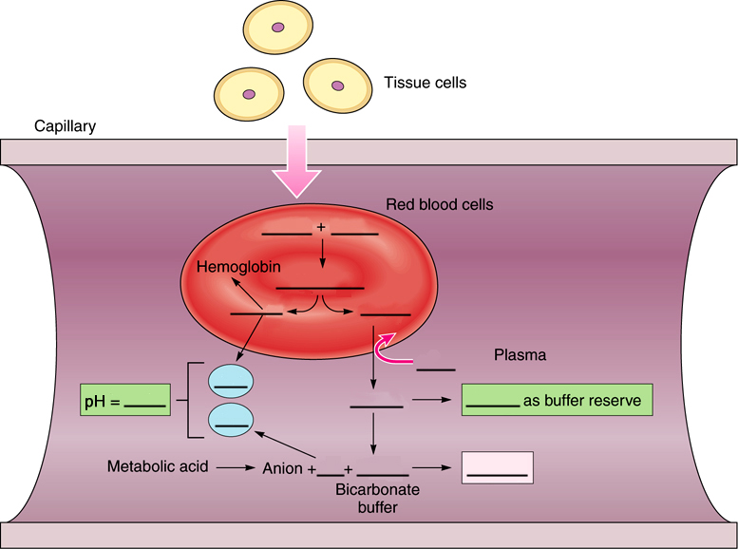

Figure 16.3 The effect of bicarbonate on blood pH. Bicarbonate released into the plasma from red blood cells buffers the H⁺ produced by the ionization of metabolic acids (lactic acid, fatty acids, ketone bodies, and others). Binding of H⁺ to hemoglobin also promotes the unloading of O₂.

VIII. Acid-Base Balance of the blood
The pH of blood plasma is maintained within a narrow range of values through the functions of the lungs and kidneys. The lungs regulate the carbon dioxide concentration of the blood, and the kidneys regulate the bicarbonate concentration.

A. Multiple Choice
- Which statement regarding acid-base balance in the body is false?
a. Bicarbonate ion (HCO₃⁻) is the major buffer in the blood plasma.
b. The lungs and kidneys are the two organs most responsible for maintaining a constant body pH.
c. Normal blood plasma pH is maintained near 7.4 within the range of 7.35 to 7.45.
d. All acids in the body are considered nonvolatile acids.
- In metabolic acidosis,
a. the production of nonvolatile acids is abnormally increased.
b. CO₂ production exceeds CO₂ loss through ventilation at the lungs.
c. the cause can be attributed to a decrease in respirations (hypoventilation).
d. the cause can be attributed to an increase in bicarbonate ion concentration in the blood.
e. severe vomiting is usually evident.
- In respiratory alkalosis,
a. the blood pH usually falls below 7.35.
b. the rate of respirations are abnormally increased (hyperventilation).
c. both the blood levels of P_{CO2} and HCO₃⁻ levels are unusually high.
d. the cause can be attributed to prolonged breath holding maneuvers.
e. severe vomiting is usually evident.
- Which statement about ventilation and acid-base balance is false?
a. In hyperventilation, the rate of ventilation is greater than the rate of CO₂ production.
b. In hyperventilation, the P_{CO2} in the arteries would decrease, causing less formation of carbonic acid and a subsequent rise in the pH.
c. In hypoventilation, the ventilation is not sufficient to “blow off” carbon dioxide, causing the carbonic acid production to rise.
d. In hypoventilation, inadequate ventilation leads to a rise in the plasma pH.
- In respiratory acidosis, the
a. carbon dioxide concentration of the blood would be abnormally high.
b. production of CO₂ exceeds CO₂ loss through ventilation.
c. cause is usually an abnormally low rate and depth of respiration (hypoventilation).
d. production of carbonic acid is excessively high.
e. All of these statements about respiratory acidosis are true.
- In metabolic acidosis,
a. blood pH falls below 7.35.
b. partial compensation results in an abnormal increase in respirations (hyperventilation).
c. aortic and carotid bodies are stimulated by the acidosis.
d. abnormally high levels of H⁺ (acid) are formed as a result of increased metabolism.
e. All of these statements about metabolic acidosis are true.

B. True or False/Edit
- The kidneys primarily regulate the carbon dioxide concentration of the blood whereas the lungs regulate the bicarbonate concentration of the blood.
- Carbonic acid is referred to as a volatile acid because it can be converted into a gas; and thereby its blood concentration can be altered by changes in ventilation.
- Uncontrolled diabetes mellitus is a clinical condition that can result in excessive production of ketone bodies and a metabolic alkalosis.
- The Henderson-Hasselbalch equation can be used to demonstrate the relationship between abnormal levels of bicarbonate and respiratory acidosis or alkalosis.
- Ventilation is normally adjusted to keep up with changes in the metabolic rate, and thus keep up with the tissue production of carbon dioxide gas.
- Through its control over the excretion of hydrogen ion (H⁺) and bicarbonate ion (HCO₃⁻) in the urine, the kidney is the organ most responsive to metabolic acidosis and alkalosis.
- Hyperventilation can cause dizziness because it raises the pH of cerebral spinal fluid (alkalosis of the CSF) that constricts cerebral blood vessels so that blood flow to the brain is reduced.

IX. Effect of Exercise and High Altitude on Respiratory Function
The arterial blood gases and pH do not significantly change during moderate exercise because ventilation increases during exercise to keep pace with the increased metabolism. Adjustments are also made at high altitude in both the control of ventilation and the oxygen transport ability of the blood to permit adequate delivery of oxygen to the tissues.

A. Multiple Choice
- Which statement about hyperpnea is false?
a. Hyperpnea is an increase in ventilation rate and/or depth above the usual.
b. Hyperpnea can occur during exercise.
c. Hyperpnea causes a decrease in blood PCO₂ levels.
d. Hyperpnea may be caused by chemical factors in the blood (humoral) or by nerve activities (neurogenic), or by both of these means.
e. All of these statements about hyperpnea are true.
- Which statement about continued moderate to heavy exercise is false?
a. It may cause muscles to reach a “lactate threshold.”
b. It usually results in increased lactic acid production as muscles respire anaerobically.
c. It results in a dramatic fall in the arterial oxygen hemoglobin saturation (normally at 97% saturation).
d. An increase in the number of mitochondria and respiratory enzymes results in an increase in the muscle’s aerobic efficiency.
e. The “lactate threshold” occurs when about 50% to 70% of the person’s maximal oxygen uptake has been reached.
- Which adjustment would not occur during acclimatization to high altitude — such as at an altitude of 7,500 feet?
a. Ventilation is increased due to decreased arterial PO₂ (known as the hypoxic ventilatory response).
b. The percent oxyhemoglobin saturation is reduced below 97%.
c. Oxygen unloading at the tissues is increased due to an overall decrease in the affinity of oxygen for hemoglobin.
d. The secretion of the hormone erythropoietin from the kidneys is decreased.
e. The red blood cell count can rise, resulting in an increase in the hematocrit (to as high as 55% to 60%).

B. True or False/Edit
- Especially in well-trained athletes, the arterial blood PO₂, PCO₂, and pH remain surprisingly constant during exercise due to the complex action of various homeostatic mechanisms.
- Early in exercise, a pain or “stitch” may develop in your side as a result of inadequate oxygen delivery to the tissues (hypoxia) and anaerobic respiration in particular muscles (including the diaphragm).
- The major effect of endurance training is to increase skeletal muscle myoglobin, mitochondria, and metabolic enzymes so that the overall aerobic efficiency of the muscles is improved.
- Nitric oxide (NO) appears to provide some relief from the chronic hypoxia of life at high altitude by dilating pulmonary vessels, by hitching a ride with hemoglobin to the tissues for greater blood flow there, and by binding to sulfur atoms (SNOs) in the cysteine groups of proteins molecules – and thereby may stimulate the respiratory control center to increase breathing.
- Erythropoietin release from kidneys is stimulated by low oxygen delivery — and results in stimulating bone marrow to increase its production of hemoglobin and red blood cells.

X. Chapter Review

A. Match 'n' Spell — Respiratory Volumes and Terms
For each of the following numbered statement below, select the correct term from the column on the right. Place the corresponding letter to the left of the applicable number. Then, write out the term in the larger remaining space between the two columns — be sure to spell the terms correctly!

- “shortness of breath” feeling __________
- maximum volume inspired after normal inspiration __________
- reduced vital capacity (as in pulmonary fibrosis) __________
- tidal volume X (times) breaths per minute __________
- maximum inspiration to maximum expiration __________
- maximum volume expired after normal expiration __________
- normal, comfortable breathing at rest __________
- unforced normal volume inspired or expired __________
- reduced FEV_{1.0} (as in asthma) __________
- remaining lung volume after maximum expiration __________
- complete cessation of breathing __________
- total chest volume after maximum inspiration __________
- percent of vital capacity expired in 1 second __________
- tidal volume (TV)
- vital capacity (VC)
- total lung capacity (TLC)
- inspiratory reserve volume (IRV)
- expiratory reserve volume (ERV)
- residual volume (RV)
- total minute volume
- forced expiratory volume (FEV)
- restrictive disorder
- obstructive disorder
- dyspnea
- apnea
- eupnea

B. Acid-Base Balance Brain Teaser
Complete the important acid-base reaction sequence below by supplying the missing chemicals. When finished, use this reaction and the text as references to answer the questions that follow.
_______ + H₂O ↔ ________ ↔ ________ + _______
- What is the full name of the enzyme that catalyzes this reaction? (Hint: 2 words) _________________ ________________
- Where is this enzyme typically located in the body? (Hint: Where is it most needed?) ___________
- Which chemical in these reactions is considered a major plasma buffer (remember, a buffer stabilizes pH by opposing drastic swings in pH)? ______________________
- Which chemical is counted directly when pH is measured? ____________; Can you name the instrument used to measure the pH of solutions? ______________
- Which half of the above reactions is altered primarily by respiratory events such as breathing, resulting in a respiratory acidosis or alkalosis? The _____________(right/left) half. Why?
- Which half of the reaction is altered primarily by metabolic events such as exercise, resulting in metabolic acidosis or alkalosis? The ______________ (right/left) half. Why?
Convince yourself that these reactions are balanced like a teeter-totter and that the momentum can swing in either direction driven by the law of mass action (from greater mass to lesser mass). Also, this reaction can be used to compensate (correct) for an acidosis or alkalosis condition that is already present. Committing this reaction to memory now will provide you with the best crib note available to answer most acid-base questions and to further your understanding of acidosis and alkalosis in future study.

C. Crossword Puzzle — Respiratory Physiology

Across
1. Equipment used in baseball
3. Blood gas — major stimulant of the carotid inspiration
8. Number of heme subgroups in a molecule of hemoglobin
9. Ease with which the lungs expand under pressure; distensibility
14. Spirometry is used to measure pulmonary __________
15. Female sheep
16. Respiratory control centers alter both the __________ and depth of ventilation
17. Ion most responsible for acid-base measurements and pH
19. What happens to old fruit
20. Secretion from the type II alveolar cells
23. Another name for the pelvis
24. The unloading of oxygen from hemoglobin can be graphed in the shape of a _________________________
26. Most important oxygen-carrying molecule in the body
32. Storage container
34. Common exclamation when a mistake is made
35. Government security group like the FBI
36. Egyptian snake
38. Oxygen-binding atom in the center of each heme group
39. Small portable bed
40. Method of measuring pulmonary function—aids in the diagnosis of pulmonary disorders
42. Factor that reduces the partial pressure of oxygen in the blood
43. Hemoglobin has two of these polypeptide chains in each subgroup—missing in fetal hemoglobin
45. One location for chemoreceptor bodies sensitive to blood gas and pH
46. Law stating that air pressure is inversely related to volume
48. The branching of the bronchioles is often compared to that of a _________________________
49. Ventilation of air and perfusion of blood are often expressed in the form of a _______________________
50. The rib cage is also known as the chest _____________
Down
2. One factor that affects the oxygen-hemoglobin dissociation curve
3. Movement of this ion balances the movement of bicarbonate ion across the RBC membrane
4. To forbid by law; prohibit
5. Device for rowing a boat
6. Security group within most cities
7. Airways leading to the alveoli
9. Neural receptors found in the carotid sinus and the aortic arch
10. Obstructive disease characterized by inflammation of the airway
11. Obstructive disease characterized by the destruction of the alveoli
12. The visceral pleura covers this organ
13. Blood cells that contain hemoglobin
18. Abbreviation for a professional basketball organization
21. Slang term for a taxi
22. Cavity that encloses the lungs
25. Salt or fresh water fish shaped like a snake
27. Physical form of oxygen or carbon dioxide in the atmosphere
28. The rhythmicity center that regulates breathing is located in the medulla _________________________
29. Result of contraction of the diaphragm and intercostal muscles
30. In the absence of oxygen
31. Law separating atmospheric pressure into partial pressures
32. An alkalosis may indicate the presence of too much _________________________
33. Bone moved by an intercostal muscle
37. The tension of water applied to the law of LaPlace in the description of lung mechanics
41. Membrane covering the lung or lining the chest wall
42. Cessation of breathing
44. The effect of pH on the affinity of hemoglobin for oxygen
47. Like blood flow, air always flows from high pressure to ____________________ pressure



D. Essay

Essay Tutorial
This essay tutorial will answer the first essay question found in the “Review Activities” section of your Human Physiology textbook. Please read Essay Question 1 in the “Test Your Understanding of Concepts and Principles” section located at the end of chapter 16 and let me guide you through one possible answer. Watch for key terms in boldface type, helpful tips and general suggestions on writing the essay or short-answer questions. Enjoy!

143. Using a flow diagram to show cause and effect, explain how contraction of the diaphragm produces inspiration.

Note: By careful analysis of the question, we must restrict our answer to the diaphragm muscle and to inspiration only. The flow diagram should focus on both the cause and the effect of stimulating the diaphragm on inspiration. Use arrows to direct the flow of events and to illustrate the proper sequence.
Answer. Contraction of the dome-shaped diaphragm downward (cause);  increase in thoracic volume vertically;  intrapleural pressure is decreased below atmospheric (Boyle’s law);  transpulmonary pressure is decreased below atmospheric pressure;  alveolar pressure is decreased below atmospheric;  air flows into the respiratory passageways to the alveoli from higher to lower pressure, and thus fills the alveoli with inspired air (effect).
Terrific! Now relax, take a deep breath (this is a good chapter to appreciate this, right?) and try these questions.
144. Define the terms compliance and elasticity and demonstrate the differences between these terms during inspiration and expiration.

145. Describe how the alveoli have lowered the high surface tension of water to permit ventilation, incorporating in your answer the law of LaPlace and hyaline membrane disease.

146. From memory, if possible, write the reaction between carbon dioxide and water and the enzyme involved. Define respiratory acidosis and metabolic acidosis, use examples of each, and explain how the body may compensate for each acidosis following this reaction. (Hint: Review the acid-base brainteaser, part B.)

147. Describe the structure and function of a single molecule of hemoglobin. Now explain why the presence of hemoglobin S (substituting valine for glutamic acid) cannot be detected in fetal or neonatal blood.

148. Draw your own oxyhemoglobin dissociation curve on a graph of percent hemoglobin saturation versus partial pressure of O₂ in mmHg. Explain the changes surrounding hemoglobin that cause the O₂ to dissociate from hemoglobin, both at rest and during extensive exercise.

Answers — Chapter 16

- The Respiratory System
- 1. d, 2. a, 3. a, 4. e, 5. e, 6. b
- 7. F—Replace “Respiration” with “Ventilation,” 8. T, 9. F—Replace “small” with “large,” 10. F—Gas exchanges occur only in the respiratory bronchioles and alveoli, 11. F—Switch “respiratory” with “terminal,” 12. T, 13. T
- Label the Figure — The Thoracic Cavity; See figure 16.8 in the text.
- Physical Aspects of Ventilation
- 14. a, 15. c, 16. b, 17. d, 18. d, 19. a, 20. c
- 21. T, 22. F—Replace “Inspiration” with “Expiration,” 23. T, 24. F—Replace “higher” with “lower,” 25. F—a better word for compliance is “distensibility” or “stretchable,” or how easy is it for the lungs to inflate!, 26. T, 27. T, 28. F—Replace “raise” with “lower”
- Mechanics of Breathing
- 29. d, 30. a, 31. d, 32. c, 33. b, 34. a
- 35. T, 36. F—Replace “inspiration”' with “expiration,” 37. F—Replace “inspiration” with “expiration,” 38. T, 39. F—Replace “vital capacity” with “functional residual capacity,” 40. T, 41. T, 42. T
- 43. 3, 8, 6, 4, 1, 5, 7, 2, 9
- Label the Figure — Lung Volumes and Capacities; See figure 16.17 in the text
- Gas Exchange in the Lungs
- 44. d, 45. c, 46. b, 47. a, 48. b, 49. b, 50. c
- 51. T, 52. F—Water vapor does not exert partial pressure that must be included here, 53. T, 54. T, 55. F—Most (99%) of the O₂ is bound to hemoglobin, 56. F—Switch “venous” and “arterial,” 57. T, 58. T, 59. T
- Regulation of Breathing
- 60. e, 61. e, 62. a, 63. b, 64. d, 65. c
- 66. T, 67. F—Sinuses sense pressure (baroreceptors), 68. T, 69. F—Replace “bicarbonate ion” with “water,” 70. T,
71. T, 72. T, 73. F—Replace “oxygen content” with “pH,” 74. T
- Hemoglobin and Oxygen Transport
- 75 e, 76. b, 77. d, 78. d, 79. a, 80. e, 81. c
- 82 T, 83. T, 84. F—Replace “dioxide” with “monoxide,” 85. F—Switch “oxyhemoglobin” with “carboxyhemoglobin,” 86. F—Replace “liver” with “kidney” and “higher” with “lower,” 87. T, 88. T, 89. F—Replace “left” with “right,”
90. T, 91. T, 92. T, 93. F— Switch “gamma” and “beta,” 94. T, 95. T
- Carbon Dioxide Transport
- 96. b, 97. b, 98. d,
- 99. T, 100. F—Switch “out of” and “into,” 101.T, 102. T
- Label the Figure — Carbon Dioxide Transport; See figure 16.40 in the text
- Acid-Base Balance
A. 103. d, 104. a, 105. b, 106. d, 107. e, 108. e,
B. 109. F—Switch “kidneys” with “lungs,” 110. T, 111. F—Replace “alkalosis” with “acidosis,” 112. F—Replace “bicarbonate” with “carbon dioxide,” 113. T, 114. T, 115. T
- Effect of Exercise and High Altitude on Respiratory Function
- 116. c, 117. c, 118. d
- 119. T, 120. T, 121. T, 122. T, 123. T
Chapter Review
- 124. k, 125. d, 126. i, 127. g, 128. b,
129. e, 130. m, 131. a, 132. j, 133. f, 134. l, 135. c, 136. h
- 137. carbonic anhydrase, 138. inside the red blood cells (RBCs),
139. bicarbonate ion (HCO₃⁻),
140. the hydrogen ion (H⁺), 141. left half, 142. right half

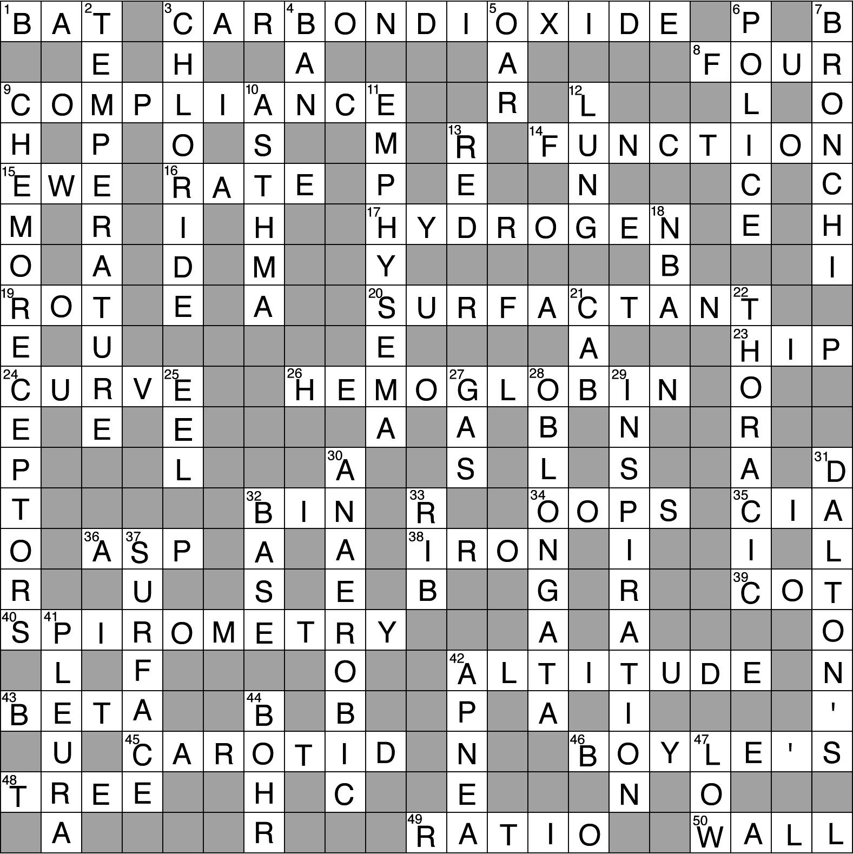
- Crossword Puzzle

