Interfacing GDP/10 With Blackboard – Student View

Prepared by Dr. Jack E. Johnson

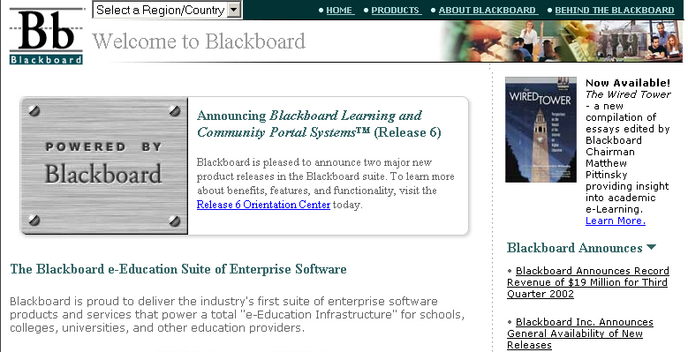
After the student keys in www.blackboard.com, this screen is displayed.

At the bottom right of the screen is a Login link that is clicked to enter the Blackboard login screen. The student clicks Login to enter a username and password.

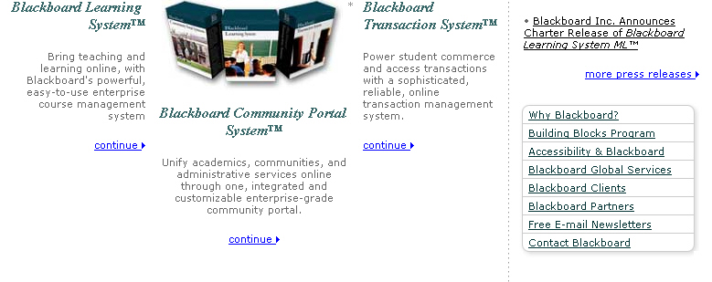

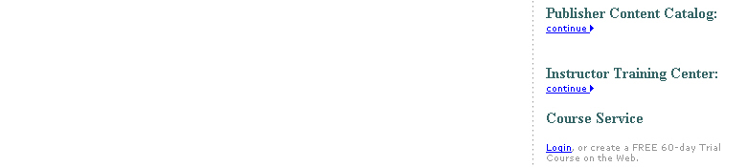

This screen allows the student to type in a Username and Password.

The student is now at a screen that allows a particular course to be accessed.

In the My Courses box, the student clicks on the appropriate class. In this example the class is Keyboarding.

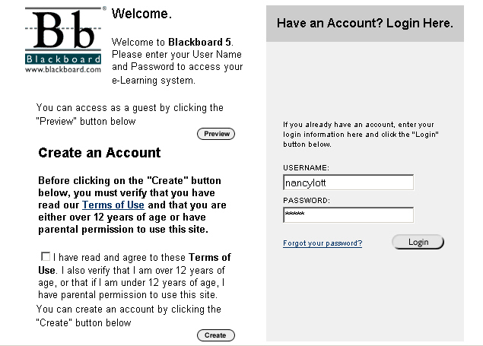

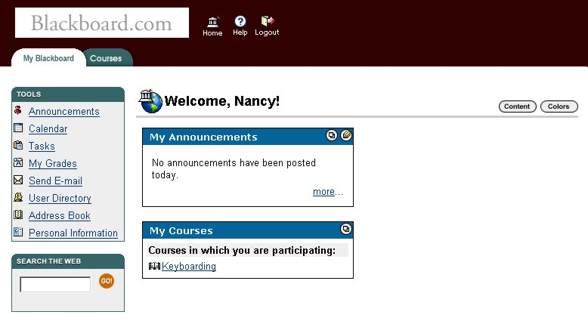

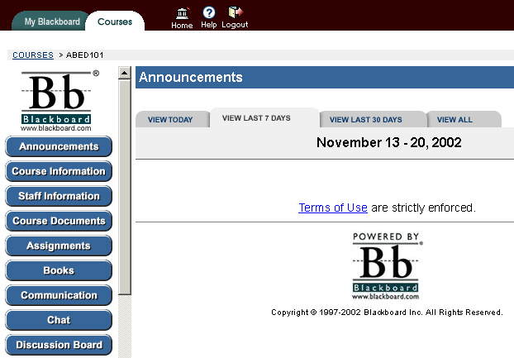
The opening course screen is shown at the right, with options listed in blue in the left panel.

The Tools link is used to access the next screen in Blackboard. The student clicks the Tools link.

On the Tools page, the student has access to all the various actions to be performed in the course.

To access an area where assignments can be uploaded, the student clicks Digital Drop Box.

November 13 – 20, 2005

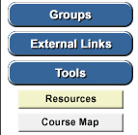

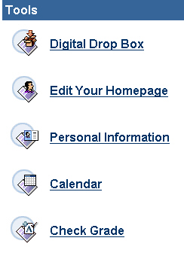

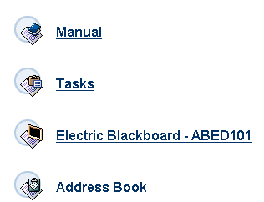

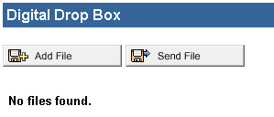
Clicking on Digital Drop Box brings up this screen. In the drop box screen, the student can view which assignments have been completed and are ready to be uploaded to the instructor.

In the example at the right, no assignments have been completed, as indicated by
the No files found message.

To add an assignment—such
as a 12-second timed writing—
to the Drop Box, the student
first clicks Send File.
[Note: Add File places a file in the student’s workspace; Send File places a file in the student’s workspace AND sends it to the instructor.]

Once Send File has been clicked, the File Information screen appears. The student…
- Keys in the title of the activity.
- Browses his/her computer to find the file to be
added to Blackboard.com.

To complete the process, the student clicks Submit.

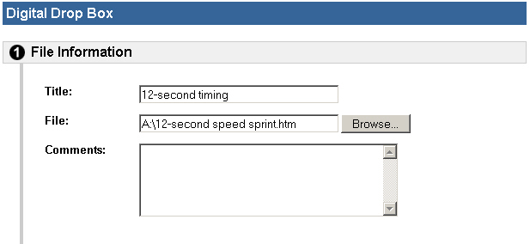

12-second timed writing

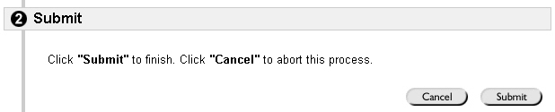

The Digital Drop Box now shows that the 12-second timed writing
has been placed in the student’s workspace and has also been submitted to the instructor.

As each file is sent to the instructor’s website, its identity is added to this screen. The example at the right now shows a 12-second timed writing and a letter that were uploaded to the instructor.

If a student clicks on 12-second timed writing, the work is displayed on the screen, as shown at the right. This report comes directly from the GDP/10 program after being converted to an .htm file when the student clicked Export to HTML at the bottom of the Detailed Report Screen in GDP/10.

If the student clicks on September 27 meeting letter from the Digital Drop Box, the screen at the right appears. This File Download screen lets the student know that he/she is attempting to open a non-.htm file. In this instance, the letter is a Microsoft Word document. The student must click Open
to view the letter.
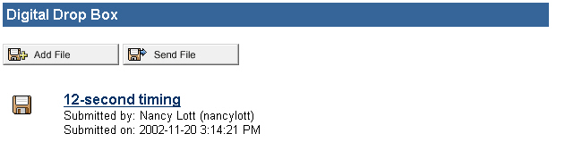

12-second timed writing

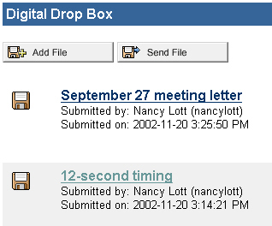

12-second timed writing

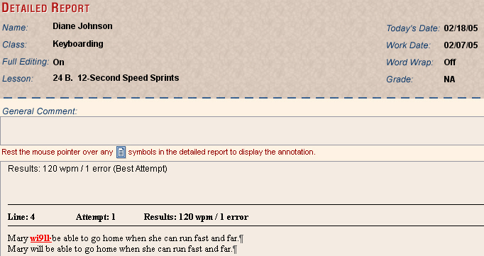

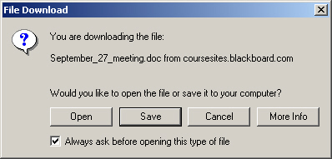

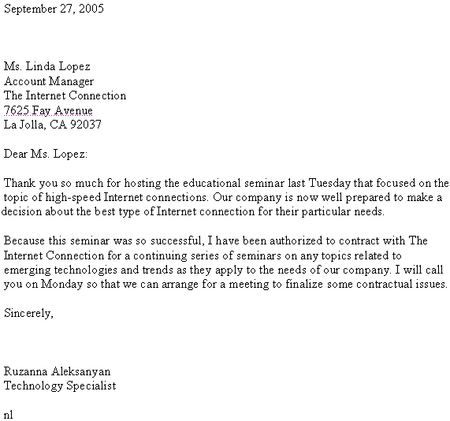

The letter now appears
on the screen as
though the student
were viewing it as a
Word document.

