Chapter  1 | Excel Basics

SOFTWARE OBJECTIVES: In Chapter 1, you will use the software to:

- Start Microsoft Excel.

- Identify parts of the Excel screen.

- Move around the workbook.

- Create a new spreadsheet.

- Enter data on your spreadsheet.

- Clear cell contents, edit data, enter numeric data, and save spreadsheets.

- Format data, resize columns and rows, and insert rows.

- Use page setup.

- Print spreadsheets.

- Complete the exercises and activities in Chapter 1.

WEB OBJECTIVES: In Chapter 1, you will do these Internet activities:

- 1. Go to Microsoft Excel’s website at http://office.microsoft.com/excel.

2. Use your Internet browser to go to the book’s website at www.mhhe.com/yachtexcel.

Comment: Setting a Bookmark

In Chapters 1-16, the web objectives will refer to accessing the book’s website (www.mhhe.com/yachtexcel). Since you are going to use this website in every chapter, you should set a bookmark. Bookmarks help you keep track of websites that are frequently visited. A bookmarked link is saved on your browser for easy access.

Follow these steps to set a bookmark using Internet Explorer 6.0

- Start IE.
- In the “Address” field type www.mhhe.com/yachtexcel.
- From IE’s menu bar, click on Favorites, then Add.
- The “Add Favorite” screen pops up. Click . (If you select , you can create a new folder to save your bookmark.

- Complete the Internet Activities.

Excel 2002 is part of the Microsoft Office XP suite of applications. Excel is an electronic spreadsheet that is used to organize and manipulate numeric data. A spreadsheet is a table of values arranged in rows and columns. Spreadsheets allow users to calculate and correct complicated problems in a fraction of a second. Before the invention of electronic spreadsheets, entire spreadsheets (also known as worksheets) were calculated manually. Electronic spreadsheets allow accountants to save time and be more accurate in their computations.

The ability of spreadsheets to manipulate large amounts of numeric data quickly made them a popular tool; for example, spreadsheets are used by teachers, scientists, engineers, doctors, lawyers, and many other professions.

Excel is one of the most widely used spreadsheet applications. Excel’s basic features are shown in this chapter. As you complete the chapters of this book, you will learn much more about Excel’s capabilities.

GETTING STARTED

Follow these steps to start Excel 2002.

- Start Windows. If Excel is not installed on your computer, refer to Appendix A for installing the software and student data disk that accompanies this textbook.

- There are two ways to start Excel from your Windows desktop.

  - The Windows desktop shows various icons for software applications.


Double-click on the Excel icon to start the application.

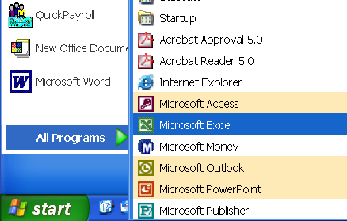
b. Another way to start Excel, is to click on “Start,” then “All Programs” from your Windows taskbar. Double-click on “Microsoft Excel” to start the program. If an application is open, the taskbar identifies the open application with a button. For example, when Excel is open, the taskbar includes a button.

The All Programs list may differ depending on your computer’s configuration. This illustration shows one possible All Programs list; yours will probably differ.

Comment

If you are using an earlier version of Windows (for example, Windows 98 or Windows 95), from your Windows desktop, click on "Start," "Programs," then "Excel." (In this book, the screen illustrations are done with Excel 2002 and Windows XP.) Some differences may occur between the screen illustrations in the text and the ones shown on your screen.

- A “Microsoft Excel – Book1” screen appears. Compare your screen to the one shown below. (Your screen’s toolbars may differ. This is OK; continue with the next section. On page 13, toolbar options are explained in more detail.)
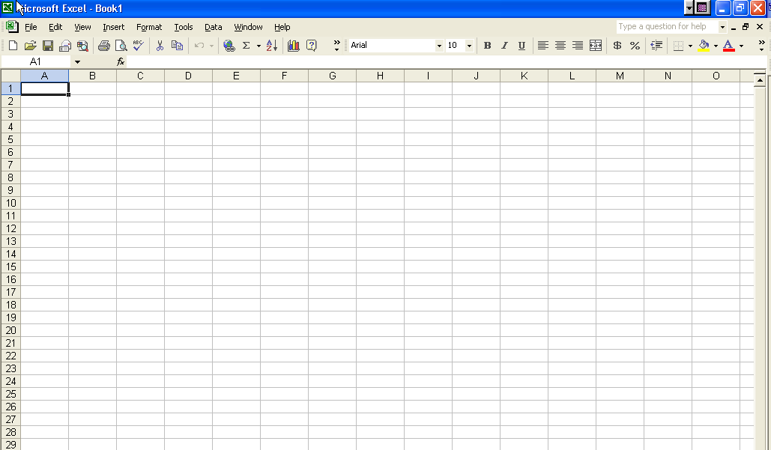

IDENTIFY PARTS OF THE SCREEN

You will begin using Excel with a new workbook. Excel calls the blank screen a workbook. In Excel 2002, the default workbook consists of three sheets. Each sheet is referred to as a spreadsheet or a worksheet. The term spreadsheet and worksheet are used interchangeably.

Comment

There are a couple of ways to begin a new workbook. Using Office XP, you can select “New Office Document” from the “Start” menu, then select “Blank Workbook.” A more common way is to click on the Excel icon from your Windows desktop or select “Start,” then “Microsoft Excel” from the programs list.

In Excel 2002, the default screen appears similar to this one.
1) Title Bar
2) Menu Bar

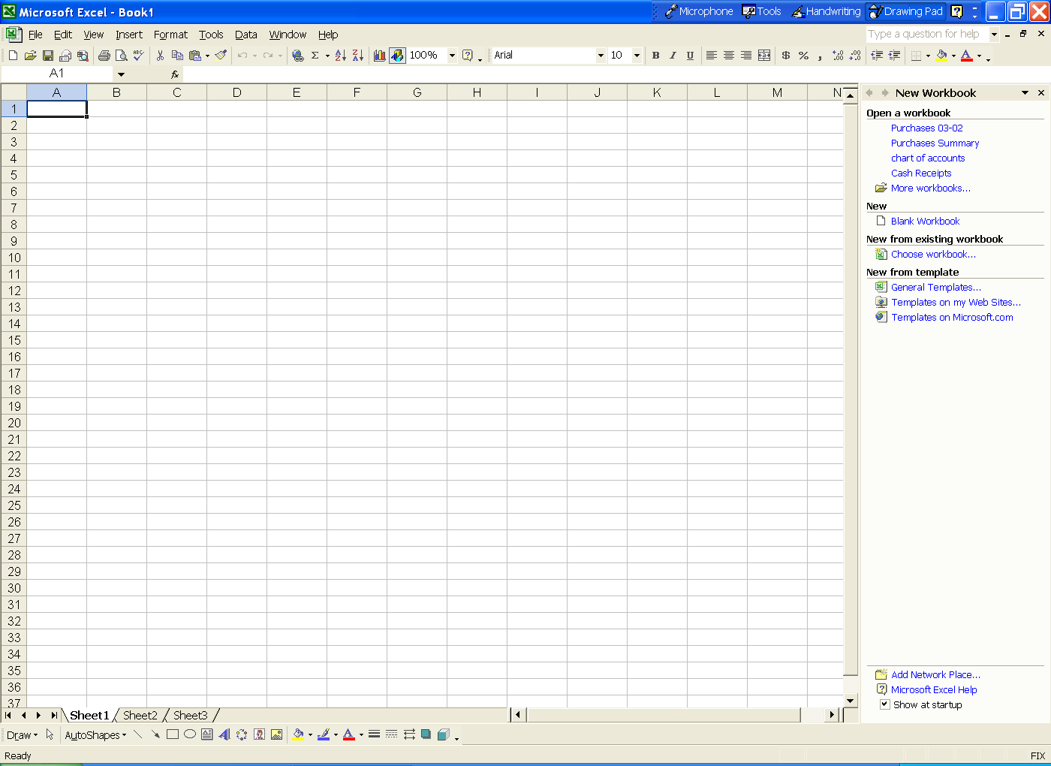
3) Toolbar
6) Formula bar
7) Column Header
4) Name box
5) Active Cell
9) Vertical scroll bar
8) Row Header
10) Task pane
12) Sheet tab
11) Horizontal scroll bar bbar
13) Status bar
14) Drawing toolbar

1) The title bar displays the name of the application and the name of the file being viewed. When you open a new workbook in Excel, the title bar will display “Microsoft Excel – Book1.” Below the title bar is the menu bar.

2) The menu bar has nine selections: File, Edit, View, Insert, Format, Tools, Data, Window, and Help. As you complete this book, each one of these selections will be studied in more detail.

3) Below the menu bar is the toolbar. The toolbar has icons and buttons that allow the user to perform common tasks by clicking on one of the buttons; for example, clicking on the open folder allows you to open a file or workbook. Excel normally displays a standard toolbar and a formatting toolbar. The standard toolbar displays common tasks such as opening or saving a file, printing, copying and pasting. The formatting toolbar displays formatting tasks that affect the appearance of the document. Remember, toolbars can be customized so your screen’s toolbar may look different.

4) The next row down contains the name box. The name box contains information about the selected cell.

5) The active cell is identified by the column and row coordinate; for example, the callout is pointing to vertical column A, and horizontal row 1.

6) The formula bar displays the content of the selected cell.

7) The column header is identified by alphabetic characters: A, B, C, D, etc.

8) The row header is identified by numbers.

9) The vertical scroll bar allows you to move up and down the spreadsheet.

10) In Windows XP, the task pane appears automatically when you start Excel. The task pane lists the last spreadsheet(s) saved and other frequently used features. The task pane can be closed by clicking on the “X” on the “New Workbook” title bar.

11) The horizontal scroll bar allows you to move across the spreadsheet.

12) The sheet tab identifies which worksheet you are using. Excel includes three sheet tabs for each workbook. Think of the sheet tabs as subsidiary (or secondary) workbooks related to the first worksheet or spreadsheet created. The sheet tabs at the bottom of the screen allow the user to select different sheets to view. Just as a book has pages, an Excel workbook has different spreadsheets.

13) The status bar includes information about applications that are open, the time and date, and other Windows-related information. The status bar on the illustrated spreadsheet displays “Ready.”

14) The drawing toolbar allows you to select various shapes that can be added to your spreadsheet.

MOVING AROUND IN A WORKBOOK

You can move around a spreadsheet using either the mouse or the keyboard. Using the mouse, you can click in a cell or click on the scroll bar to scroll up and down or right and left. If using the mouse is not convenient, you may also move around using the arrow keys on the keyboard, or combinations of certain keys. The following table shows the keys you can use to move around in a spreadsheet.

Keys | Action
<Home> | Moves to column A of the current row.
<Ctrl>+<Home> | Moves to cell A1. (Upper left cell of spreadsheet)
<Ctrl>+<End> | Moves to the lower right cell in a spreadsheet.
<Page Up> | Moves the active cell up one full window.
<Page Down> | Moves the active cell down one full window.
<Tab> | Moves the active cell one cell to the right.
<Shift>+<Tab> | Moves the active cell one cell to the left.
<Alt>+<Page Down> | Moves the active cell one window to the right.
<Alt>+<Page Up> | Moves the active cell one window to the left.
<End>+<Arrow key> | If you are in a blank cell, this will move to the next filled cell in the direction of the arrow key. If you are in a filled cell, this will move to the next blank cell in the direction of the arrow key.

ENTERING DATA

If you do not have a new workbook open, open one now by clicking on "Excel" from the "Start" menu. You are going to create a quarterly budget for Mike’s Surf and Sea.

Before you begin developing a new spreadsheet, you should have a plan. You should know what data you need to input, the calculations you will have to make, and a general idea of what you want your output to be.

Entering Text

Follow these steps to type data into your Excel spreadsheet. Boldface characters indicate the word or words that you should type.

1. Type Mike’s Surf and Sea in cell A1. Press the <Enter> key or the down arrow to go to cell A2.

- Type Budgeted Income Statement in cell A2. Press the <Enter> key or the down arrow to go to cell A3.

- Type for the year ended 2002 in cell A3. Press the <Enter> key three times to go to cell A6.

- Use your right-arrow or cursor to go to cell B6. Type January in cell B6. Press the <Enter> key two times to go to cell B8. Use the left-arrow key to go to cell A8.

- Type Revenues in cell A8, then press <Enter>.

- Type Salaries in cell A9, then press <Enter>.

- Type Rent in cell A10, then press <Enter>.

- Type Utilities in cell A11, then press <Enter>.

- Type Total Expenses in cell A12, then press <Enter>.

- Type Net Income in cell A13, then press <Enter>. Your cursor is in cell A14. Compare your screen with the one shown below.
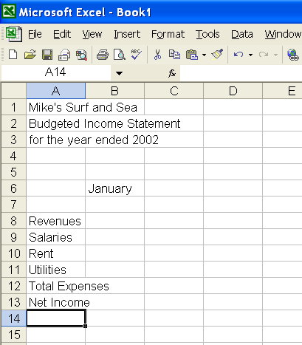

Clearing Cell Contents

After reviewing your spreadsheet, you realize that you want the columns to be quarters rather than months. In cell B6, you have typed the month of January. Instead of January you want to identify the columns by quarters.

In Excel, there are usually two or three different ways to do things. One way to clear cell contents is to right click on the cell and select “Clear Contents.” Another way is to click on the cell and press the <Delete> key.

Follow these steps to clear the cell’s contents using the <Delete> key.

- Move your cursor to cell B6 and press the <Delete> key.
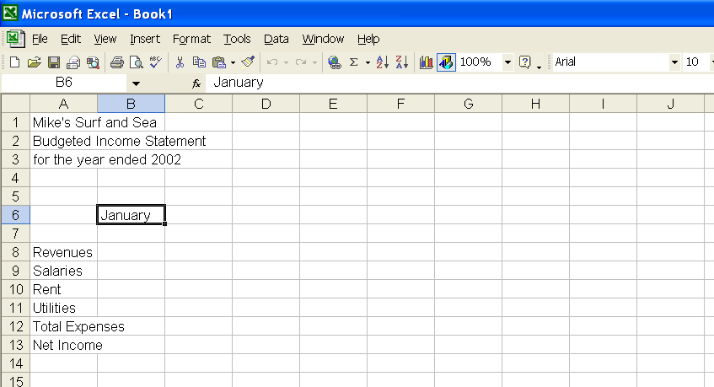

Click on cell B6, then press the <Delete> key.

2.
The contents of cell B6 are deleted.

Using Undo or Redo

After deleting January from cell B6, you realize that you did not want to clear the cell’s contents. Here are three ways to undo a previous action in Excel.

● Click on the Undo button on the toolbar (or select Edit, Undo Clear). (Hint: The toolbar has Excel’s icons.)

● Or, Use the shortcut keystroke <Ctrl+Z>.

● From the menu bar, click on Edit, then select Undo Clear.

1. After selecting Undo button , the label “January” returns to cell B6. Since you want to delete it, click on the Redo button (or select Edit, then Redo Clear). The label “January” is now removed from cell B6.

Comment: What if my toolbar does not show the Redo button?
If your toolbar does not show the Redo button , from the menu bar, select View, then Toolbars. Make sure that “Standard” has a checkmark next to it.

Here are the steps for checking that your toolbar includes the buttons used in this chapter.
- Click on the “Toolbar Options” button 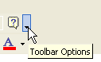.
- A list drops down. Select Add or Remove Buttons, then “Standard.” Make sure that your screen shows the same checkmarks as the ones shown below.

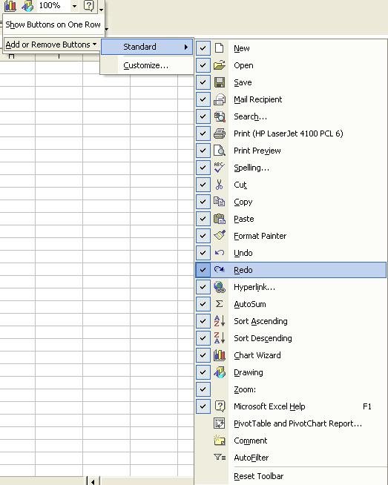

3. When you are finished, press the <Esc> key three times.
- Since you want to display quarters instead of months, type Quarter 1 in cell B6.

Editing Data

There is more than one way to edit data, too. You can replace the entire contents of a cell by simply selecting the cell and typing the new data. Or, you can edit data by selecting the cell and editing the data in the formula bar. Let’s say you want to replace the label “Salaries” with “Wages.”

- Go to cell A9. Notice that “Salaries” is shown in two places: the formula bar and cell A9.

- With your cursor in cell A9, type Wages. Observe that the formula bar also changed to “Wages.” Press the <Enter> key.

Another way to perform the same thing would be to go to cell A9, then click on the “formula bar” and delete the word “Salaries.” Then, type the word “Wages” on the formula bar. Once you press the <Enter> key, the contents of cell A9 is changed from “Salaries” to “Wages.”

Using AutoFill

You can quickly fill in a series of data by selecting the cell and dragging the fill handle. The fill handle is the black square in the bottom right corner of the cell selector. To see how this works, follow these steps.

- Go to cell B6. Click on the fill handle (little box at bottom right corner of rectangle) and drag it with your cursor to cell F6.
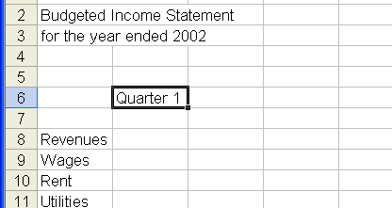

Click on the fill handle and drag to cell F6.

Notice that Excel has determined that you are using a series of quarters. Once you reach the end of the series (Quarter 4), Excel begins the series again (with Quarter 1).

- Replace the data in cell F6 with Total. Compare your spreadsheet to the one shown below.

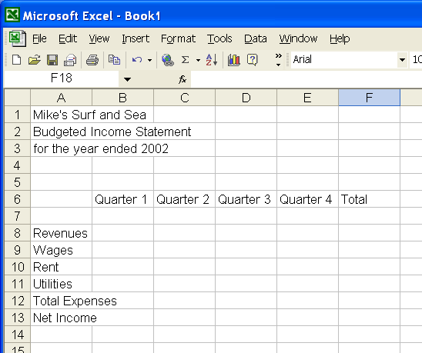

Adding Numeric Data

Follow these steps to add numeric data to your spreadsheet.

- Type 150 in cell B8, then press <Enter>.

- Type 25 in cell B9, then press <Enter>.

- Type 10 in cell B10, then press <Enter>.

- Type 5 in cell B11, then press <Enter> three times. Compare your spreadsheet with the one shown on the next page.
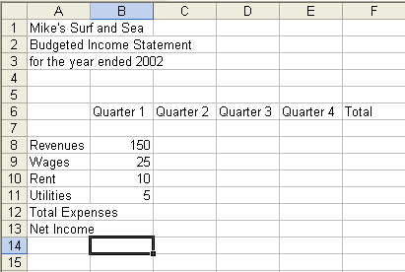

SAVING A FILE

- Follow these steps to save your file to a floppy disk. You can also save to a network location, hard drive, or other media.

- Insert a floppy disk into the floppy drive (usually drive A).

- Click on the save icon. The “Save As” dialog box appears.

- Select from the “Save in” field. Note, if you are saving to a location other than the My Documents folder, you must select the location here before saving.
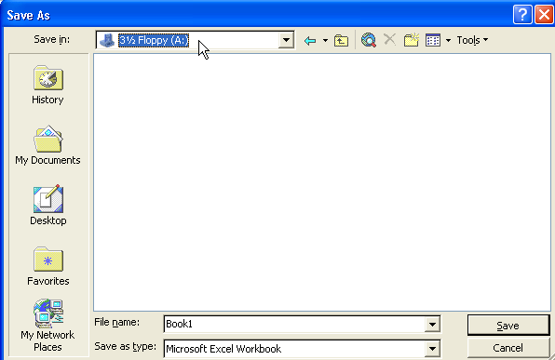

4. Type Budgeted Income Stmt in the “File name” field.

Compare your screen with the one shown below.

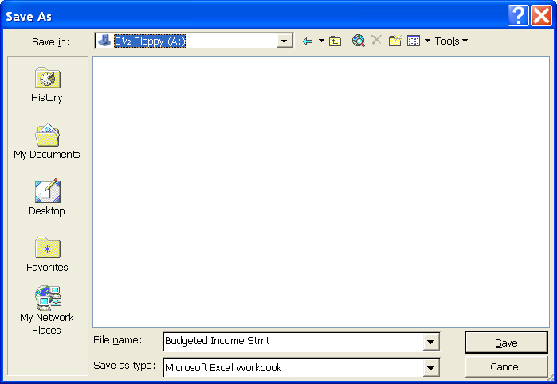

Observe that your are saving to a floppy disk in drive A and that the file name is “Budgeted Income Stmt.”

- Click 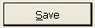 or press <Enter>. Your file is now saved as “Budgeted Income Stmt.”

FORMATTING DATA

Excel spreadsheets are very flexible. You can change the way they look by changing the font type, font size, font color, alignment of columns, etc. Excel includes a formatting toolbar for that purpose. The illustration below shows Excel’s formatting toolbar.
Increase/Decrease Indent
Font Size
Alignment
Fill Color

Font
Number Formatting
Borders

Bold, Italics, Underline
Font Color

Let’s examine this illustration. Starting from the left side, notice that the “Font Size” is “10.” There are numerous font size selections. “Alignment” has three selections: left justified, centered, right justified. “Increase/Decrease Indent” is just that – you can increase or decrease indentations. The “Fill Color” is indicated by a bucket. “The Font” is “Arial.” There are numerous font selections. The “B,” “I,” and “U” indicate bold, italics or underline choices. “Number Formatting” choices include $, %, etc. “Borders” can be changed, as well as the “Font Color."

Let’s begin by centering, bolding and underlining the column headings.

- Highlight cells B6 through F6. (Hint: Put your mouse in B6, then holding the left-mouse button highlight cells B6:F6. Or, you can click cell B6, then use <Shift>+<→> to highlight cells B6:F6.)

- Click on the Center button.

- Click on the Bold button.

- Open the Borders drop down list by clicking on the arrow next to the “Borders” button.
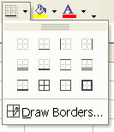
- Select the Bottom Border button (first row, second column).

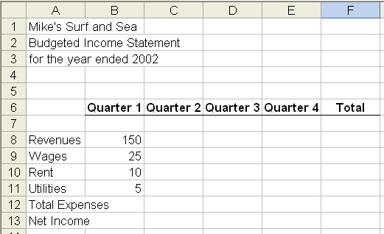

Next, you will format the Title information so that it is centered across the spreadsheet.

- Highlight cell A1 through F1.

- Click on the Merge and Center button. “Mike’s Surf and Sea” is now centered across cells A1 through F1, and the cells have been merged into one cell.

- Click on the Bold button.

- Change the font size to 18 points. The formatting toolbar should look now like this.

- Format row 2 with Merge and Center, Bold and 14-point font size.

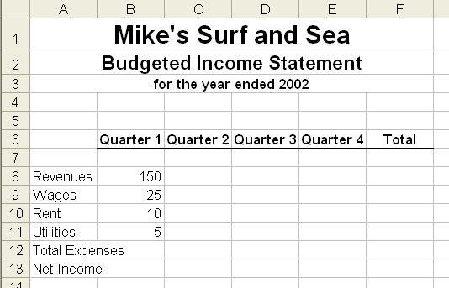
- Format row 3 with Merge and Center, and Bold. Compare your screen to the one shown below.

Resizing Columns and Rows
You may want to resize the columns and rows on your spreadsheet. Follow the steps in the next section which describes how to insert columns and rows.

Inserting Columns and Rows

Whenever you insert columns and rows, keep in mind that Excel will insert columns to the left of the highlighted column and above the highlighted row. To insert a column or row, right-click on the column or row header and select Insert.

The following steps will help you insert a row between “Revenues” (row 8) and “Wages” (row 9).

- Right-click on the row 9 header, “Wages.” A pop-up menu appears. Compare your screen with the one shown on the next page.

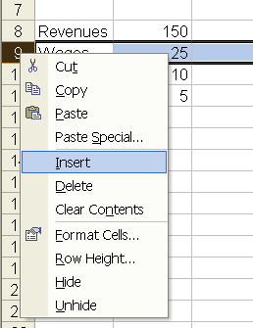

- Select Insert. The “Insert” screen pops up. Select Entire row, then click on <OK>. (Hint: Observe that there is also a selection for inserting a column. In this example, you are inserting a row.)

- A blank row is inserted after row 8. The former row 9 is now row 10.

- Move your cursor over the boundary between the column headers A and B (the gray letters at the top of row 1). Observe that the cursor changes to a cross bar. Double click the boundary. Column A automatically widens to the longest cell in column A.
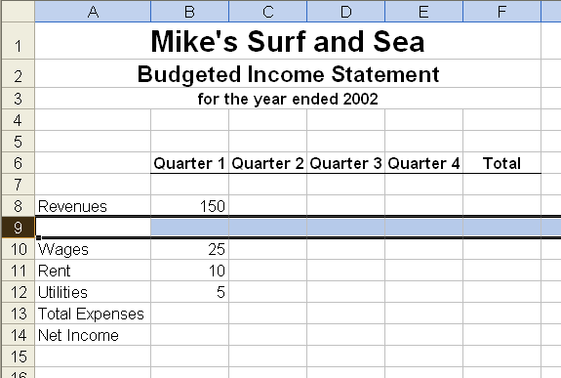

USING PAGE SETUP

Before printing your spreadsheet, you should make sure it will print properly. Follow these steps to preview your spreadsheet before you print it.

- To view your document, click on the Print Preview button. This will allow you to see how your document will print.

- Click on the Setup button to go to the Page Setup dialog box. The first time you do this, the Page tab will be highlighted.

Page Tab

The page tab will allow you to control the orientation of the printed page as well as how many pages you print. Compare your screen to the one shown below.

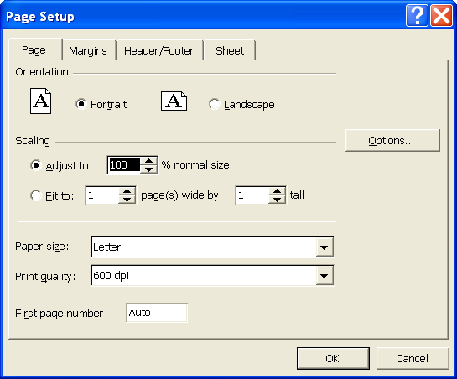

The “Scaling” section allows you to change the size of the spreadsheet. For example, if your spreadsheet is a little too large to print on one page, you can reduce the spreadsheet to a smaller percentage of its original size. Generally, it is not a good idea to reduce the size of the spreadsheet to less than 80% of its original size or the data may be too small for many readers. The “Adjust to” field on your page should show “100% normal size.”

You can also choose how many pages to print; for example, if you want to print your spreadsheet on only one page, select the “Fit to” radio button and change the pages to one page wide by one page tall.

The last section controls the Paper size and Print quality. If you are printing on a letter size paper, you should leave this section alone.

Margins Tab

1. Click on the “Margins” tab and this screen appears.

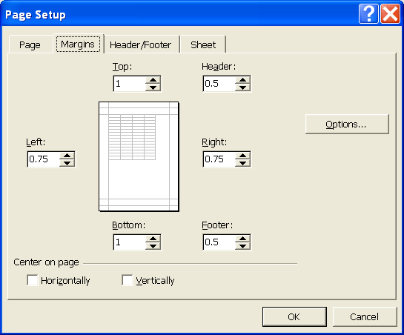

The Margins tab allows you to control the margins on the page. You can also choose to center your spreadsheet horizontally and/or vertically.

- On most documents, you will want to center horizontally on the page. To do this, click on the box to the left of “Horizontally” to place a checkmark in it.
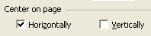

Header/Footer Tab

- Click on the “Header/Footer” tab. This tab controls what prints in the header and footer sections of each page. You can select from preformatted headers and footers by clicking on the dropdown list for the header or footer.

If you do not want to use any of the preformatted headers or footers, you may enter information by selecting either the 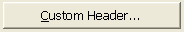 or buttons.

2. Click on the Custom Header button. The Header dialog box appears. The Footer dialog box is similar to the Header dialog box. Compare your screen to the following image.
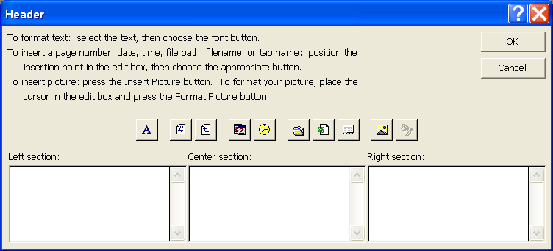

Notice that the box has three sections in it. Everything in the Left section will print on the upper left side of the page with the text being left aligned. Text in the Center section will print in the upper center of the page and will be center aligned. Text in the Right section will be appearing on the upper right and be right aligned.

The buttons in this dialog box will allow you to format the data in each section or insert commands.

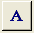 | Displays the Fonts dialog box.
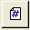 | Inserts page numbers.
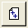 | Inserts the total number of pages.
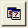 | Inserts the date.
 | Inserts the time.
 | Inserts the path and file name.
 | Inserts the file name.
 | Inserts the sheet name.
 | Displays the Insert Picture dialog box.
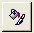 | Displays the Format Picture dialog box.

3. Click on “Cancel” to return to the Page Setup dialog box.

Sheet Tab

1. Click on the “Sheet” tab. The sheet tab allows you to control what prints on each page.
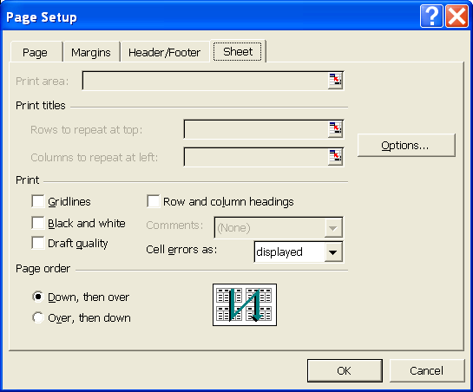

The “Print area” allows you to print certain cells or a range of cells.
In the screen illustration above, the “Print area” is grayed out. This indicates it is inactive.

The “Print titles” area will print the same rows or columns on every page.

In the “Print” area, notice that there are a number of check boxes.

Gridlines – allows you to print the horizontal and vertical gridlines.

Black and white – if you are using a black and white printer and have color objects in your spreadsheet, you should check this box.

Draft quality – allows faster printing. This will not print gridlines and graphics.

Row and column headings – selecting this box will print row numbers (1, 2, 3…) and the column letters (A, B, C…).

Comments – this controls how the spreadsheet comments will be displayed.

Cell errors as – sometimes, your screen may display errors. “Cell errors as” controls how these errors are displayed.

2. Click on “Cancel.”

PRINTING

Before printing, it is a good idea to save your document. Follow these steps to save your spreadsheet.

- If your print preview screen is displayed, click on “Close.”

- From the menu bar, select File, Save As.

- Make sure that the Save in field shows “3½ Floppy (A:).”

- Highlight “Budgeted Income Stmt.”
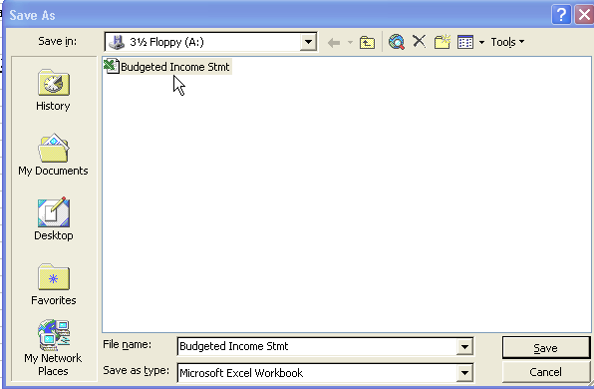

- Click on Save. A “Microsoft Excel” warning screen pops up.

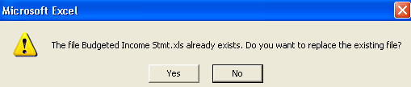

- Read the information on this screen, then click on “Yes.” Your spreadsheet is saved to the disk in drive A.

Checklist Before Printing

You should always use “Print Preview” before printing any document. Follow these steps to do that.

- Click on the “Print Preview” button.

- Click on the Setup button and perform the following tasks:

- If necessary, click on the “Page” tab. Make sure scaling to print is set at 100% of normal size.

- Click on the “Margins” tab. Center horizontally on the page.

- Click on the “Header/Footer” tab. Select Custom Header.

- Type your name in the Left section.

- Insert the spreadsheet’s file name in the Center section. (Hint: the name of this file is “Budgeted Income Stmt.”)

- Insert today’s date in the Right section using the date button.

- Click 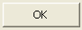 in the Header dialog box.

- Click in the Page Setup screen.

Your spreadsheet should now look like the one shown below. (Your date will differ from the one shown.)

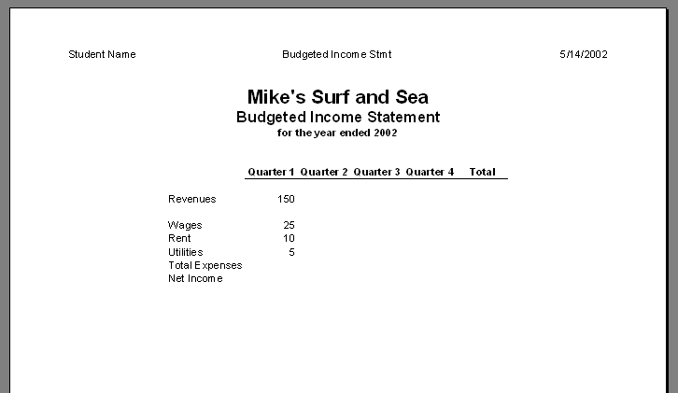

- Click on the Close button.

- Click on the Save button now. Notice that the file is automatically saved to your floppy disk in drive A. The file name and drive was selected on pages 26 and 27, steps 4 and 5.

- Click on the Print button. Your spreadsheet starts to print. Compare it to the one shown above.

- Click on File, Exit to exit Excel.

INTERNET ACTIVITIES
The Internet is a worldwide electronic communication network that allows for the sharing of information. The World Wide Web (WWW) or Web is a way of accessing information over the Internet. To read about the differences between the Internet and the Web, go to www.webopedia.com/DidYouKnow/Internet/2002/Web_vs_Internet.asp.

To make an Internet connection, your computer must be equipped with a modem. The word modem is an abbreviation of Modulator/Demodulator. A modem is a device that translates the digital signals from your computer into analog signals that can travel over telephone lines. There are also wireless radio modems, cable modems, DSL (digital subscriber lines), and T-1 lines for faster connections.

Websites are time and date sensitive. When using the Internet, be aware that changes are the rule.
1. | From your Internet browser, go to the textbook’s website at www.mhhe.com/yachtexcel. Go to the student link.
2. | Link to Internet Activities, then WEB EXERCISES, PART 1 – Chapter 1.
3. | Complete the ACCOUNTINGWEB activity at www.accountingweb.com.
4. | Access this website http://office.microsoft.com/excel.
5. | For purposes of this assignment, go to two links from the Excel website; Using a word processing program, write a summary about the links you selected. Include the website address of each link. Your summary should be no more than 75 words or less than 50 words.
SUMMARY AND REVIEW: In Chapter 1, you used the software to:

- Start Microsoft Excel.

- Identify parts of the Excel screen.

- Move around the workbook.

- Create a new spreadsheet.

- Enter data on your spreadsheet.

- Clear cell contents, edit data, enter numeric data, and save spreadsheets.

- Format data, resize columns and rows, and insert rows.

- Use page setup.

- Print spreadsheets.

- Complete the exercises and activities in Chapter 1.

WEB OBJECTIVES: In Chapter 1, you did these Internet activities:

- 1. Went to Microsoft Excel’s website at http://office.microsoft.com/excel.

2. Used your Internet browser to go to the book’s website at www.mhhe.com/yachtexcel.

Multiple-Choice Questions: In the space provided, write the letter that best answers each question. You may refer to the textbook to complete these questions.

_____1. The website for Excel Accounting is:

  - http://office.microsoft.com/excel.
  - www.mhhe.com/business/accounting.
  - www.accountingweb.com.
  - www.mhhe.com/yachtexcel.
  - None of the above.
_____2. Electronic spreadsheets are used to:

a. Organize word processing documents.
b. Complete application utilities.
c. Organize and manipulate numeric data.
d. Access work-related websites for research.
e. None of the above.

_____3. An advantage of using an Excel spreadsheet is that complicated data is:

  - Calculated quickly.
  - Organized in an attractive way.
  - Able to be reformatted.
  - All of the above.
  - None of the above.

_____4. The name of the application and the name of the file being viewed is shown on the:

- Toolbar.
- Menu bar.
- Active cell.
- Title bar.
- None of the above.

_____5. Information about a selected cell is found in the:

- Toolbar.
- Menu bar.
- Name box.
- Active cell.
- None of the above.

_____6. The coordinate of a column and row, for example, A1, is known as the:

- Active cell.
- Name box.
- Formula bar.
- Task pane.
- None of the above.

_____7. The column header is identified by a/an:

- Numeric character.
- Alphabetic character.
- Alphanumeric character.
- Coordinate of a column and row.
- None of the above.

_____8. The row header is identified by a/an:

- Numeric character.
- Alphabetic character.
- Alphanumeric character.
- Coordinate of a column and row.
- None of the above.

_____9. You can add shapes to your spreadsheet by selecting the:

- Toolbar.
- Vertical scroll bar.
- Drawing toolbar.
- Horizontal scroll bar.
- None of the above.

____10. Information about which applications are open; for example, the time and date, and other Windows-related information, can be found on the:

- Toolbar.
- Taskbar.
- Scroll bar(s).
- Formula bar.
- None of the above.

True/Make True: If the statement is true, write the word “True” in the space provided. If the statement is not true, write a correct statement in the space provided. You may refer to the textbook to complete these questions.

- Spreadsheets allow users to calculate and correct complicated problems in a fraction of a second.

___________________________________________________

___________________________________________________

12. The Budgeted Income Statement developed in this chapter is for the first four months of the year.

___________________________________________________

___________________________________________________

- Use the “Redo” button to undelete an item from a cell.

___________________________________________________

___________________________________________________
- You cannot format numeric and alphabetic data on an Excel spreadsheet.

___________________________________________________

___________________________________________________

- Before printing your spreadsheet, you should preview it, and then save your file.

___________________________________________________

___________________________________________________

16. From the “Setup” selection, use the “Page” tab to add a header to your spreadsheet.

___________________________________________________

___________________________________________________

- Use “Sheet” tab to change the margins of your spreadsheet.

___________________________________________________

___________________________________________________

18. In the first quarter, the utilities are 5.

___________________________________________________

___________________________________________________

  - In the first quarter, the rent is 25.

___________________________________________________

___________________________________________________

  - In the second quarter the wages are 25.

___________________________________________________

___________________________________________________

Exercise 1-1: Follow the instructions below to complete Exercise 1-1.

  - Use the following data to create a spreadsheet for Carol’s Surf Shop.

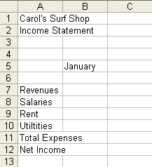

  - Change “Salaries” to “Wages.”

  - AutoFill cells B5 through F5 with months.

  - Replace the data in cell F5 with Total.

  - Either save your spreadsheet to drive A, or continue with Exercise 1-2. If you are saving the file, use Exercise 1-1 as the file name. If you are not continuing with Exercise 1-2, save then exit.

Exercise 1-2

If you saved Exercise 1-1 and exited, follow these steps:

- Start Excel.
- Put your disk in drive A.
- Click on the Open button.
- Select drive A.
- Highlight “Exercise 1-1,” then click on Open. Your Exercise 1-1 spreadsheet appears.

1. Add the following data:

Cell B7: 200
Cell B8: 50
Cell B9: 15
Cell B10: 9

- Boldface, center, and underline cells B5 through F5.

- Insert a row between cell B7 and B8.

- Either continue with Exercise 1-3 or save your spreadsheet. Use Exercise 1-2 as the file name.

Exercise 1-3

- If necessary open Exercise 1-2, then continue.

- In cells A1 and A2, change the font size to 18; boldface; and merge and center over columns A through F.

- Preview your spreadsheet to make sure that the information is correct.

- Save or continue. Use Exercise 1-3 as the file name.

Exercise 1-4

- If necessary open Exercise 1-3, then continue.

- Add the following header information:

Left section: Your Name
Center section: Exercise 1-4
Right section: Today’s Date

- Make the selection to horizontally center your spreadsheet.

- Preview, then save your spreadsheet to a floppy disk in drive A. Use Exercise 1-4 as the file name.

- Print your spreadsheet.
CHAPTER 1 INDEX

Active cell 8, 9
Adding numeric data 15
Bookmark 4
Checklist before printing 27
Clearing cell contents 11
Column header 8, 32
Drawing toolbar 9
Editing data 14
Entering data 10
Entering text 10
Fill handle 14
Formatting data 18
Formula bar 8, 14
Getting started 5
Header/footer tab 24
Horizontal scroll bar 8
Identify parts of the screen 6
Inserting columns and rows 20
Internet activities 29
Margins tab 23
Menu bar 7, 12, 13, 26
Modem 29
Moving around in a workbook 9
Name box 8
Numbered rows 8
Page tab 22
Printing 26
Resizing columns and rows 20
Row header 8, 20
Saving a file 16
Sheet tab 8, 25
Task pane 8
Taskbar 5, 9
Title bar 7, 8
Toolbar 7, 9, 12, 13, 18, 20
Using AutoFill 14
Using page setup 22
Using undo or redo 12
Vertical scroll bar 8
Workbook 3, 6, 7, 8, 10, 30
World wide web 29

?Words that are boldfaced and italicized are defined in the Glossary. The Glossary is on the textbook’s website at www.mhhe.com/yachtexcel.
?The less-than (<) and greater-than (>) signs around a word indicate individual keys on the keyboard; for example, <Home> for the “Home” key; <Ctrl> for the “Ctrl” key; <Page Up> for the “Page Up” key, etc.

