POWERPOINT 2003 TUTORIAL

INTRODUCTION
This tutorial supplements the discussion of PowerPoint on pages 349-369 of your textbook.
After reviewing the basics of getting started in PowerPoint 2003, the tutorial provides step-by-step instructions for inserting text, images, and sounds onto slides; for formatting slides; and for enhancing slides with special features such as animation and transitions.
You can read the instructions through from beginning to end, or you can access particular sections through the table of contents at the beginning of the tutorial. In either case, try to practice the instructions as we discuss them. This will take extra time, but it’s a surefire way to learn the fundamentals of PowerPoint 2003.
Table of Contents

POWERPOINT 2003 TUTORIAL

INTRODUCTION

GETTING STARTED

Opening PowerPoint 2003

PowerPoint 2003 Screen Elements

Templates

Slide Layouts

Creating a New Slide

Saving Your Work

INSERTING TEXT, IMAGES, AND SOUNDS

Text

Photographs

Clip Art

Graphs

Sounds

Video

Copyright Credits

FORMATTING SLIDES

Adjusting Color

Adjusting Fonts

Sizing and Spacing Objects

Adding Animation

Creating Transitions

Inserting Blank Slides

SHOWING YOUR SLIDES

GETTING STARTED

Opening PowerPoint 2003
To open PowerPoint for the first time, click the Start button and select Programs. Find Microsoft PowerPoint in the list of programs and click on it. (To save time in the future, you can create a PowerPoint icon that will appear on your computer’s desktop. You can then open PowerPoint simply by clicking on the icon.)

Return to Contents

PowerPoint 2003 Screen Elements
If you have not used PowerPoint 2003 before, you should take a moment to familiarize yourself with its screen elements. Figure 1 identifies these elements.
- Menu Bar: Located at the top of your screen, the menu bar helps you perform major functions such as opening and closing presentations, choosing fonts, inserting images, and viewing slides. When you click the boxes on the menu bar, drop-down menus appear with more choices.
- Upper Tool Bar: The upper tool bar appears just below the menu bar. It provides shortcuts that help you perform such tasks as creating new slides, adding bold or italicized text, undoing your previous action, and saving your work.
- Lower Tool Bar: The lower tool bar stretches across the bottom of the screen. Among the items on this bar are three View buttons with icons just above Draw in the lower-left-hand corner. These buttons allow you to move instantaneously among different views of your presentation. If you place your mouse pointer on each button, a sign will appear identifying the button’s function. The lower tool bar also includes shortcuts for such functions as adding text boxes, charts, clip art, and color.
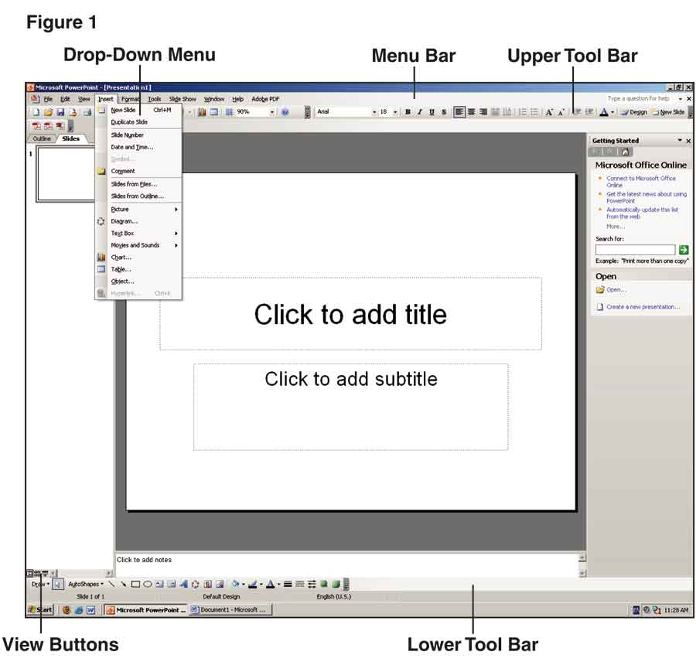
When you open PowerPoint 2003, the main part of the screen will default to what PowerPoint calls Normal view. As illustrated in Figure 2, this view is divided into three areas.
- The center area displays your current slide.
- On the left is a task pane that allows you to switch between viewing an outline of all your slides and thumbnails of the slides.
- On the right is a task pane that provides tools for getting started. The vertical arrow to the right of Getting Started exposes a drop-down menu that allows you to perform a number of additional tasks. (Some PowerPoint commands will cause the task pane to disappear. If this happens, click View in the menu bar and select Task Pane from the drop-down menu.)
Return to Contents
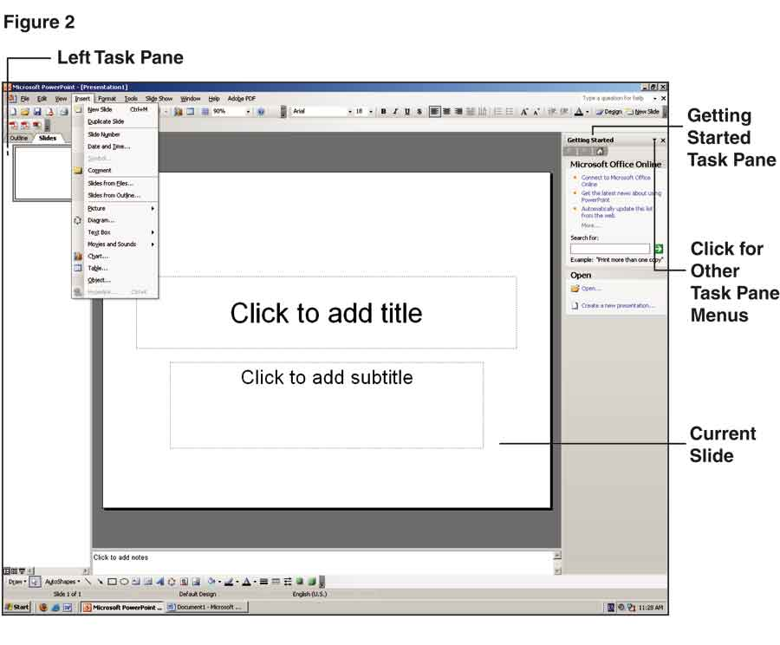

Templates
When you open PowerPoint 2003, click the vertical arrow to the right of Getting Started in the task pane on the right of your screen and select New Presentation. You will then see three methods for creating a presentation: Blank Presentation, From Design Template, and From AutoContent Wizard (Figure 3).

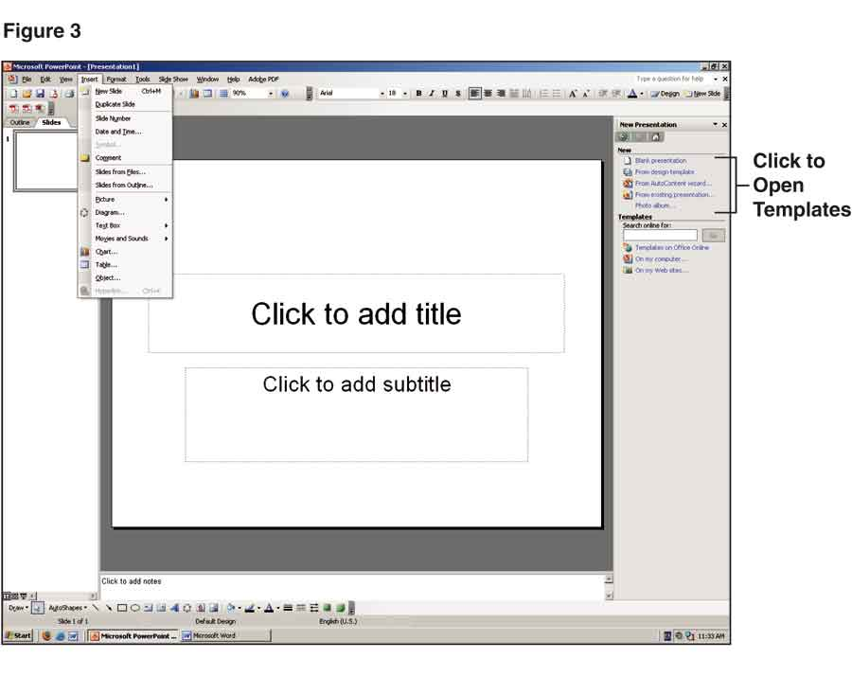
When you choose Blank Presentation, you start with a white background on your slides, which you can easily change if you desire. You can also adjust all the other elements of your slides to get the exact look you want.
The Design Template option generates a presentation in which all the slides are unified by a preselected combination of colors, fonts, and graphics. When you choose Design Template, thumbnails of sample templates appear in the task pane on the right of the screen (Figure 4). Click any template to preview it in the main part of your screen.

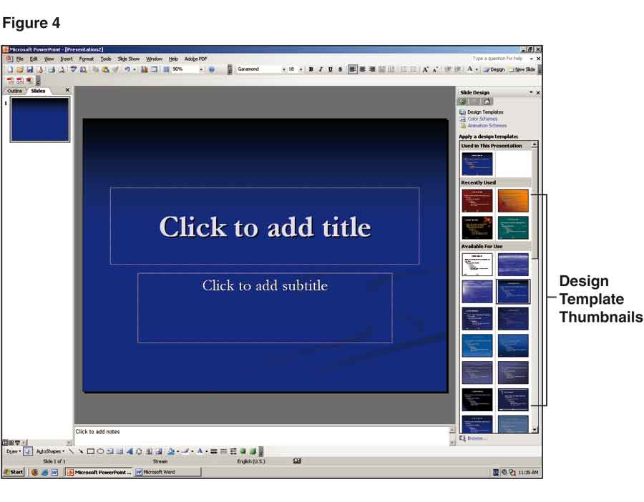
Designed for business speakers, AutoContent Wizard provides templates with predetermined outlines and sample text for two dozen kinds of presentations, such as Employee Orientation, Project Overview, and Facilitating a Meeting. Although helpful in some situations, AutoContent Wizard is seldom used outside a business setting.
Return to Contents

Slide Layouts
If you choose Blank Presentation, thumbnails of 31 slide layouts will appear in the right column—as shown in Figure 5 (use the scroll bar to see all the thumbnails). When you place the cursor on one of the thumbnails, its name will be displayed underneath it. Click on any layout, and it will appear in the middle of your screen.
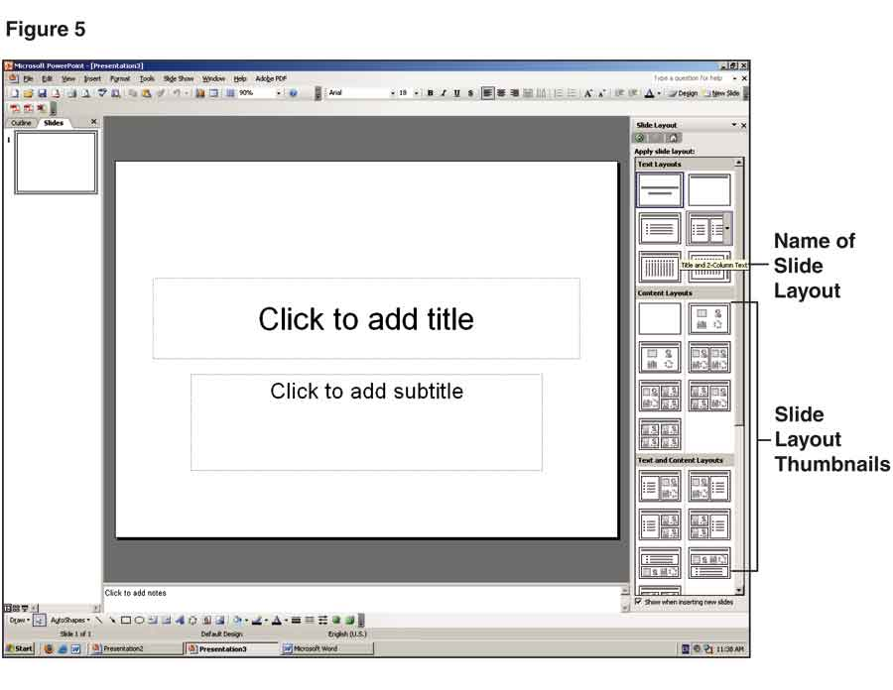
If you choose Design Template, the first slide will default to a Title Slide layout. When you create a second slide, you will be able to select from the same 31 layouts as in Blank Presentation—but with a consistent design in the background.
Return to Contents

Creating a New Slide
As with most functions in PowerPoint 2003, there are several ways to create a new slide:
- The fastest is to click New Slide on the far right of the upper tool bar (Figure 6).
- You can also click Insert on the menu bar and choose New Slide from the choices on the drop-down menu.
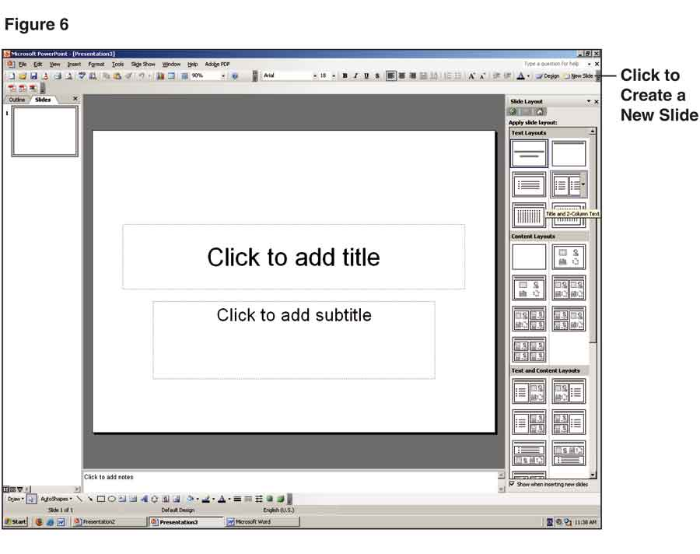
No matter which method you use, executing the command will prompt layout options to appear in the task pane.
Return to Contents

Saving Your Work
As with any computer program, you should save your work on a regular basis when working in PowerPoint. To do so, press Ctrl + S or go to the menu bar at the top of the screen, click File, and choose Save from the drop-down menu.
The first time you save your presentation, the Save As dialog box will appear with either the opening words of your title slide or the label “Presentation1.ppt” highlighted in the File Name panel near the bottom (Figure 7).
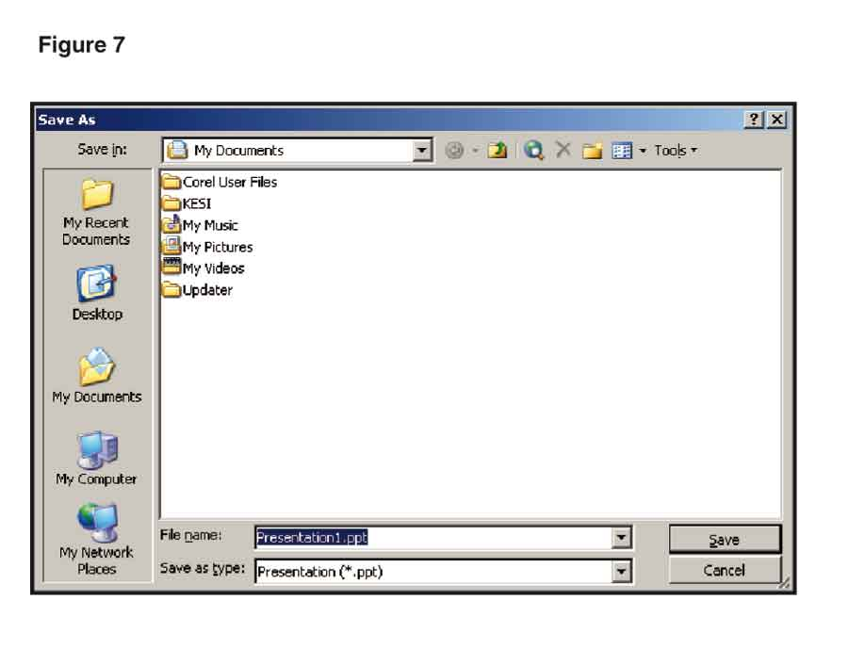
Decide whether you want to save the presentation on your hard drive or on a floppy disk, CD, or zip disk. Choose the drive and file name under which you want to save the presentation and click the Save button at the lower right of the dialog box.
Return to Contents

INSERTING TEXT, IMAGES, AND SOUNDS
Now that you know your way around the basic elements of PowerPoint, you’re ready to start developing slides for your speech. There are two major steps in developing slides. The first is creating text and finding visual images and perhaps sounds or video clips to insert on your slides. The second is to format your slides for maximum impact.
As you become more proficient in PowerPoint, you will probably find yourself moving simultaneously between these two steps. Here we will go over each step separately so we can explain them as clearly and systematically as possible.
Return to Contents

Text
There are two main ways to add text to a slide. One is to use the text placeholders on the slide layouts. These placeholders are boxes that say “Click to add title” or “Click to add text” (see Figure 8).
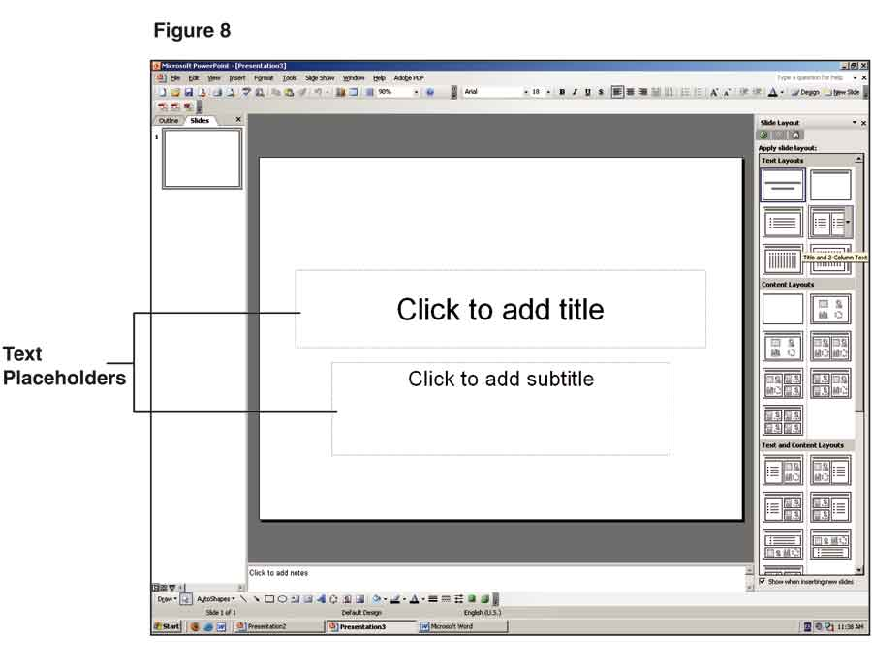
When you click in a placeholder, the instructions disappear and you’re ready to type in your text. When you finish entering your text, move the mouse pointer outside the box and click to make the placeholder borders disappear.
Another way to add text is with the text box function, which you can access by clicking Insert on the menu bar at the top of the screen and selecting Text Box from the drop-down menu. Once you have activated the text box function, click the spot where you want the text to appear on your slide. Type your text in the resulting box.
To change the location of the text box, place your cursor on the border, click, and use the arrow keys to move the box to the desired spot. Then click outside the text box to make its borders disappear. (You can bring the borders back by clicking anywhere on the text.)
Return to Contents

Photographs
If you’re speaking on a topic drawn from your personal experience, you can use PowerPoint 2003 to display your own photographs. For other topics, you can download photographs from the Web.
Figure 9 lists of some of the best online sources for photographs on topics of current and historical interest:
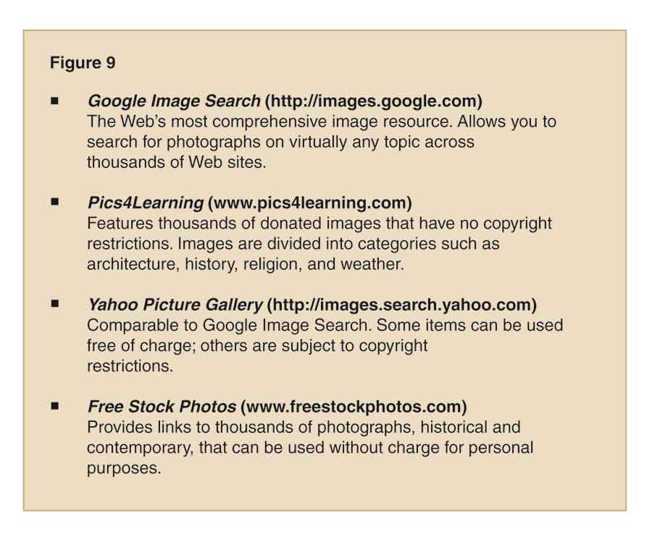

Once you locate a photograph you want to use, place the mouse pointer on it and right click. A list of options will appear, from which you should choose Save Picture As (Figure 10). Create a file name that will be easy for you to find later and save the photograph to your computer. (It will automatically be saved in your My Pictures directory unless you specify a different location for it.)
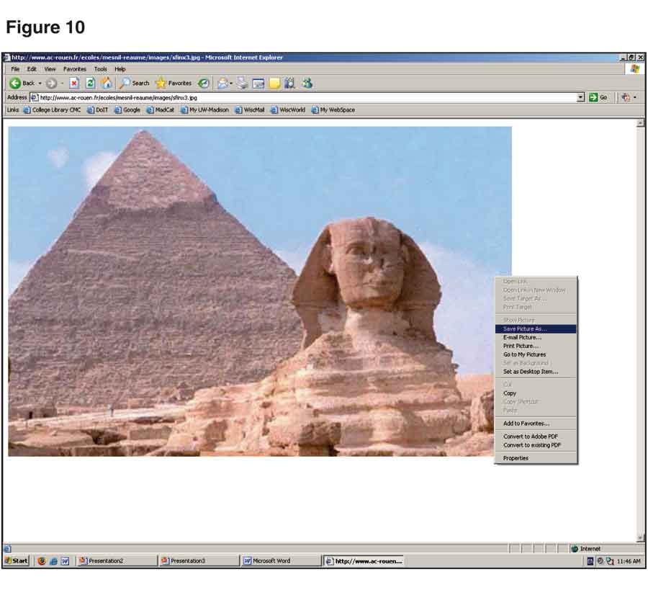
To insert a downloaded photograph on a slide, follow these steps:
- Click Insert on the menu bar at the top of your screen.
- Choose Picture, followed by From File.
- The Insert Picture dialog box shown in Figure 11 will appear with a list of all the photographs and other images you have downloaded to your computer. Highlight the photo you want and click Insert to add it to the slide you are currently working on.
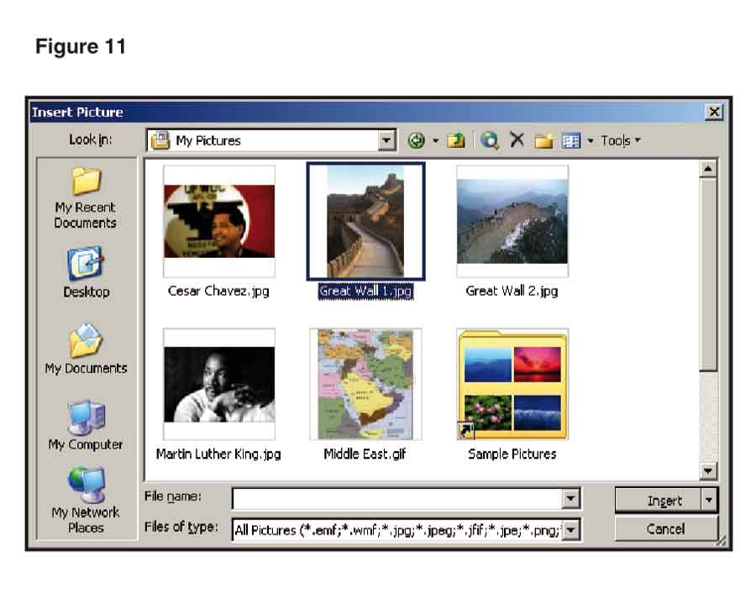
To make a slide displaying a photograph and nothing else, follow these steps:
- Go to the Content Layouts category in the Apply Slide Layout task pane on the right of your screen in Normal view.
- Select Blank, which is the first choice in the Content Layouts category.
- If you want a title at the top of your slide, use the Title and Content layout, which is directly under the Blank layout. (Microsoft uses the word “content” in the layouts to refer to visual items such as photographs, clip art, charts, videos, and the like.)
It’s also possible to combine photographs with text. Suppose you want a title above the picture and a brief description to the left of it:
- Scroll down the right task pane and select the Title, Text, and Content layout, which is the first option in the Text and Content Layouts category.
- To insert your photograph, click the icon in the lower left corner of the box on the right side of the slide. (The words “Insert Picture” will appear below the icon when you place your cursor on it.)
- When the Insert Picture dialog box appears, double click on the picture you wish to insert. You can then type the title in the box at the top of the slide and the description in the text box on the left. The result might look like the slide in Figure 12.

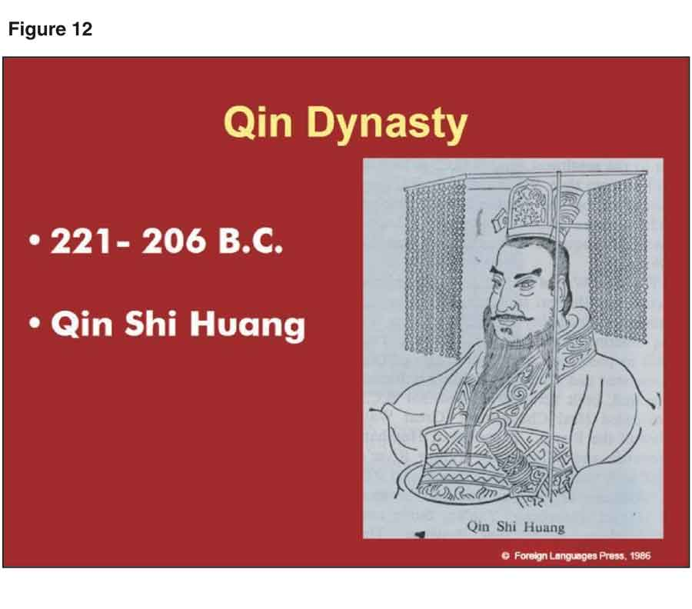
Whether you are adding a photograph alone or combining it with text, the process is remarkably simple. It can also be used for other objects—including clip art, graphs, maps, charts, drawings, and even videos.

Return to Contents

Clip Art
There are several ways to add clip art to a slide. The easiest is to select one of the first two layouts under the Other Layouts category on the right of your screen in Normal view. When the layout appears on screen, double click the icon for adding clip art—as shown in Figure 13.
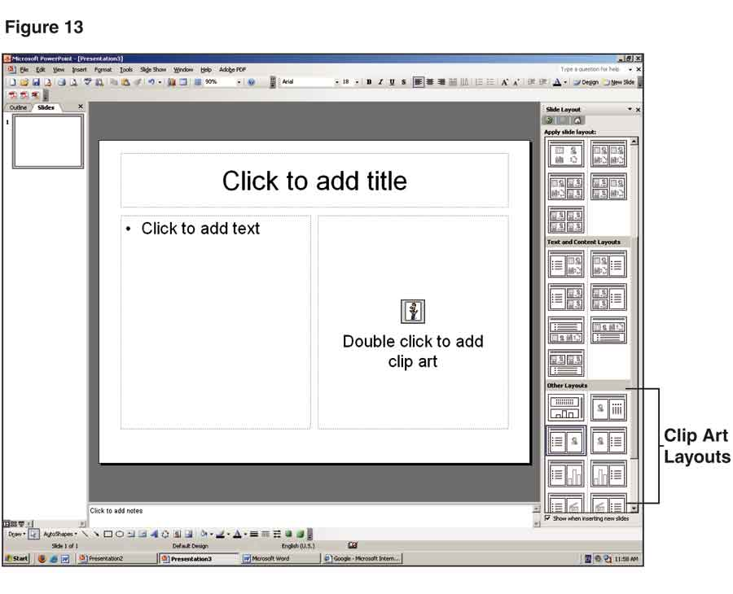
After you click the icon for clip art, the Select Picture dialog box will appear. Scroll through the options and double click on the item you want to add to your slide.
You can also use PowerPoint to find clip art online. Here’s how:
- In Normal view, click the vertical arrow to the right of the Slide Layout label in the task pane.
- Select Clip Art from the drop-down menu. (If the Add Clips to Organizer dialog box appears, click the Esc key to get rid of it.)
- Click Clip art on Office Online in the lower right column. This will take you to Microsoft’s Design Gallery Live, where you can search for clip art by keyword or by category—as shown in Figure 14.
- When you locate a clip you want to use, click the checkbox directly beneath it.
- To display all the clips you have chosen, click Selection Basket at the upper left of the website.
- When the next screen appears, click Download to send the selected clips to your computer.
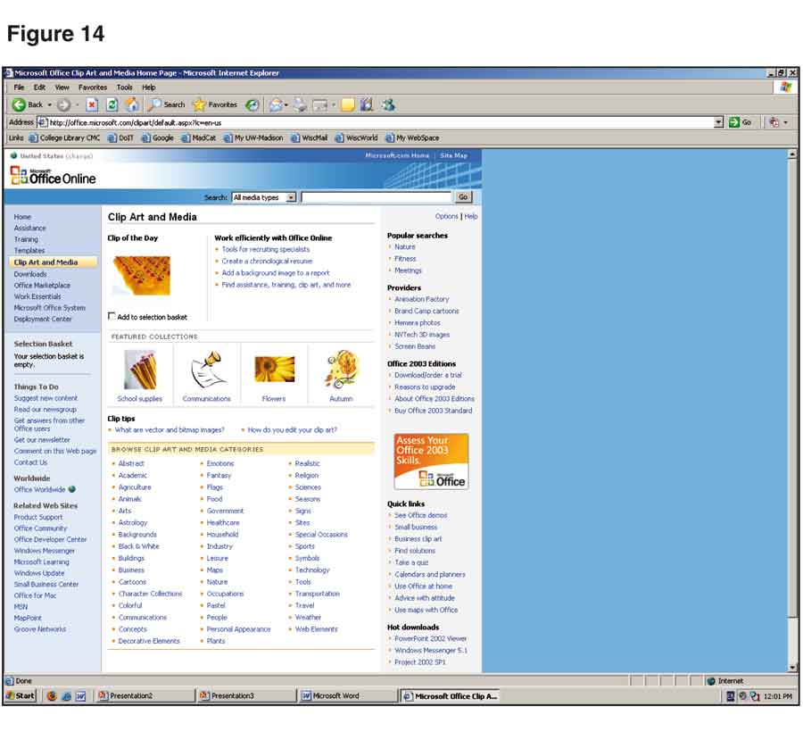
To insert downloaded clip art on a slide, follow the same procedure explained earlier for adding a downloaded photograph:
- Click Insert on the menu bar at the top of your screen and choose Picture, followed by From File.
- When the Insert Picture dialog box appears, choose the file that contains the clip art you want and click Insert to add it to your slide.
Return to Contents

Graphs
PowerPoint gives you a number of ways to incorporate graphs into your speeches. One option is to create a graph using data you have gathered.
- Scroll down to Other Layouts in the task pane on the right side of the screen in Normal view. Select a slide layout that contains a graph.
- When the slide appears, double click on the add-chart placeholder. (Microsoft uses the words “graph” and “chart” interchangeably.) This will open the Microsoft Graph program.
- Your screen will display a PowerPoint slide with a graph and, below it, a datasheet that supplies the information on which the graph is based (Figure 15).
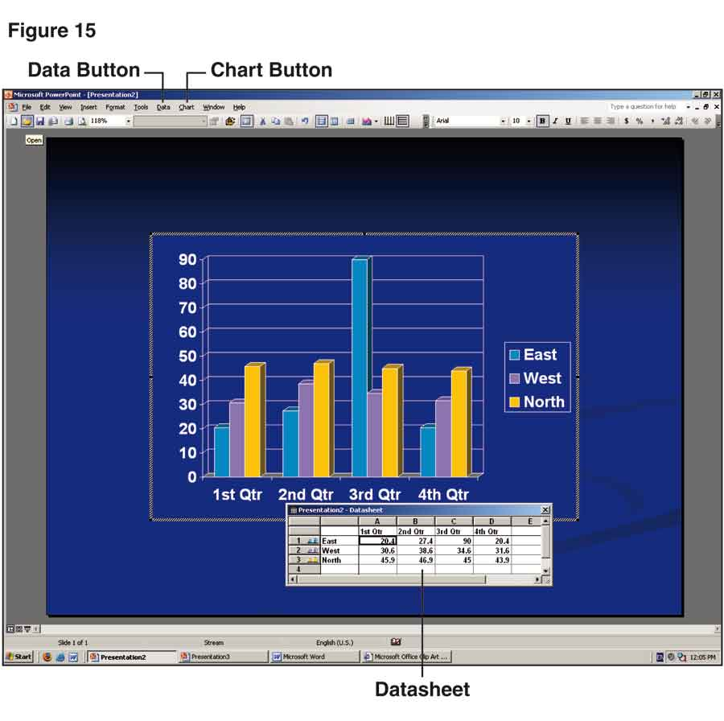

The datasheet is a separate window. As you replace the labels and numbers on the default datasheet with your own labels and numbers, the graph will change accordingly. When you are finished, click anywhere outside the graph or datasheet to leave Microsoft Graph and return to the slide.
When you enter Microsoft Graph, you will see the default graph shown in Figure 15. To create a different kind of graph, stay in Microsoft Graph. The PowerPoint menu bar at the top of the screen will be replaced by the graph menu bar that includes Data and Chart buttons.
Click Chart, followed by Chart Type. A dialog box will appear with options for various kinds of graphs—as shown in Figure 16:

Highlight the graph you want, click OK, and it will replace the graph on your slide. You can now modify the graph using the datasheet at the bottom of your screen.
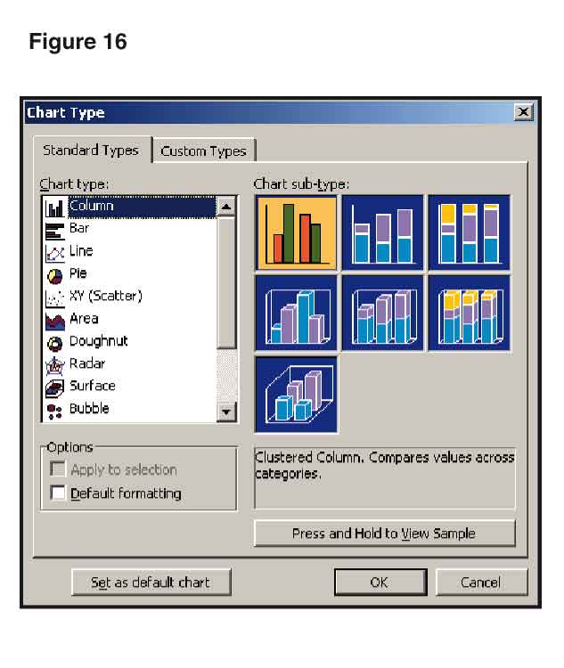

Working with the graph program takes a little practice, but once you get the hang of it, you should be able to create the kind of graph you need for just about any speech.
In addition to creating your own graphs, you can use PowerPoint to download graphs from the Internet. (Websites for government agencies, newspapers, and magazines are all excellent sources for graphs.)
When you find a graph you want to use, right click on it and choose Save Picture As. Create a file name that will be easy for you to find later and save the graph to your computer.
To access the graph for use in a slide, follow the steps described earlier for inserting clip art and photographs you have downloaded from the Web.
Return to Contents

Sounds

Adding Sounds
One way to incorporate sound into your presentation without creating problems with disk space is to play a portion of a CD from the computer’s CD drive. (You can do this only if you are running your presentation from the hard drive or the floppy disk drive, rather than from the CD drive.)
- Click the Insert button on the menu bar at the top of your screen.
- Select Movies and Sounds from the drop-down menu, followed by Play CD Audio Track. This will display the Movie and Sound Options dialog box shown in Figure 17.
- Enter the track of the CD you want to play.
- Also note where in the track you wish to begin and end; enter this information in minutes and seconds.
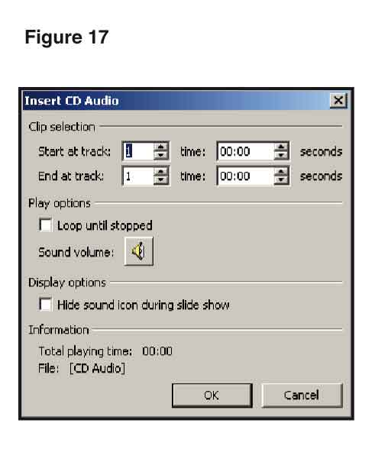

- When you click OK, another dialog box will ask if you want the sound to play automatically when the slide appears on screen or when you click the sound icon. In most cases, you should choose the second option, so you can control exactly when the CD will play.
- After you make your selection, the dialog box closes and a sound icon appears on the screen. You can place the icon anywhere on the slide by dragging it to your desired location.
Another way to incorporate sounds into a PowerPoint presentation is to download sound clips from the Internet. You can use a clip that you have downloaded previously, or you can download one specifically for your speech. In either case, the procedure is the same for inserting the clip onto a PowerPoint slide:
- Click Insert on the menu bar, followed by Movies and Sounds from the drop-down menu.
- Select Sound from File to display the Insert Sound dialog box (Figure 18).
- Find the file that contains the clip you want and click OK to add it to your slide.
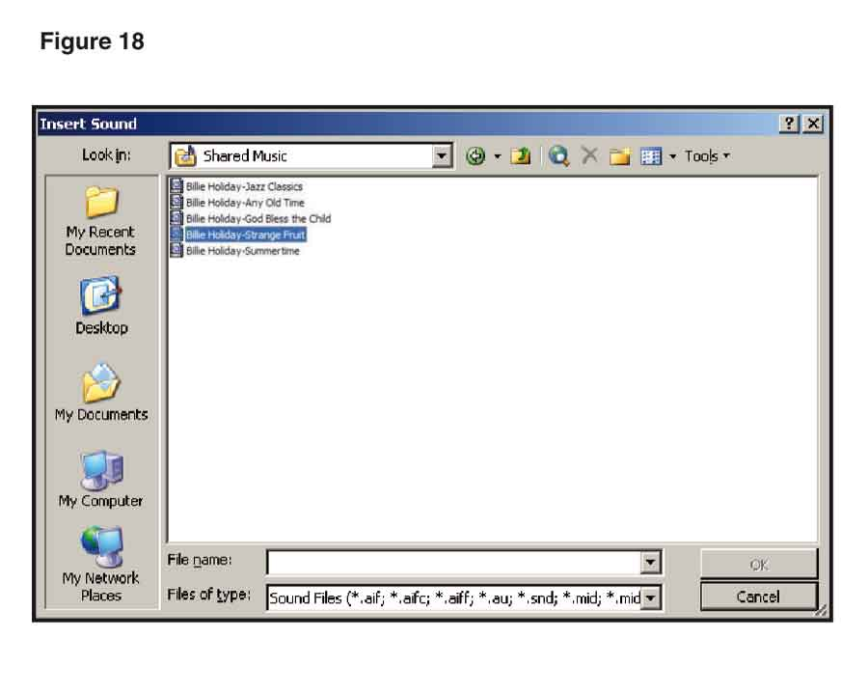
If you use downloaded sounds in your presentation, be sure to follow the copyright provisions discussed in your textbook. Also be aware that unless you have sound editing software, you cannot excerpt a portion of the downloaded file to use in your speech. You have to add the entire file—which may take up too much space on a floppy disk if that’s what you’re using for the presentation.
Playing Sounds
Regardless of where you find your sounds, you have two ways to play them in PowerPoint. One way, as discussed earlier, is to click the sound icon that appears on screen after you insert a sound onto a slide.
A second way is to assign the sound file to a photograph, chart, graph, text box, or other object on the slide. Rather than having a sound icon appear on screen, you play the sound by clicking the object to which you have assigned it. This results in a more polished presentation and is the method preferred by most experienced speakers. Here’s how to use it:
- Make sure the slide on which you want to insert the sound is displayed on screen.
- Insert the photograph, text box, or other object that you want to associate with the sound.
- Right click anywhere on the object and choose Action Settings from the shortcut menu (Figure 19).
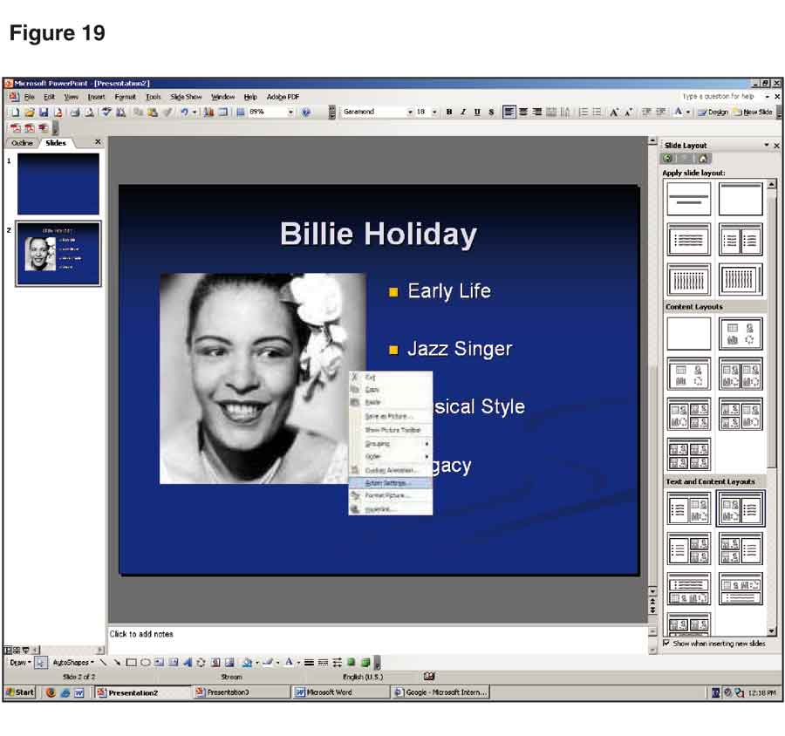
- Select the Play Sound checkbox in the Action Settings dialog box shown in Figure 20.
- Click on the arrow at the right of the Play Sound box to reveal the drop-down list. Scroll to the bottom of the list and choose Other Sound. This will open the Add Sound dialog box.
- Select the file you want from the Add Sound dialog box and click OK.
- The sound you have chosen is now associated with the object on your slide. To play the sound during your presentation, simply click on the object.
Return to Contents

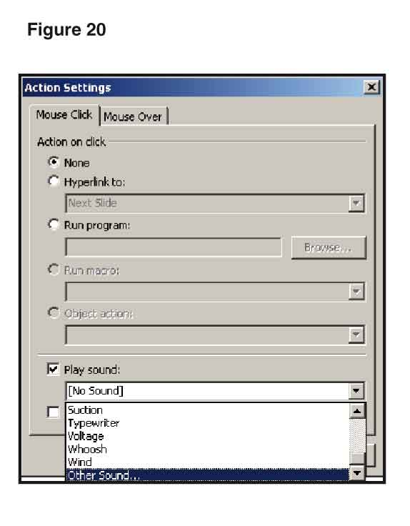

Video
To insert a video clip from a computer file to a PowerPoint slide, display the slide on which you want the video to appear. Then follow these steps:
- Click Insert on the menu bar, followed by Movies and Sounds, then Movie from File.
- When the Insert Movie dialog box appears, locate the file you want to add to your slide and click OK.
The first frame of the video will appear on the slide along with a dialog box asking if you want the video to play automatically or when you click it. In most cases, you should take the second option, since it gives you full control over when the video runs during your presentation.
Return to Contents

Copyright Credits
As we discussed on pages 365-366 your textbook, you need to be sure to include copyright credits when you use copyrighted material on a PowerPoint slide. Follow these steps:
- Move the photograph, chart, map, or other object for which you are providing credit up slightly on the slide so there is room to insert a text box below the object.
- Click Insert on the menu bar at the top of the screen and select Text Box.
- Click on the slide below the object where you want to place the text box.
- When the box appears, click Format on the menu bar, followed by Font, which will generate the Font dialog box shown in Figure 21.
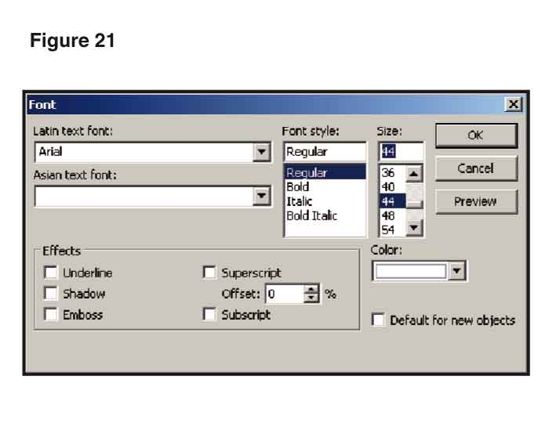
- Use the Size option to change the font size from 24 to 10 and click OK.
- Drag the text box so it is aligned with the bottom outside corner of the object on the slide and click outside the box to make the lines disappear.
- When you are finished, the copyright information should be displayed inconspicuously so it does not detract from the content of the slide--as in Figure 22.
Return to Contents



FORMATTING SLIDES
Once you have the text, images, sounds, and/or videos that you want to include on your slides, the next step is to format the slides to communicate your message as effectively as possible. Although PowerPoint provides a number of advanced formatting features, you can start creating sharp, professional-looking slides right away by mastering a few simple techniques for the use of color, fonts, space, sizing, animation, and transitions.
Return to Contents

Adjusting Colors
Both the Design Template and AutoContent Wizard options come with built-in color schemes for your slides. If you use Blank Presentation, you will need to choose the colors yourself. Doing so, however, is easy and is often necessary to get just the look you want.
- Make sure you have a slide on your screen.
- Click Format on the menu bar, followed by Slide Design on the drop-down menu.
- The top of the task pane at the right of your screen will now say Slide Design. Click the Color Schemes option to display thumbnails of a dozen schemes for you to choose among (Figure 23). Click the scheme you want, and it will be applied to all your slides.
Return to Contents

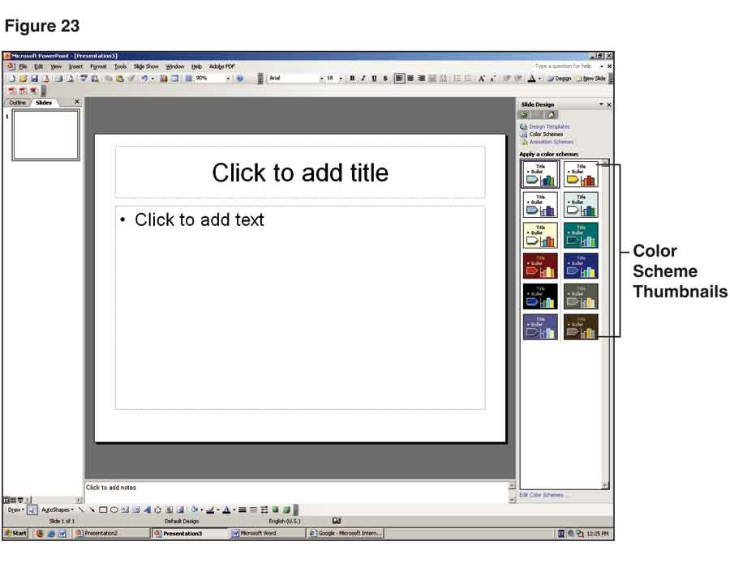

Adjusting Fonts
To adjust the font on a single slide, highlight the text you want to change and select a new font and size from the font attribute box in the upper toolbar shown in Figure 24.

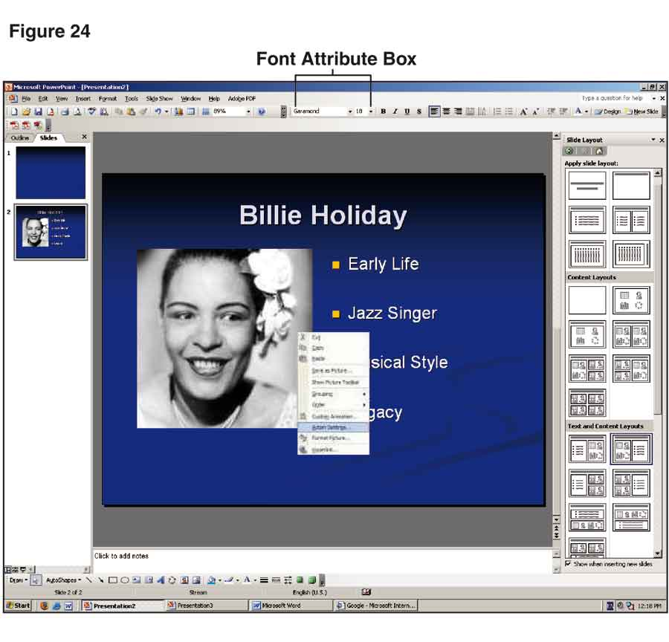

If the font attribute box is not visible, select Format from the menu bar, followed by Font, and make your choice from the Font dialog box shown in Figure 25.

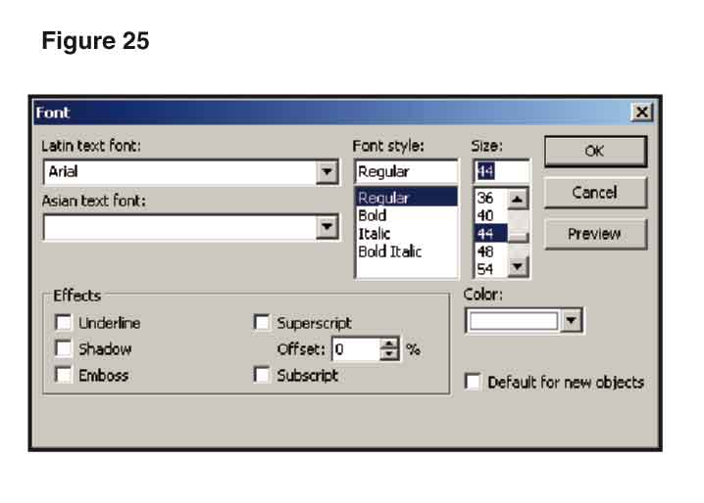

Changing the font on all the slides in a presentation is more complicated, but sometimes is necessary to get just the look you want. To begin, make sure you have a slide on your screen. Then proceed as follows:
- Go to the menu bar and click View, followed by Master and then Slide Master. Figure 26 shows what you will see.
- Click in the box that says “Click to edit Master title style.”
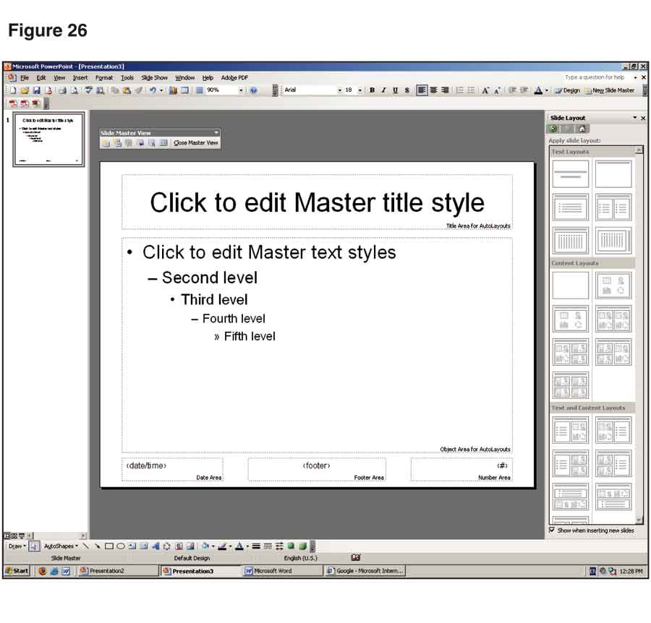

- Go to the menu bar at the top of the screen and click Format, followed by Font, which will open the Font dialog box (Figure 27).
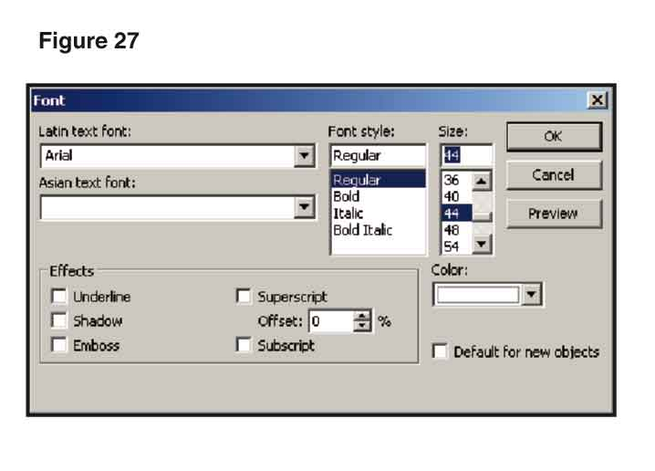
- Highlight the text box on the currently displayed slide that says “Click to edit Master title style.”
- Scroll through the list of fonts in the font box, choose the font and size you want, and click OK. This will change the title font.
- To change the font for the rest of your text, go to the lower box on your screen and highlight all the other levels of text.
- Reactivate the Font dialog box and choose the desired font and size. PowerPoint will apply your selection to all the levels of text that you highlighted. (If you wish, you can choose a different font here than the one you selected for your title; just make sure it works well in combination with the title font.)
- When you’re finished, click View on the menu bar, then Normal on the drop-down menu. This will apply the new font—or fonts—to all the slides in your presentation. (One of the nice features of PowerPoint 2003 is that you can make this change at any point when developing your presentation.)

Return to Contents

Sizing and Spacing Objects
When you add any object to a slide—text, photograph, clip art, etc.—it will be surrounded by small dots, as in Figure 28. These dots are sizing handles that enable you to enlarge or shrink the object. (If they disappear, click on the image to make them reappear.)
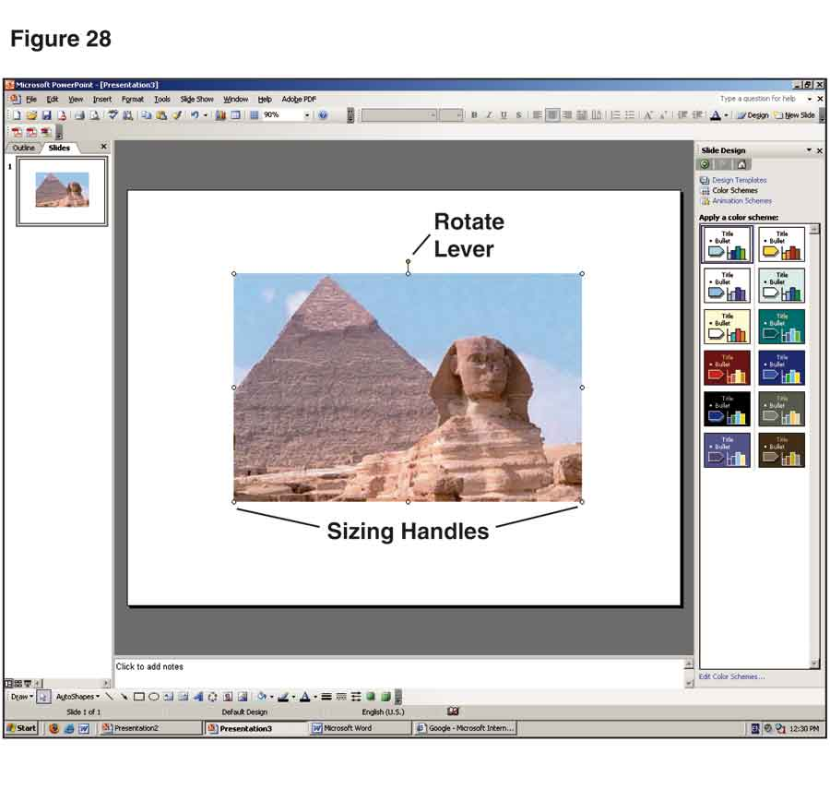
When you enlarge or shrink an object such as a photograph, clip art, or chart, you need to so do so in a way that does not distort the image by making it disproportionately wide or tall. To maintain the proper proportions, use only the dots at the corners of the object to change its size. Place the cursor over one of the corner dots. The cursor will change into a thin double-ended arrow. Hold down the left mouse button and expand or contract the object until it reaches the size you want.

As you work with an object, a dotted outline will show its size and location. If you need to change the location of the object once you have sized it, click in the middle of the object and drag it up, down, or sideways as needed.
PowerPoint 2003 also provides a green lever at the top of an object that enables you to rotate the object (see Figure 28, above). Place your cursor on the lever, hold down the left mouse button, and rotate the object until it is in the desired position.
As you work with the elements on your slides, keep in mind that a photograph or piece of clip art will become less sharp as it gets larger. Take care not to make the image so big that it becomes grainy or blurry. On the other hand, remember that a small image which is easy for you to see on your computer screen may not be as clear to your audience from across the room—even when shown with a projector. This is especially important for slides that contain charts, graphs, or other objects with lots of details.
Return to Contents

Adding Animation
In PowerPoint, “animation” refers to the way objects enter or exit a slide. Without animation, all the items on a slide appear at the same time when the slide is displayed. With animation, you can control when words, pictures, and even parts of graphs show up on the screen.

Preset Animation
One way to generate animation is by using PowerPoint’s preset animation effects. To add preset animation to an individual slide, display the slide in Normal view and follow these steps:
- Click Slide Show on the menu bar at the top of your screen, followed by Animation Schemes from the drop-down list. The left column on your screen will show thumbnails of all the slides in your presentation. The right column will present a list of animation effects arranged by category: No Animation, Subtle, Moderate, and Exciting (Figure 29).
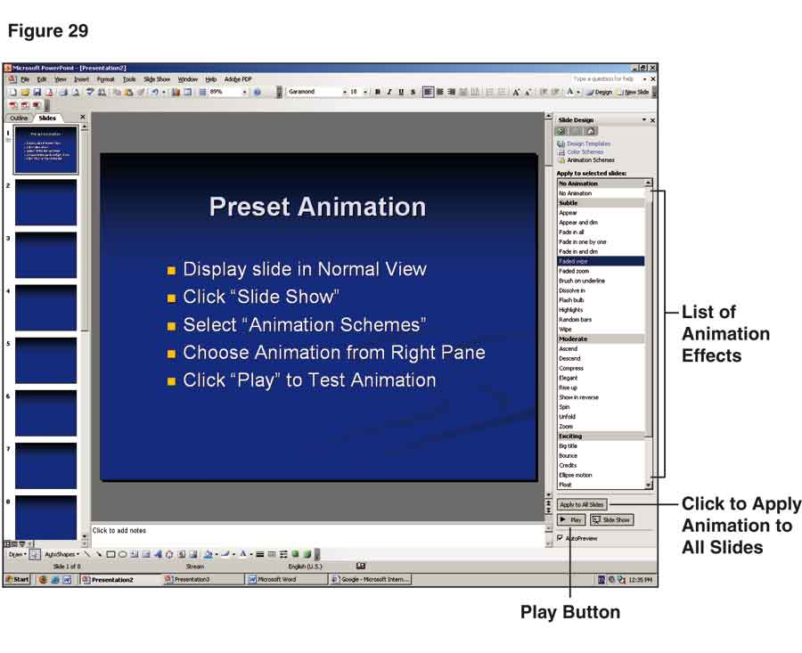

- Click the effect you want and it will be added to the slide that is currently on screen.
- To test the animation, click Play at the bottom of the right column.
- If you want to apply the animation to all the slides in your presentation, click Apply to All Slides.
Although preset animation is quick and easy to use, it has some drawbacks. The major one is that you sacrifice flexibility in the animation effects available to you and in the manner you apply them. You can avoid these drawbacks by using PowerPoint’s custom animation—which is what most experienced speakers prefer.

Custom Animation
As its name implies, custom animation gives you full control of all your animation effects. There are six steps in adding custom animation:
- Make sure the slide to which you want to add animation is displayed in Normal view.
- Click Slide Show on the menu bar at the top of the screen.
- Choose Custom Animation on the drop-down menu to display the Custom Animation task pane at the right of your screen—as seen in Figure 30.
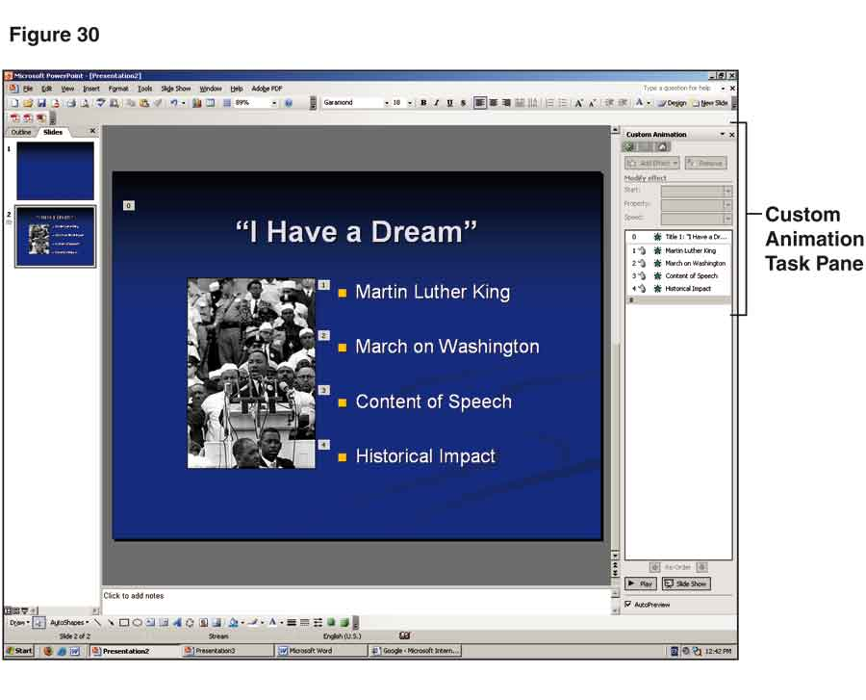

- Click on the object or text you want to animate.
- Click Add Effect in the Custom Animation task pane, followed by Entrance and More Effects from the resulting shortcut menus shown in Figure 31.
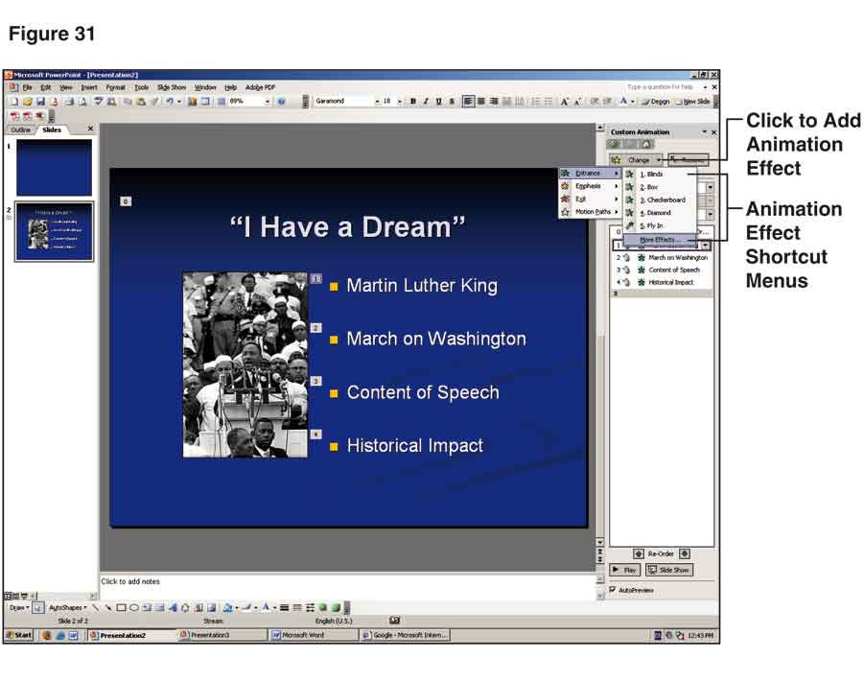
- The Add Entrance Effect dialog box will now be displayed on screen (Figure 32). Click on any effect to preview it. Once you have decided which effect to use, click OK to apply it to your slide.
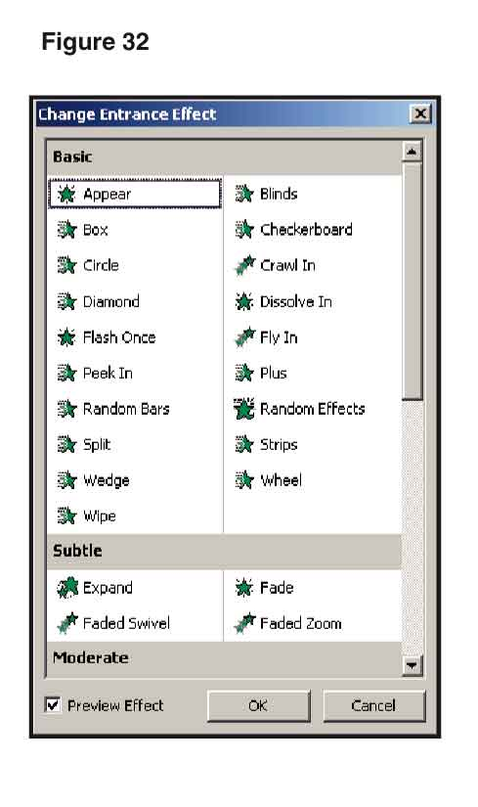
When choosing an animation effect, stick with those in the Basic, Subtle, and Moderate categories—such as Appear, Dissolve In, Strips, and Stretch. Those in the Exciting category are fun to experiment with, but are too distracting for most speeches. Also, stick with a limited number of animation effects and use them consistently from slide to slide.

Timing, Direction, and Speed of Animation Elements
Depending on the animation effect you pick, you may need to choose its timing, direction, and speed. You can adjust all of these with the boxes under Modify in the Custom Animation task pane.
- To open the pane, make sure the slide to which you want to add animation is displayed in Normal view.
- Click Slide Show on the menu bar at the top of the screen.
- Choose Custom Animation on the drop-down menu to display the Custom Animation task pane at the right of the screen (Figure 33).
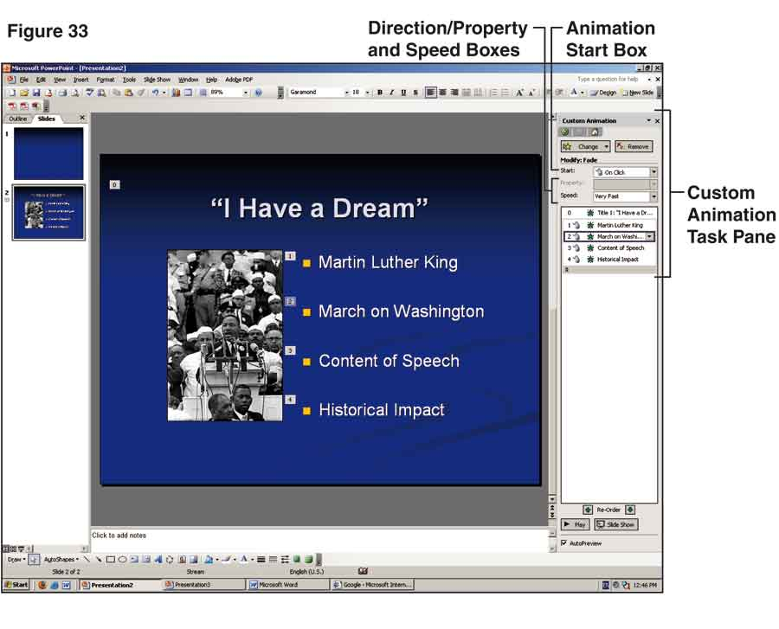
- The default option for starting animation effects is On Click, which prevents objects from showing up on screen before you’re ready. If you want items to appear automatically, click the arrow at the right of the Start box to expose a drop-down menu and select another option.
- To control the direction and speed of animated items, highlight the desired item and click the down arrows in the Direction and Speed boxes in the Custom Animation task pane. This will expose drop-down menus with a number of options—as in Figure 34. Click the desired option to apply it to your slide.

As with other aspects of animation, choose direction and speed options that are not going to distract your audience. For example, if you’re using Fly In, it’s usually best to choose From Left for text that is located on the left of the slide and From Right for text that is on the right of the slide.
Although the best speed will depend on the exact animation effect you select, Fast and Very Fast are usually preferable because they get the text or object on screen quickly without drawing undue attention to the animation effect.
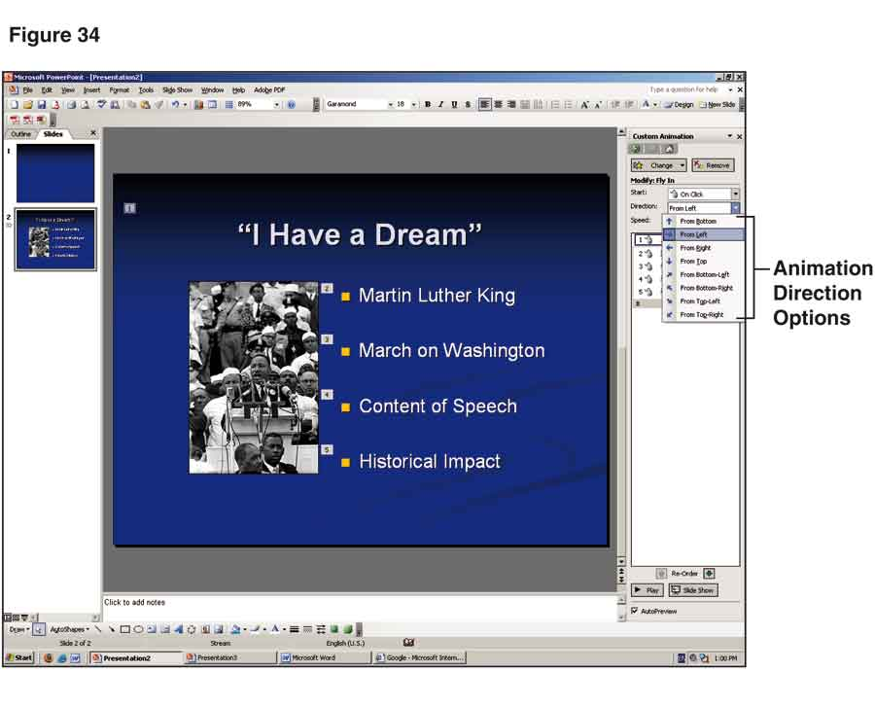

Order of Animation Elements
If you’re animating multiple elements on a single slide, you need to check when you finish the animations to make sure the elements appear in the order you wish.
- To the left of each animated element on the slide is a small box with a number that shows the order in which the element will appear. In the Custom Animation task pane on the right of your screen is a numbered list of animation elements that corresponds to the numbers on the slide (Figure 35).
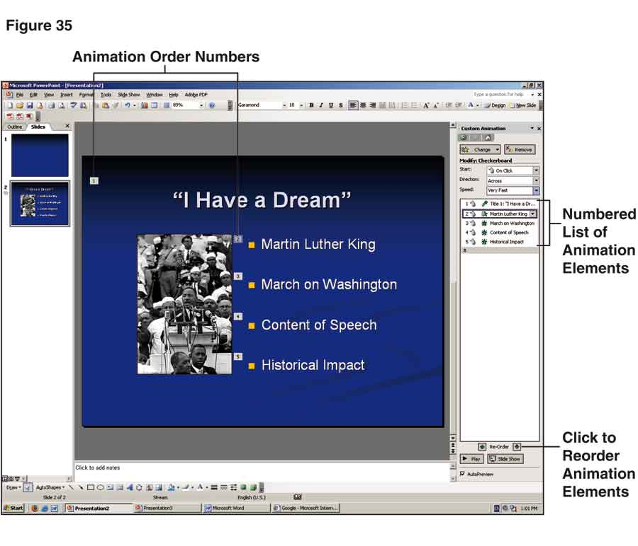

- To change the order of your animations, highlight an element in the task pane and move it up or down the list by clicking one of the Re-Order arrows at the bottom of the pane. As you re-order the elements, the small numbers indicating their entrance order will change on the slide. (The numbers will not appear when the slide is shown during your speech.)
- To view the animation of the slide you are working on, click the Play button at the bottom of the task pane.
- To check animation in the entire show, click the Slide Show button located next to the Play button. After the first slide appears, click your mouse to move from slide to slide and from element to element within slides.
- Press the Esc key at any time to return to Normal view.
Return to Contents

Creating Transitions
While animation controls the entry and exit of individual items on a slide, transitions refer to the way entire slides enter the screen. The default option is for slides simply to appear on screen—which is usually the best choice.
There may be situations, however, in which you want to explore other options. To do so, follow these steps:
- Click View on the menu bar at the top of your screen and choose Slide Sorter from the drop-down menu. This will display all the slides in your presentation—as show in Figure 36.
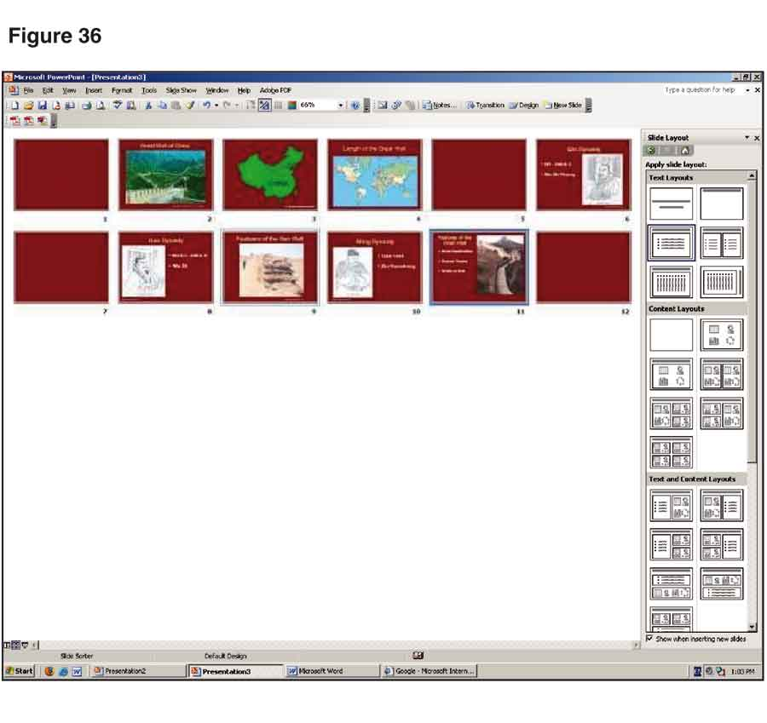

- Next click Slide Show on the menu bar, followed by Slide Transition from the drop-down list. A list of transition options will appear in the Slide Transition task pane on the right of your screen—as seen in Figure 37.
- Click one of the transition effects from the list to apply it to the currently selected slide. To change effects on the same slide, click another option from the list.
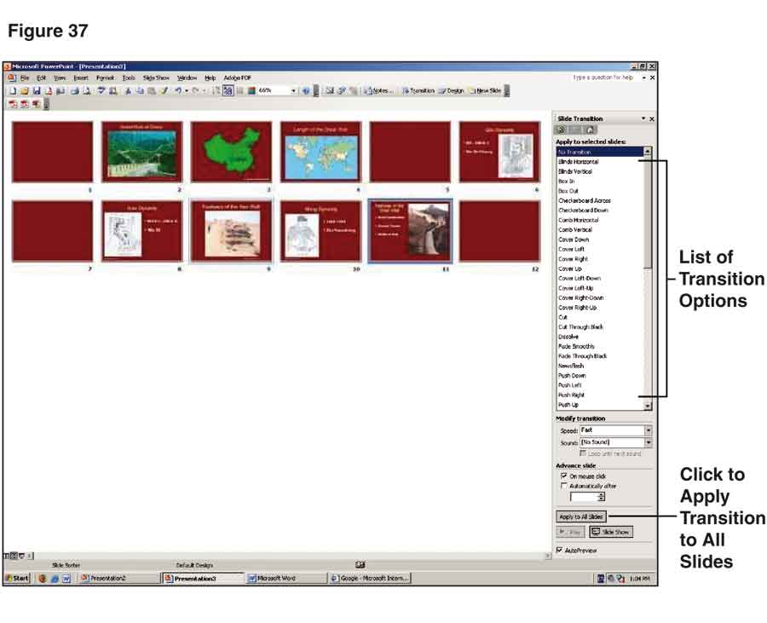
If you click Apply to All Slides at the bottom of the task pane, the most recently selected transition effect will be applied to all your slides.
You can also use the Slide Transition task pane to add sound, to adjust the speed of your transitions, and to control how the transitions will advance, but you’re usually better off sticking with the default options for these items.
As with animation effects, be careful not to get carried away by the array of transition possibilities. If you decide to use something other than the default option, go for a straightforward choice such as Cut, Dissolve, or Fade Smoothly. Whatever you select, stick with it throughout your presentation.
Return to Contents

Inserting Blank Slides
As with other kinds of visual aids, PowerPoint slides should be visible only when you are discussing them. Unless you are moving immediately to another slide, you should insert a blank slide that you can display until you get to the next slide.
Unless you are projecting the title of your speech in PowerPoint, you may also need a blank slide at the beginning, so your first content slide will not be exposed until you get to the appropriate place in your speech. In addition, you should add a blank slide after your last visual aid so it will not continue to be exposed after you have finished discussing it.
- To insert a blank slide, make sure you’re in Normal view.
- On the left side of the screen will be either thumbnails of your slides or an outline that shows the text of your slides (Figure 38).
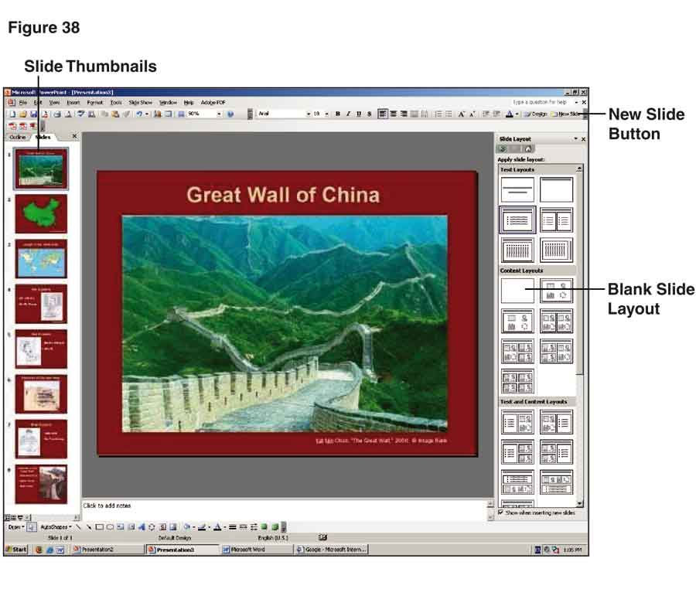

- Click on the slide after which you want to insert a blank slide.
- Click New Slide at the far right of your upper tool bar. This will create a slide following the same layout as the previous slide.
- Click Blank from the thumbnails of layout options in the right column to switch to a blank slide. (Blank is the first option under Content Layouts.)
If you prefer not to create blank slides, you can temporarily pause your slide show at any point by pressing the B or W keys. The B key will turn the screen black, while the W key will turn the screen white. To resume the show, press the B or W key again.
Return to Contents

SHOWING YOUR SLIDES
Use the following commands to review your slides after you have finished preparing them or to show them during a speech:
- To begin the slide show, click View in the menu bar at the top of your screen. Select SlideShow from the drop-down menu and your first slide will appear.
- To begin the animation on the first slide or, if there is no animation, to advance to the next slide, click the mouse anywhere on the slide. You can accomplish the same thing by pressing N, the space key, the right arrow key, or PgDn. It doesn’t matter which option you use, but you should settle on one and use it consistently.
- You can return to the previous animation or, if there is no animation, the previous slide by pressing P, the Backspace key, the left arrow key, or PgUp. As with advancing slides, you should choose one command and stick with it.
- If you need to switch to a slide out of order, type the number of the slide followed by Enter. If the slide is animated, click your mouse to start the animation.
- You can end your slide show at any time by pressing the Esc key. This will return you to Normal view.
If you are conducting a question-and-answer session after the speech, you might want to return to a particular slide when answering a question. Be sure to add a blank slide at the end of your presentation, so you can remain in SlideShow view even after the speech is over. To return to a previous slide, type the number of the slide and press Enter. This will bring the slide back on screen.
Finally, you can use the mouse pointer to draw the audience’s attention to specific parts of a map, photograph, or chart without having to use a laser pointer:
- To activate this function, press the A or = key and move the pointer with the mouse. (Be careful not to click the mouse while using the pointer, or you will advance the slide.)
- When you are finished using the pointer, press A or = again.
- If you plan to use the mouse pointer, be sure to practice with it when you rehearse the speech.
The more you work with PowerPoint 2003, the more proficient you will become with its many features. If you need additional assistance, be sure to check the Help function in the upper right corner of the menu bar.
Return to Contents

